

Year 11 > 12 Bridging Work
Summer Term 2026


Subject | Business
Course | A-Level
Awarding Body | Pearson

Contents:
 |  | Page(s)
 | Course/specification overview | 3-5
 | Our department expectations | 6
 | Review/revise | 7
 | Watch – knowledge acquisition/consolidation | 8
 | Listen to – knowledge acquisition/consolidation | 9
 | Read - knowledge acquisition/consolidation | 10
 | Research knowledge acquisition/consolidation | 1
 | Complete – Compulsory Task | 12-13
 | Appendices/resources | 14

Course/specification overview

Course Topic Content
Theme 1 and 2 (Yr12) and Theme 3 and 4 (Yr13)
Examinations

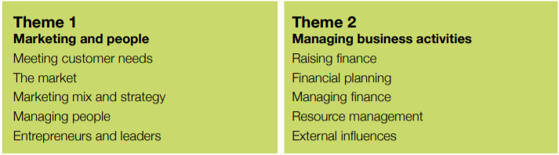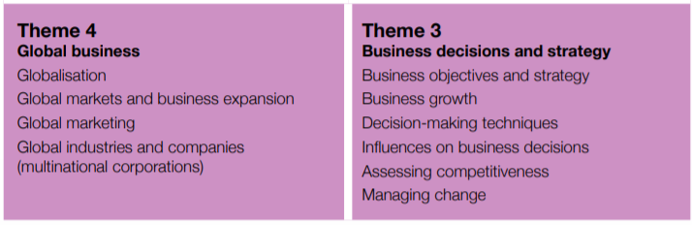

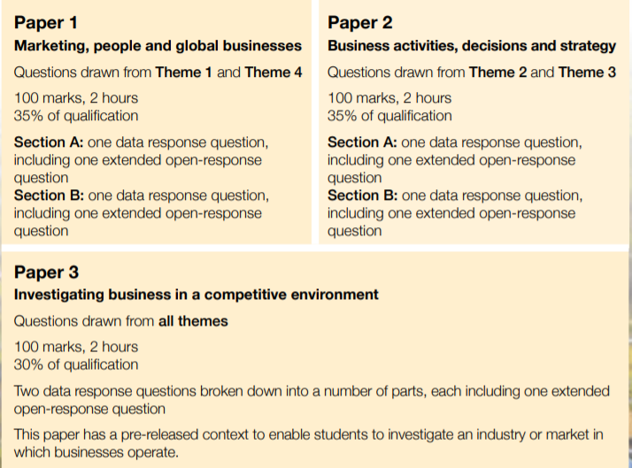

What does the A-Level have to offer?

Clear and coherent structure – four engaging and up-to-date themes, assessed through three externally examined papers.

Continuous progression – students are introduced to core business concepts and develop a broad understanding of how businesses work before they consider the decision-making tools that help business people move towards a more scientific approach to management.

Helps develop a holistic understanding of business – students investigate, analyse and evaluate business opportunities and issues. Building on this, and by using both qualitative and quantitative methods, they are encouraged to take a strategic view of their decisions and recommendations.

Reflects today’s global world – in the second year of study, students develop an understanding of current global issues that impact on business, preparing them for their next steps in today’s global world.

Develops transferable skills for progression to higher education – students will develop a multitude of skills, including numeracy, communication and an understanding of research methodology in order to make a smooth transition to the next level of study.

Possible career options?

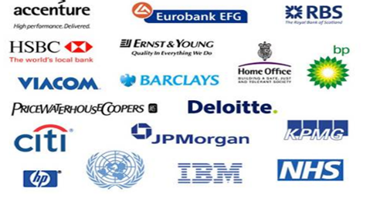

The subject provides you with such a wide range of transferable skills. This will enable you to enter a variety of different careers, with the above being just a few. Famous individuals who have studied the subject include John Grisham, Clint Eastwood, Kevin Costner, Ivanka Trump and Eddie Izzard.

Our department expectations

Expectations

The Business Studies and Economics Department has high expectations of both students and teachers. Our teachers work exceptionally hard to deliver a challenging, relevant and engaging curriculum, and we expect students to demonstrate the same commitment to their learning.

Students are expected to:

- Be willing to learn independently and take responsibility for their own progress.
- Show respect to teachers, classmates and the learning environment.
- Make their very best effort in every lesson.
- Engage positively with all learning activities and opportunities.

We are proud to offer some of the most popular courses in the Sixth Form, reflecting both the quality of our provision and our passion for the subjects we teach. We encourage all students to share this enthusiasm and approach their studies with curiosity, commitment and ambition.

Lesson Preparation and Organisation

Students are expected to:

- Complete any pre-reading tasks set by teachers (e.g. textbook or revision guide activities).
- Maintain well-organised folders, including notes, topic resources, data sheets and Personal Learning Checklists (PLCs).
- Regularly check school email and Satchel One (SMHW) for updates, resources and homework.
- Arrive fully equipped for every lesson, including pens, pencils, rulers, highlighters and a scientific calculator.

Independent Study

Students are expected to:

- Catch up promptly on any work missed due to absence.
- Make effective use of timetabled study periods for:
  - Pre-reading and lesson preparation.
  - Reviewing and consolidating classwork.
  - Completing practice questions and exam-style tasks.
- Revise thoroughly for all tests, assessments and examinations.
- Apply the study and revision techniques taught in lessons and assemblies.
- Take ownership of their progress by regularly reviewing their strengths and areas for development.
Students working below their target grade will be expected to:
- Attend subject support or intervention sessions when required.
- Complete additional practice questions and exam-style tasks to strengthen understanding.
- Act on feedback provided by teachers and demonstrate sustained effort to improve performance.

Review/revise
The Importance of Profit
- How is it calculated?
- Why is it a key objective to so many businesses?
- Should it be the only priority for a business?

Dynamic Markets
- Why would a consumer’s purchasing habits change over time?
- Why is it particularly hard for businesses to compete in the fashion industry?

Technology in Business
- How has technology altered the way that many businesses operate?
- Should the use of capital intensive production always be more favourable than labour intensive production?

Globalisation
1. Why do we buy products that are made in places other than the U.K?

Please use the following link to help inspire creativity into your revision techniques: https://hayestl.com/students/
Watch


Inside ALDI at Christmas
https://www.my5.tv/inside-aldi-at-christmas/season-1/inside-aldi-at-christmas
Key Thinking Question: Is it ethical for businesses such as ALDI to replicate the products from well-known brands?


TED TALK: How I turned a deadly plant into a thriving business.
https://www.youtube.com/watch?v=iqEHuB-T2qQ
Key Thinking Question: Should business aim to help the community in which it operates?

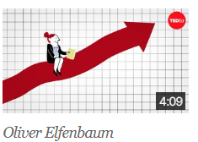
TED TALK: How does the stock market work?
https://www.youtube.com/watch?v=p7HKvqRI_Bo
Key Thinking Question: Which PLC would you buy shares in and why?

For Netflix users:

American Factory
Search through your Netflix account
Key Thinking Question: For big US businesses who move their production to China is ‘cheaper costs’ a valid enough reason?

Listen to

Bloomberg Business Podcast - Spotify

50 Things That Made the Modern Economy - Tim Harford - Spotify and BBC Sounds.

Freakonomics Radio – Spotify

The Bottom-Line Podcast - Evan Davis – Spotify

Today in Focus - The Guardian – Spotify

Rabbit Hole - The New York Times – Spotify

The Diary of a CEO - Steven Bartlett

Listen to this radio programme about how the marketing industry uses our sense of guilt to influence what we buy: Marketing: The Power of Shame - BBC Sounds

Read

Rebel Ideas: The Power of Diverse Thinking - Matthew Syed
https://www.amazon.co.uk/Rebel-Ideas-Power-Diverse-Thinking/dp/1473613949/ref=tmm_pap_swatch_0?_encoding=UTF8&qid=1587737636&sr=8-1
The Art of War - San Tzu
https://www.amazon.co.uk/Art-War-Sun-Tzu/dp/1789430062/ref=pd_sbs_14_3/260-9489557-4033354?_encoding=UTF8&pd_rd_i=1789430062&pd_rd_r=0d0a3f29-7080-4745-a32f-4fd57160a272&pd_rd_w=YrUU6&pd_rd_wg=U2IlL&pf_rd_p=2773aa8e-42c5-4dbe-bda8-5cdf226aa078&pf_rd_r=H6PE4V90WAQHGYRZ9H46&psc=1&refRID=H6PE4V90WAQHGYRZ9H46
The Lean Start-up - Eric Ries
https://www.amazon.co.uk/Lean-Startup-Entrepreneurs-Continuous-Innovation/dp/B005MR4NCC/ref=sr_1_5?dchild=1&keywords=business+books&qid=1587737852&sr=8-5
The Culture Code - Daniel Coyle
https://www.amazon.co.uk/Culture-Code-Secrets-Highly-Successful/dp/1847941273/ref=pd_sim_14_2/261-5543609-5601853?_encoding=UTF8&pd_rd_i=1847941273&pd_rd_r=af2a9a41-66c8-4ade-bc06-0574b74ed2a9&pd_rd_w=kxzcC&pd_rd_wg=0yBRh&pf_rd_p=7df4b67e-ebf6-4e8b-b5dd-7a46501724e8&pf_rd_r=0TT1STVJF34V4DW5KK89&psc=1&refRID=0TT1STVJF34V4DW5KK89
The Economist Magazine
https://www.economist.com/
The Financial Times
https://www.ft.com/
Read this article about leadership skills and styles, plus advice on how to improve your own leadership.

Become a Leader Future Learn

Research


Key Research Question
“Traditional Business Studies theory suggests that marketing is based on the 4 Ps (Product, Price, Place and Promotion). Which of these will be the most important for businesses in the post lockdown world, and in what ways will the whole business landscape change after Coronavirus is beaten?”

Research Guidance
There is so much research that you can find online. The important thing is to research carefully, specifying exactly what it is you want. Copying and pasting from Wikipedia will not be acceptable in an A Level Business Studies essay answer. Links to several of the most used on-line resources can be found on the Appendices/Resources page.
Beyond the internet there are still a substantial number of resources that you can access. The Financial or Business pages of any quality newspaper (particularly the Sunday papers) are a rich resource and will enable students to be able to reference current business examples in their written work.
The school library should stock current and past copies of magazines and periodicals like “The Economist” and “Business Review”, the latter of which is written specifically for A Level students.

Complete – Compulsory Task
MOPS Business Research Project
Introduction
The transition from GCSE to A-Level Business requires students to develop stronger research, analytical and evaluative skills. This Bridging Unit will introduce you to key business concepts and help you become familiar with several businesses that reflect the type of organisations studied throughout the Edexcel A-Level Business course.
You will complete a MOPS analysis for four businesses.
Businesses to Research
- Gymshark (UK fitness apparel)
- PureGym (UK health and fitness)
- Starbucks (International coffee retailer)
- Tesla (Electric vehicles and sustainable energy)
What is MOPS?
For each business, research and analyse:
M – Mission
Investigate:
- The business's mission statement or purpose.
- What the business is trying to achieve.
- How the mission influences business decisions.
Questions to consider
- Why does the business exist?
- What values does it promote?
- How does its mission help attract customers?
O – Objectives
Identify and explain at least three objectives that the business may have.
Examples include:
- Profit maximisation
- Growth
- Market share
- Customer satisfaction
- Sustainability
- Innovation
International expansion

For each objective:
- Define it.
- Explain why it is important to the business.
- Provide evidence where possible.

P – Products
Research the products and/or services offered by the business.
Include:
- Main products or services
- Target market
- Unique Selling Point (USP)
- Any recent innovations or developments
Questions to consider
- What customer needs are being met?
- What makes the business different from competitors?
- How has the product range changed over time?
S – Situation
Analyse the current situation of the business.
Include:
Strengths
- What advantages does the business have?
Weaknesses
- What internal challenges might it face?
Opportunities
- What external opportunities could help the business grow?
Threats
What external threats could affect success?
You should also consider:
- Competition
- Economic conditions
- Technology
- Consumer trends
- Government policies
- Sustainability issues

Appendices/resources

Additional resources and websites:

https://qualifications.pearson.com/en/qualifications/edexcel-a-levels/business-2015.resources.html?filterQuery=category:Pearson-UK:Publisher%2FPearson

https://www.tutor2u.net/business/store/selections/edexcel-a-level-business-essential-teaching-resources-for-2018

https://www.tutor2u.net/business/collections/edexcel-a-level-business-study-resources-for-theme-1-marketing

https://www.tutor2u.net/business/blog/edexcel-a-level-business-year-1-as-key-calculations-formulas

https://www.bbc.co.uk/news/business

https://www.bbc.co.uk/iplayer/episode/m0006nzb/panorama-nodeal-brexit-are-we-ready

https://www.bbc.co.uk/iplayer/episode/m000fjdz/panorama-amazon-what-they-know-about-us

https://www.youtube.com/results?search_query=a+level+business+studies+edexcel

