



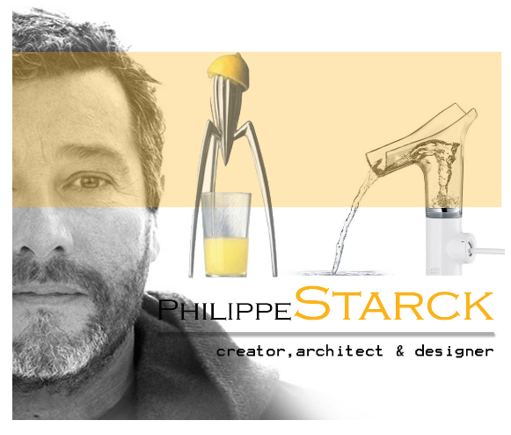
Year 11 > 12 Bridging Work
Summer Term 2026



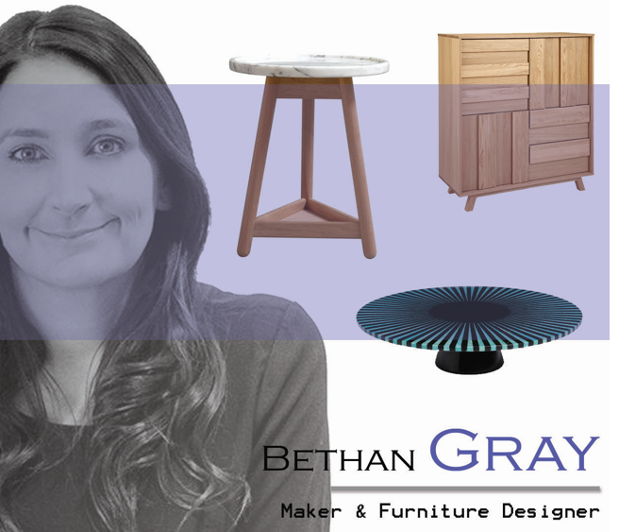

Subject | Product Design
Course | A-Level
Awarding Body | AQA

Contents:
* The key thing on this page is to complete the tasks on
pages 13-14.
 |  | Page(s)
 | Course/specification overview | 3-4
 | Our department expectations | 5-6
 | Review/revise | 7
 | Watch | 8
 | Listen to | 9
 | Read | 10
 | Research | 11-12
 | *Complete | 13-14

Course/specification overview

You will be studying the AQA A- Level Product Design (7552). You will sit two exams and submit one piece of coursework for this course.
- Technical Principles Exam – 120 Marks
- Designing and Making principles Exam - 80 Marks
- NEA (coursework) - 100 Marks
The Technical Principles exam is 2 hours and 30 minutes long. The Designing and Making Principles exam is 1 hour and 30 minutes long. Combined, the exams amount to 50% of your overall grade. The remaining 50% comes from your coursework submitted at the end of the course.
The website link to the AQA A Level Specification:
https://filestore.aqa.org.uk/resources/design-and-technology/specifications/AQA-7552-SP-2017.PDF

Course Content Overview:
Technical principles | Questions  Mixture of short answer and extended response questions. | - Materials and their applications  - Methods for investigating and testing materials  - Performance characteristics of materials  - Enhancement of materials  - The use of finishes  - Modern industrial and commercial practice  - Efficient use of material  - Digital design and manufacture  - Product design and development  - Health and Safety  - Protecting designs and intellectual property  - Design for manufacture, maintenance, repair and disposal  - Feasibility studies  - Enterprise and marketing  - Design communication
Designing and making principles | Questions  Section A:  - Product Analysis: 30 marks  - Up to 6 short answer questions based on visual stimulus of product(s).  Section B:  - Commercial manufacture: 50 marks  - Mixture of short and extended response questions | - Design methods and processes  - Design theory  - Technological and cultural impact on design  - Product life cycle  - Design processes  - Critical analysis and evaluation  - Selecting appropriate tools equipment and processes  - Accuracy in design and manufacture  - Responsible design  - Design for manufacture and project management  - National and international standards
NEA (coursework) | A portfolio of approximately 45 slides | - Identifying and investigating design possibilities  - Producing a design brief and specification  - Development of design proposal(s)  - Development of design prototype(s)  - Analysing and evaluating

Our Department expectations

- You come equipped to lessons, with exercise books/folders, Pen, Pencil, ruler and Rubber.

- You abide by the Health and Safety rules within the department. Respect materials and equipment.

- If you cannot be trusted in a practical room, you will not be in the practical room.

- You are punctual to lessons and arrive on time, ready to learn

- You respect your peers and teachers and allow others to learn and make progress in their studies.

- You present and keep your notes in an organised manner

- You engage with class discussion and ask thoughtful questions

- You make use of the department resources outside of lesson time. Please organise a time with your teacher where you can use the workshop in frees/afterschool to focus on a specific task or develop a workshop based skill.

- You do not stop thinking about your coursework (yr13). Gathering inspiration from everything you do and see.

- You produce ideas in and outside of lessons, sketches by hand, 3D models, and computer generated ideas.

- You spend time understanding your strength and weakness. Embrace them and work on accordingly. The required skills include;

- Strong writing skills to apply to lengthy essay writing
- Mathematics skills & are able to apply them to show a level of technical precision
- Creativity
- Problem solving
- Computer skills including; 2D design, fusion 360 & Tinker CAD (we will teach)
- Modelling in a variety of materials
- Time management
- Reflective evaluation & annotation

- If you fall behind with work you can expect to have some free periods directed where you will be given specific tasks to complete within that free. This will be continued until you are back on track as decided by your teacher.

Thinking skills - Try to take a questioning attitude to the things you watch, hear and read. Do you agree with what’s being said? If you watch/hear/read something where people have different attitudes towards something, which do you agree with most, or least, and why?

- Carry out wider reading to extend your subject knowledge

- You complete ALL the activities in the ‘complete’ section of the Bridging unit booklet. There are 4 lessons with activities in them. You must complete All prior to starting the course and hand to your teacher.

Review/Revise
Some parts of this course you may not be familiar with, which is of course expected and also exciting. However, there are some elements that you may have covered in one way or another at GCSE. If you studied GCSE Product Design (Particularly AQA) or if you have come from GCSE Electronic, Graphics or Art, it would be useful for you to go back and briefly review/revise over the following areas.
Materials / Manufacturing Processes / Finishes / New & Emerging Technologies
- Technologystudent.com
- Bitesize – Design and Technology AQA
- SENECA
Linking to CAD:
Tinker CAD – free to use
Tinker CAD is accessible on mobile devices and online. Play around with the tool box of shapes given. You can also access a library of shapes designed by others.
Tinker CAD is free to use and is accessible here:
https://www.tinkercad.com
There are a variety of tutorials accessible both on YouTube and the Tinker CAD website https://www.tinkercad.com/learn

Autodesk Fusion 360 – free to use
This is like Tinker CAD but more powerful as its cloud based and lots more tools. It is free to download here:
https://knowledge.autodesk.com/support/fusion-360/troubleshooting/caas/sfdcarticles/sfdcarticles/How-to-activate-start-up-or-educational-licensing-for-Fusion-360.html%20
Use your school email account and make sure you select personal use as your license type.
Useful tutorials to try at home: https://warwick.ac.uk/fac/sci/wmg/about/outreach/resources/fusion_tutorials/

Watch
When watching films/documentaries/programmes, try to take a questioning attitude to the things you watch. Do you agree with what’s being said? If people have different attitudes towards something, which do you agree with most, or least, and why?
TV Shows:
• How to Make – New Series BBC 4
Thursdays BBC Four 8PM or catch up on iplayer.
https://www.bbc.co.uk/programmes/m000gwzg

• Soup cans and superstars BBC iplayer.
Pop Art and its influence on the wider world.
https://www.bbc.co.uk/programmes/b067ftp7

• Bauhaus 100 BBC iplayer
The story of the design school and its influence on the world.
https://www.bbc.co.uk/iplayer/episode/m0007trf/bauhaus-100

• Rams; principles of good design Vimeo https://vimeo.com/304626830?fbclid=IwAR0F_pw_FKbVLDPKireqhpgXs1N1U8xE0IvmzGFxNaGUEEjIgKqUb9SaAVg

• How It's Made - Discovery UK or Youtube
Looking at how factories make products we use daily. What process do you recognise from your GCSE?

• Abstract: The Art of Design - Netflix
https://www.netflix.com/gb/title/80057883

• The Big Life Fix with Simon Reeve – BBC Show or youtube
The UK's leading inventors create ingenious new solutions to everyday problems and build life-changing solutions for people with a range of disabilities and needs.

Ted Talks and debates:
There are plenty to stimulate your questioning and reasoning skills. There are loads of talks on here, so use the search engine to find topics that interest you.
Practise note-taking; write notes as you listen, just as you would if you were listening to a real-life lecture, and practise the skill of jotting down key points at speed. Ask yourself questions when you get to the end: what were the speaker’s key messages? Do you agree with the speaker? What might someone who disagreed say, and what might their reasons be?
First Secret of Good Design – TED talk
https://www.youtube.com/watch?v=9uOMectkCCs
Biomimicry Design – TED talk
https://www.youtube.com/watch?v=k_GFq12w5WU
Listen to
When listening to the podcasts - Try to take a questioning attitude to the things you hear. Do you agree with what’s being said? If you listen to a podcast where people have different attitudes towards something, which do you agree with most, or least, and why?
Podcasts and videos:
50 things that made the modern economy.
Series of podcasts about all sorts of products that have changed the way we live; some surprising choices.
https://www.bbc.co.uk/programmes/b08k9pv0

30 animals that made us smarter
Series of podcasts about how studying animals and biomimicry has helped humans develop new products.
https://www.bbc.co.uk/programmes/w13xttw7/episodes/downloads

Read

When reading these books, try to take a questioning attitude to the things you read. Do you agree with what’s being said? If you read a book where people have different attitudes towards something, which do you agree with most, or least, and why? What Type of designer do you want to become? What eras do you like? What styles appeal to you?

Recommended D&T AQA Text books to purchase:

AQA AS/A-Level Design and Technology: Product Design

Essential Maths Skills for AS/A Level Design and Technology – Especially important if you are not confident with your maths.

Other books to read:
Materials for Design Chris Lefteri ISBN978-1-78067-344-8
Making IT Manufacturing Techniques for PD ChrisLefteri ISBN 978-1-85669-749-1
The Pocket Universal Principles of Design: William Liddell ISBN: 978-1631590405
The Pocket Universal Methods of Design: Hannington & Martin ISBN: 978-1631593741

Free online reading:
• Design Week Magazine Online
https://www.designweek.co.uk/

• Core77 Industrial design Magazine Online
https://www.Core77.com

• Make Magazine Online
https://makezine.com/tag/uk/

• Science Focus online – links to materials and technology developments.
https://www.sciencefocus.com/

Research
There are lots of resources online and in books to help you develop as a designer or become aware of the opportunities out there for you.

Design in a nutshell
Design era talks plus try the quiz to find out which designer your design thinking is similar to.
http://www2.open.ac.uk/openlearn/design_nutshell/

Sketch-a-day
Spencer Nugent developing sketching skills
https://www.youtube.com/channel/UCBtSgEZk914z5InEs_U2J3w

Product designer maker
Product design with a focus on sketching and design development
https://www.youtube.com/user/camtopher

Eric Strebel
Industrial designer focusing on practical processes and modelling
https://www.youtube.com/user/lunakov

Virtual Museums (Or, visit the museum)
V&A London
Take a trip through their collections
https://www.vam.ac.uk/collections?type=featured

Design Museum
Digital Museum content
https://designmuseum.org/digital-design-calendar
Design information
https://designmuseum.org/design

Designers’ information
https://designmuseum.org/designers
Dyson
As you are aware Dyson has dedicated his life to become an amazing designer and success, with the do not give up attitude. However, he has also dedicated his time and money in passing this on to the younger generation. Producing amazing resources and opportunities.
Read about how works as a designer to develop his design ideas.
Next steps after College or university what opportunities he has produced.
Look at and complete some of the design challenges he has produced for KS2-3 children.

https://www.dysoninstitute.com
https://www.dezeen.com/2020/04/07/dyson-children-coronavirus-lockdown/ https://careers.dyson.com/en-gb/what-you-can-do/engineer/

Shell
Shell is also a company that has dedicated time and money into educating the next generation of STEM designers. Visit their website and find out.
What they do for sustainability in the world
Complete some of their Bright Ideas Competitions from 2017-20
Visit their YouTube page

https://www.shell.co.uk/sustainability/society/supporting-stem.html
https://www.shell.co.uk/sustainability/society/supporting-stem/bright-ideas-challenge/winners.html
https://www.shell.co.uk/careers.html
https://www.youtube.com/user/Shell
https://www.youtube.com/watch?v=uoKFukF-VxA

Complete

You MUST complete ALL of the following ‘lesson activities’ in the appropriate order in preparation of the course. There are 3 ‘lessons’ for you to complete tasks for which are focused on bridging the gap in knowledge from GCSE to A Level.
Key tasks you MUST complete:
Use the suggested resources below as well as others in this document (as a starting point) to help you to complete the following tasks:

Lesson 1: Sketching and rendering technique.

- Create an A3 page with 5-10 shapes of your choice from watching the tutorials from the You Tube channel below.
https://www.youtube.com/@productdesignermaker

- Try to render half of the shapes you draw using pencil crayons or markers if you have them.
- Complete one sketch of either a product from home or a product from one of the tutorial videos.

Lesson 2: The Bic Pen. 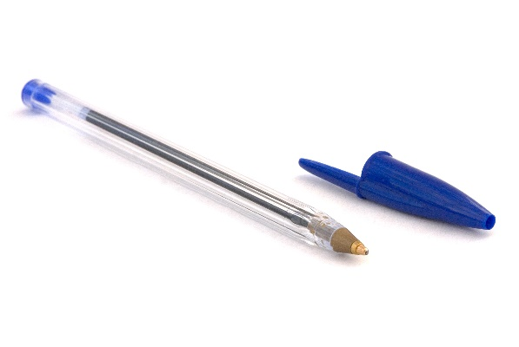

1) Analyse the Bic Pen product. Consider function, manufacture, ergonomics, size, safety, sustainability. ​Identify strengths & weakness of the design and try to think like the user.

2) Research the history of the Bic pen and write 200-300 words on key developments.

3) Suggest 3 ways to improve the design of the item, ​through sketching and annotations. Create one A3 page.

Be creative and experimental with your designs. Look at other handheld products to get ideas for shape, form or ergonomic grip. Add images from magazines or the internet to explain where your ideas came from. Annotate and explain your design ideas.​

Lesson 3: Product design research

Designers you should already know about and recognise 2 if not more of the following designers and companies;

- Charles Rennie Macintosh
- Philippe Starck
- Harry Beck
- Marcel Breuer
- Ettore Sottsass
- Gerrit Reitveld
- Norman Foster
- Raymond Templier
- Sir Alec Issigonis
- Marianne Brandt.
- Margaret Calvert
- Dieter Rams
- Charles and Ray Eames
- Alessi
- Apple
- Braun
- Dyson (James Dyson)

a) Select one you have never heard of and produce an information pack / case study on them. This should be two to three sides of A4.
You must find out:
- Specific years they were famous. From and to, could be present day for example.
- What is so iconic about their designs
- How their designs developed and have changed over time
- What other products/companies/designers are influenced by this designer/company.
b) Produce a page of sketch designs based on the designer or Companies style and form. It can be any product but have this designers approach.

