

Year 11 > 12 Bridging Work
Summer Term 2026
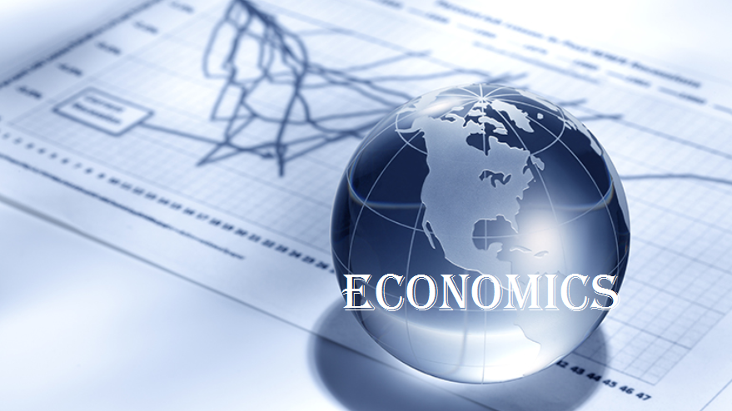
Subject | Economics
Course | A-Level
Awarding Body | Edexcel

Contents:
 |  | Page(s)
 | Course/specification overview | 3
 | Our department expectations | 4
 | Review/revise | 5
 | Watch | 6
 | Listen to | 7
 | Read | 8
 | Research | 9
 | Complete(Compulsory tasks) | 10 - 11
 | Appendices/resources | 12

Course/specification overview

Subject content
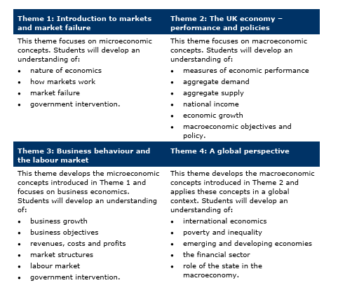

Our department expectations
Expectations
The Business Studies and Economics Department has high expectations of both students and teachers. Our teachers work exceptionally hard to deliver a broad, relevant and engaging curriculum, and in return we expect students to take ownership of their learning, show respect to others, and make their very best effort in every lesson.
We are proud to offer some of the most popular courses in the Sixth Form, reflecting both the strength of our provision and our enthusiasm for the subjects we teach. We encourage all students to share this passion by approaching their studies with commitment, curiosity and a positive attitude.
Lesson Preparation and Organisation
Students are expected to arrive fully prepared for every lesson and to maintain high standards of organisation.
- Complete any pre-reading tasks set by your teacher (using textbooks, revision guides or other resources).
- Keep all subject materials organised, including textbooks, folders, data sheets and Personal Learning Checklists (PLCs).
- Check school email and Satchel One (SMHW) regularly for important updates, resources and homework.
- Bring all required equipment to every lesson, including pens, highlighters, rulers and a scientific calculator.
Independent Study
Successful Sixth Form students are independent learners who take responsibility for their own progress.
- Catch up promptly on any work missed due to absence.
- Use timetabled non-contact study periods effectively for:
  - Pre-reading and preparation for upcoming lessons.
  - Reviewing and consolidating previously taught content.
  - Completing practice questions and exam-style tasks.
- Make full use of Up Learn to support and extend your learning.
- Revise thoroughly for all assessments, tests and examinations.
- Apply the study and revision techniques taught in lessons and study skills sessions.
By meeting these expectations consistently, students will place themselves in the strongest possible position to achieve success in Business Studies and Economics.

Review/revise

Revision
Please use the following link to help inspire creativity into your revision techniques: https://hayestl.com/students/

Numeracy
Economics, in common with your other A level options, will require a reasonable level of numeracy in the overall assessment that you will sit. As an Economics student, you should ensure that you are familiar with how to calculate:
- Percentage changes
- Mean average
- Modal average
- Median average
- Interpretation of diagrams e.g. pie charts, bar charts etc.

Watch

EconplusDal
EconplusDal provides YouTube videos that cover the full A Level Economics specification. These videos are a must watch and a playlist can be found here.

Tutor2u
An excellent resource for all A Level topics. The full range of videos can be found here.

Jacob Clifford
Non-exam board specific and American based but some good explanations and videos which can be found here.

TED Talks
A wide range of Business and Economics talks on a very wide variety of topics. These are not necessarily related to the A Level specification but will give you a good understanding of how the topics we study relate to the real world. You will need to register to view the talks here.

Masters of Money
An excellent 3-part series on the economists who have shaped recent economic thinking. A must watch for those who want an in-depth understanding of these famous economists can be seen here.

Economics related films
The following are just a few of the wide number of films that relate to economics and the recent financial crash
- The Big Short 2015
- Margin Call 2011
- Freakonomics 2010
- Too Big to Fail 2011

Listen to

- Tim Harford's 50 Things That Made The Modern Economy - Podcast (Business/Economics)
- Money Talks From Economist Radio Pod Cast (Economics)
- ‘The intelligence’ from Economist Radio – short daily summary featuring the main economic issues of the day, plus other off-beat applications of economics.
- https://soundcloud.com/weeklyeconomicspodcast
- https://www.economist.com/podcasts/



Read

Suggested Sites
BBC Economics home page can be found here.
Bank of England education section can be found here.
Tutor2U Economics blog can be found here.
https://economicsdetective.com/ A popular blog…
Wider Reading Suggestions
1. The Truth About Markets: Why Some Countries are Rich and Others Remain Poor – John Kay
2. Everlasting Light Bulbs - John Kay
3. The Armchair Economist: Economics and Everyday Life
4. The Undercover Economist or The logic of life –Tim Harford
5. Money and football. A soccernomics guide (Szymanski).
6. The $12 million Stuffed Shark – The curious economics of contemporary art and auction houses – Don Thompson
7. How do we fix this mess? The economic price of having it all, and the route to lasting prosperity – Robert Peston
8. Misbehaving: The making of behavioural economics – Richard Thaler
9. The great Divide – Joseph Stiglitz
10. House of Debt – Atif Mian and Amir Sufi
11. Capital in the 21st Century - Thomas Piketty
12. Why Nations Fail: Origins of Power, Prosperity and Poverty
(Daron Acemoglu & James Robinson)
13. Worldly Philosophers: Lives, Times, and Ideas of Great Economic Thinkers
(Robert Heilbroner)
14. The Economics Book (Niall Kishtainy)
15. The End of Alchmey - Mervyn King (former Governor of the Bank of England)
16. The Courage to Act – Ben Bernanke (former FOMC Chairman)
17. Stress test: Reflections on financial crises (former USA Treasury Secretary T Geithner)
18. The Economics Book – Niall Kishtainy
19. A little history of Economics – Niall Kishtainy
20. Doughnut Economics: 7 ways to think like 21st Century economist –Kate Raworth
Research

- Economics at A Level is split into two main sections; Microeconomics and Macroeconomics. Ensure that you understand the differences and put your findings in the table below:
Microeconomics | Macroeconomics

- One of the key concepts of economics is known as ‘Opportunity Cost’. Use some time to understand what it means without copying out a definition that you don’t understand. Can you relate the concept to your everyday life?

Complete – Compulsory Task - "Economists and Economic Events"

Part A: Four Economists
Research the following four economists:
- Adam Smith
- John Maynard Keynes
- Joseph Schumpeter
- Amartya Sen
Part A: Economist Research
- Background
- Who was/is the economist?
- When did they live?
- What was their role in economics?
2. Key Economic Ideas
Explain at least three major theories or concepts developed by the economist.

3. Links to the Edexcel A Level Specification
Identify and explain how the economist's ideas relate to at least three areas of the Edexcel A Level course.

Examples:
Economist | Relevant Specification Areas
Adam Smith | Markets, competition, invisible hand, market efficiency
John Maynard Keynes | Aggregate demand, unemployment, fiscal policy, economic growth
Joseph Schumpeter | Innovation, entrepreneurship, competition
Amartya Sen | Development economics, poverty, inequality, living standards, welfare economics, measures of development, human development, government intervention, economic development and sustainability

4. Modern-Day Relevance
How are the economist's ideas still influencing governments or policymakers today?

5. Evaluation
- What are the strengths of their ideas?
- What are the criticisms of their ideas?

Part B: Two Significant Economic Events: Research the following two economic events:
- COVID-19 Economic Crisis (2020)
- The UK Cost of Living Crisis (2021-present)
For each event, students should complete a case study covering:
1. Overview
- What happened?
- When did it happen?
- Which countries were affected?
2. Causes: Identify and explain at least three causes.
3. Economic Impacts: Analyse impacts on:
- Economic growth
- Inflation
- Unemployment
- Living standards
- Government finances
4. Government and Central Bank Responses: Explain:
- Fiscal policies used
- Monetary policies used
5. Links to Edexcel A Level Economics: Students must explain how the event links to:

Theme 2: The UK Economy
- Economic growth
- Inflation
- Unemployment
- Macroeconomic objectives
Theme 3: Business Behaviour and Labour Markets
- Productivity
- Labour markets
- Competition

Theme 4: A Global Perspective
- Globalisation
- International trade
- Financial markets
- Economic development

6. Evaluation
- Were the policy responses successful and what lessons can economists learn from the event

Appendices/resources

All necessary learning materials for the bridging assessment are included within this booklet. However, you may well want to conduct research of your own.
The following may give you an insight into some of the key topics and concepts that you will become familiar with:
- EconplusDal
Provides YouTube videos that cover the full A Level Economics specification. These videos are a must watch and a playlist can be found here.

- Tutor2u
An excellent resource for all A Level topics. The full range of videos can be found here.

- Jacob Clifford
Non exam board specific and American based but some really good explanations and videos which can be found here.

