
Year 11 > 12 Bridging Work 2026

Subject | English Language and Literature
Course | A-Level
Awarding Body | Edexcel

Any questions, please email AHM@hayes.bromley.sch.uk or EAW@hayes.bromley.sch.uk

Contents:
 |  | Page(s)
 | Course/specification overview | 3
 | Our department expectations | 4
 | Watch | 5
 | Listen to | 6
 | Read | 7
 | Complete | 8
 | Poem: The Art of Teaching II | 9

Course/specification overview
A Level English Language and Literature
Pearson Edexcel GCE – 9EL0
The course is split into three components

COMPONENT 1: Voices in Speech and Writing 9EL0/01 – 40%  - Exam lasting 2 hours 30 minutes.  - Open book – a clean copy of the drama text will be provided.  - Total of 50 marks  - Section A: Voices in 20th and 21st century texts – one comparative essay on one unseen non-fiction extract and one text from the studied anthology. AO1, AO2, AO3, AO4 – 25 marks.  - Section B: Drama – one extract-based essay question on ‘All My Sons’. AO1, AO2, AO3 – 25 marks. | COMPONENT 2: Varieties in Language and Literature 9EL0/02 – 40%  - Exam lasting 2 hour 30 minutes.  - Open book – clean copies of the texts will be provided.  - Total of 50 marks  - Section A: Unseen Prose Non-fiction – one essay question on an unseen non-fiction extract. AO1, AO2, AO3– 20 marks.  - Section B: Fiction - one comparative essay question on ‘The Great Gatsby’ and ‘The Whitsun Weddings’. AO1, AO2, AO3, AO4 – 30 marks.
COMPONENT 4: Coursework 9E:0/03 – 20%
- Internally assessed.
- Given a focus (e.g. conflict) and you will produce the following:
- One piece of original fiction writing
- One piece of original creative non-fiction writing
- One analytical commentary reflecting on stimulus material and the created pieces
- Word count: 2500-3250 words.
- AO1, AO2, AO3, AO4, AO5 – 60 marks.

Assessment Objectives
AO1 – Apply concepts and methods from integrated linguistic and literary study as
appropriate, using associated terminology and coherent written expression.
AO2 – Analyse ways in which meanings are shaped in texts.
AO3 – Demonstrate understanding of the significance and influence of the contexts in which
texts are produced and received.
AO4 – Explore connections across texts, informed by linguistic and literary concepts and
methods.
AO5 – Demonstrate expertise and creativity in the use of English to communicate in
different ways.
Our department expectations

The English Language and Literature A-Level is a fantastic course that will shape how you see and experience the world around you. In order to succeed on the course, you will need to be resilient, motivated and engaged.
In class you will need to:
- Come prepared – copies of the texts; your English book; any homework; additional notes are all essential.
- Be open to differing opinions – you will need to listen and debate ideas about a wide range of topics.
- Be brave – our English classrooms are a safe space to share your thoughts and feelings about lots of topics. The more you put in, the more you will get out.
- Listen carefully and take notes – you never know when you will need an idea later on, so being a strong and independent note taker is important.
- Seek challenge – don’t limit yourself. Every lesson is an opportunity to push yourself so do not waste it.
- Demonstrate your passion – you will need to be interested in English, in all its different forms, and showcase this within your lessons.
- Notice the small details – it is important that you can describe how a range of aspects build to have an impact on the reader.
Outside of the classroom, you will need to:
- Keep to deadlines – the course is busy and you will need to keep on top of everything. This will include reading.
- Extend your ideas and notes – keep reviewing and adding to your work.
- Read – read everything. The set texts are not the limit, they are just the start.
- Use the support available – your English teachers are available and there is a weekly support session. The earlier you get into good habits, the better you will do.
- Keep planning and practising – this is an essay-based subject. Do not limit yourself to the work that is set, create your own questions and get planning/writing.
- Stay organised – keep everything labelled and clear. You will need to revise from your notes and it is important to know where they all are and within folders or notebooks.
- Work on your writing – your coursework is about your ability to write in a creative manner. Practising these skills throughout the course will put you in a really strong position.

Watch

There are lots of interesting TED talks about Language and how it works; this is a really good example:
https://www.ted.com/talks/john_mcwhorter_txtng_is_killing_language_jk

Watch travel documentaries – anything with Simon Reeve is good; think about how he presents the places he goes to and how they have an impact on the audience.
https://www.bbc.co.uk/iplayer/episodes/p02l51m7/caribbean-with-simon-reeve

Watch the news. Everything we do in English links to the world around us. Students struggle if they are not aware of current events. When you watch, always ask yourself how the event is being reported and how the audience is being told what is happening.
Watch interviews. Think about whether they are formal or informal, how the host controls the conversation and how the guest responds to them, and whether they feel spontaneous or scripted.

Listen to
Listen to Podcasts
Develop your familiarity with a range of different podcasts. Whatever topic you are interested in, there will be something out there. Download a podcasting host app like Soundcloud, or BBC Sounds, and look around at what’s out there. It’s interesting to compare different podcasts about similar topics; think about what audience a podcast is trying to appeal to.
To get you started here are some suggestions:
https://www.bbc.co.uk/programmes/articles/5WvjXv2GNWzqnGN0Y0yxQ3n/seven-thrilling-drama-podcasts-to-download
Get the BBC SOUNDS app and listen to a range of radio programs:
Desert Island Discs is entertaining and interesting, especially if the ‘castaway’ is someone you know or like.
Word of Mouth is a very engaging radio program about language, how we use it, how it’s changing and what’s interesting about it.
Why not listen to an audiobook free of charge?
When you are on a walk or just want to sit in your room and relax, listening to an audiobook is fantastic. Audible currently has lots of work available for free on: https://stories.audible.com/discovery/enterprise-discovery-21122353011?ref=adbl_ent_anon_ds_ds_dml_cntr-4
These are all available for you:
- Jane Eyre
- Frankenstein
- Pride and Prejudice
- Brave New World
- My Antonia
- Ethan Frame
- Picture of Dorian Gray
- The Age of Innocence
- The Metamorphosis
- Wuthering Heights
- The Yellow Wallpaper and Other Stories
- The Jungle

Read – the highlighted texts are compulsory summer reading; they will be the first thing we study in September

Course texts:
All My Sons Arthur Miller
The Great Gatsby F Scott Fitzgerald
The Whitsun Weddings Philip Larkin
Non Fiction
You should aim to develop your familiarity with a range of Non-Fiction. This could include:
Travel Writing
Try anything by Bill Bryson or Paul Theroux
Biography and Autobiography
Find anything about or by a person you admire or are interested in.
Memoir/Journals/Diaries
Again, look for something by someone you are interested in – many famous people have published dairies or memoirs – Maya Angelou’s I know why the Caged Bird Sings is a great example of this genre.
Reviews
Look at film reviews – Mark Kermode is very insightful and readable

Reading for success
People who read do well in English – it’s that simple. Be in the habit of reading and develop your own sense of what you like to read. Reading should be challenging but it should also be fun, and you will enjoy it more the more you do it. Try lots of different and new things and be persistent with it. It can take a bit of time with some books before you really start to enjoy them. Be patient!
As we mentioned in the ‘Listen’ section of this booklet – most books now are available on Audiobook, so try ‘reading’ in this way too.
Good luck and happy reading!
Complete – these are compulsory; your teacher will collect and mark the written tasks in September

- Read The Great Gatsby and All My Sons

- Me as an English Student (700-800 words)
Write an autobiographical piece about yourself as an English student, up to the point where you explain why you have chosen English as an A-Level subject. It’s up to you how you write it.
  - Things you could include:

    - Your early experiences as a reader – or even of the stories told
to you before you could read
    - What you have enjoyed about English over the years; from ~
early years through to your GCSEs
    - What, in your opinion, are the benefits of studying English?
    - Why have you chosen it?
    - What are you looking forward to about doing it at A-Level?
    - Discuss the books you have been reading most recently

- Poetry Task: One hour maximum.

Read the poem on the next page.

- Annotate or highlight any writer’s methods you notice, for example: images, language, poetic features; anything which you think is significant. What impact do these methods have on the reader?
- Bullet points: what are the ideas and messages of the poem? These could be explicit or implicit.
- Write a paragraph about your response to the poem.
What makes the poem effective?
Does this resonate with your experience of English lessons?

The Art of Teaching II
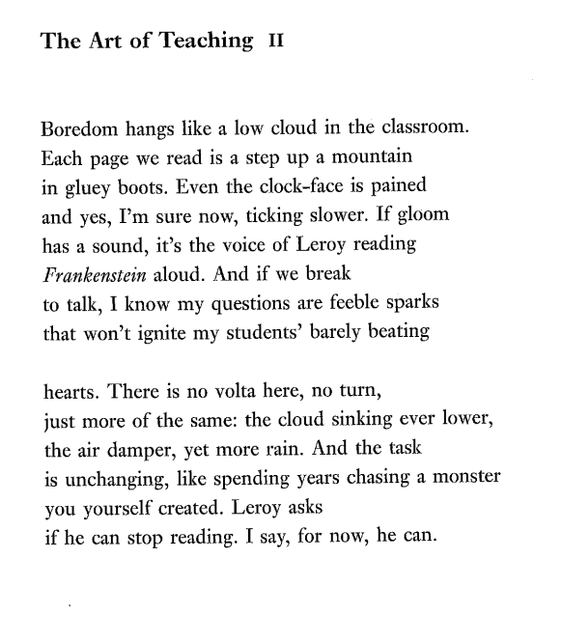
Hannah Lowe

