

Year 11 > 12 Bridging Work 2026

Subject | English Literature
Course | A-Level
Awarding Body | Edexcel

Any questions, please email AHM@hayes.bromley.sch.uk or EAW@hayes.bromley.sch.uk

Contents:
 |  | Page(s)
 | Course/specification overview | 3-4
 | Our department expectations | 5
 | Watch | 6
 | Listen to | 7
 | Read | 8-9
 | Research | 10
 | Complete | 11

Course/specification overview

A Level English Literature
Pearson Edexcel GCE – 9ET0
The course is split into four components
COMPONENT 1: Drama 9ET0/01 – 30%  - Exam lasting 2 hours 15 minutes.  - Open book – clean copies of the texts will be provided.  - Total of 60 marks  - Section A: Shakespeare – one essay question from a choice of two on ‘Hamlet’. AO1, AO2, AO3, AO5 – 35 marks.  - Section B: Other Drama – one essay question from a choice of two on ‘A Streetcar Named Desire’. AO1, AO2, AO3 – 25 marks. | COMPONENT 2: Prose 9ET0/02 – 20%  - Exam lasting 1 hour 15 minutes.  - Open book – clean copies of the texts will be provided.  - Total of 40 marks  - One comparative essay from a choice of two.  - Comparing ‘Wuthering Heights’ and ‘A Thousand Splendid Suns’.  - AO1, AO2, AO3, AO4.
COMPONENT 3: Poetry 9ET0/03 – 30%  - Exam lasting 2 hours 15 minutes.  - Open book – clean copies of the texts will be provided.  - Total of 60 marks  - Section A: Post 2000 – one essay question from a choice of two comparing a named poem with an unseen poem. AO1, AO2, AO4 – 30 marks.  - Section B: Romantic Poetry – one essay question from a choice of two on a studied collection of Romantic Poetry. AO1, AO2, AO3 – 30 marks. | COMPONENT 4: Coursework 9ET0/04 – 20%  - Internally assessed.  - One comparative essay comparing a chosen text (The Handmaid’s Tale) with a text of your choice.  - These must be different texts from those studied in other Components.  - You may choose from poetry, drama, prose or literary non-fiction.  - Word count: 2500-3000 words.  - AO1, AO2, AO3, AO4, AO5 – 60 marks.

Assessment Objectives
AO1 – Articulate informed, personal and creative responses to literary texts, using
associated concepts and terminology, and coherent, accurate written expression.
AO2 – Analyse ways in which meanings are shaped in literary texts.
AO3 – Demonstrate understanding of the significance and influence of the contexts in which
literary texts are written and received.
AO4 – Explore connections across literary texts.
AO5 – Explore literary texts informed by different interpretations.

Our department expectations

The English Literature A Level is a fantastic course that will shape how you see and experience the world around you. In order to succeed on the course, you will need to be resilient, motivated and engaged.
In class you will need to:
- Come prepared – copies of the texts; your English book; any homework; additional notes are all essential.
- Be open to differing opinions – you will need to listen and debate ideas about a wide range of topics.
- Be brave – our English classrooms are a safe space to share your thoughts and feelings about lots of topics. The more you put in, the more you will get out.
- Listen carefully and take notes – you never know when you will need an idea later on, so being a strong and independent note taker is important.
- Seek challenge – don’t limit yourself. Every lesson is an opportunity to push yourself so do not waste it.
Outside of the classroom, you will need to:
- Keep to deadlines – the course is busy and you will need to keep on top of everything. This will include reading.
- Extend your ideas and notes – keep reviewing and adding to your work.
- Read – read everything. The set texts are not the limit, they are just the start.
- Use the support available – your English teachers are available and there is a weekly support session. The earlier you get into good habits, the better you will do.
- Keep planning and practising – this is an essay-based subject. Do not limit yourself to the work that is set, create your own questions and get planning/writing.
- Stay organised – keep everything labelled and clear. You will need to revise from your notes and it is important to know where they all are and within folders or notebooks.

Watch – suggested activities

- Explore some of the TED talks that are available linked to English. Here is one to start you off:
https://www.ted.com/talks/beth_ann_fennelly_how_literature_can_help_us_develop_empathy

- Watch (or think back to) a film of TV adaptation of a novel you know, for example Northern Lights, Noughts and Crosses, Emma, David Copperfield, Sherlock Holmes, Normal People. (See BBC iPlayer for freely available dramas; Netflix and Amazon Prime have a wide selection if you have a subscription. Some complete dramas are also available on YouTube).
  - You could write your own review of the adaptation you have watched.
OR
  - Write a pitch for a different novel about how you would approach adapting it for the screen.

Listen to

Listen to a Literature podcast. There are a range to listen to below and we would recommend listening to a range and finding which ones you enjoy the most:
- Radio 4’s ‘In Our Time’: https://www.bbc.co.uk/programmes/b006qykl/episodes/player
- The Guardian Books podcast: https://www.theguardian.com/books/series/books
- Radio 4’s ‘A Good Read’: https://podcasts.apple.com/gb/podcast/a-good-read/id1813854898
- Not Another Book podcast: https://podcasts.apple.com/gb/podcast/not-another-book-podcast/id1370122551?mt=2
- The Literary Salon: https://podcasts.apple.com/gb/podcast/the-literary-salon/id495583876?mt=2
- Simon Mayo’s ‘Book of the Year’: https://podcasts.apple.com/gb/podcast/simon-mayos-books-of-the-year/id1402579687?mt=2
- Anything But Silent: https://podcasts.apple.com/gb/podcast/anything-but-silent/id1464701909
- Frank Skinner on poetry: https://podcasts.apple.com/gb/podcast/frank-skinners-poetry-podcast/id1508123116

Why not listen to an audiobook free of charge?
When you are on a walk or just want to sit in your room and relax, listening to an audiobook is fantastic.
Audible currently has lots of work available for free on: https://stories.audible.com/discovery/enterprise-discovery-21122353011?ref=adbl_ent_anon_ds_ds_dml_cntr-4
These are all available for you:
- Jane Eyre
- Frankenstein
- Pride and Prejudice
- Brave New World
- My Antonia
- Ethan Frame
- Picture of Dorian Gray
- The Age of Innocence
- The Metamorphosis
- Wuthering Heights
- The Yellow Wallpaper and Other Stories
- The Jungle

Read: the texts which are highlighted are the first ones you will be studying – these are compulsory.

SET TEXTS:
- ‘Hamlet’ by William Shakespeare – Wordsworth Classics edition
- ‘A Streetcar Named Desire’ by Tennessee Williams – Penguin
- ‘A Thousand Splendid Suns’ by Khaled Hosseini – Bloomsbury
- ‘Wuthering Heights’ by Emily Bronte – Penguin Classics
- ‘Poems of the Decade’ by Forward Arts Foundation – Faber & Faber
- ‘English Romantic Verse’ by David Wright – Penguin Classics
- ‘The Handmaid’s Tale’ by Margaret Atwood – Vintage

What sort of books do you usually read for pleasure? If you always read the same sort of novel or the same author or have got in stuck I a rut, why not try something completely different?
How to find your new read:
- Ask friends. Ask the people you know have different tastes to you.
- Follow writers, book clubs and book podcasts on Instagram, Facebook and Twitter.
- Read book reviews.
- Use websites to get ideas:
  - https://www.englishandmedia.co.uk/blog/50-great-21st-century-novels-for-6th-formers
  - https://www.theguardian.com/books/series/the-100-best-novels
  - https://www.theguardian.com/books/fiction-in-translation
Suggestions from the Hayes English Department:

- ‘1984’ by George Orwell
- ‘Atonement’ by Ian McEwan
- ‘Beloved’ by Toni Morrison
- ‘Brave New World’ by Aldous Huxley
- ‘Frankenstein’ by Mary Shelley
- ‘Heart of Darkness’ by Joseph Conrad
- ‘Jane Eyre’ by Charlotte Bronte
- ‘Mrs Dalloway’ by Virginia Woolf
- ‘Rebecca’ by Daphne Du Maurier
- ‘Small Island’ by Andrea Levy
- ‘Tess of the d’Urbervilles’ by Thomas Hardy
- ‘The Colour Purple’ by Alice Walker
- ‘The History of the World’ by J.M. Roberts
- ‘Turn of the Screw’ by Henry James

Why not try some critical books?
- ‘How Novels Work’ by John Mullan
- ‘The Art of Fiction’ by David Lodge
- ‘Reading Like a Writer’ by Francine Prose
- ‘An Introduction to English Poetry’ by James Fenton
- ‘The Poem and the Journey’ by Ruth Padel
- ‘Shakespeare – The World as a Stage’ by Bill Bryson
- ‘Shakespeare on Toast’ by Ben Crystal
- ‘How Plays Work’ by David Edgar
- ‘Doing English’ by Robert Eaglestone

Research

- Research the life and works of the Brontë sisters. Understanding their upbringing and their surroundings that inspired their works will be hugely beneficial to your understanding of ‘Wuthering Heights’.

- Artistotle’s Tragedy and Poetics – to fully understand the features of a tragedy, you need to explore where the key ideas came from. Create a summary of the key ideas, with terminology, and refer to this when reading ‘A Streetcar Named Desire’ and ‘Hamlet’.

- Find out about Romanticism: who were they important figures in the Romantic Movement, and how do Romantic ideas fit into the world if the early 1800s and now?

Complete – these are compulsory; your teacher will collect and mark the written tasks in September

- Read Wuthering Heights, A Thousand Splendid Suns, and A Streetcar Named Desire.

- Written piece: Me as an English Student (700-800 words). Write an autobiographical piece about yourself as an English student, up to the point where you explain why you have chosen English as an A-Level subject. It’s up to you how you write it.
  - Things you could include:
    - Your early experiences as a reader – or even of the stories told
to you before you could read
    - What you have enjoyed about English over the years; from
early years through to your GCSEs
    - What, in your opinion, are the benefits of studying English?
    - Why have you chosen it?
    - What are you looking forward to about doing it at A-Level?
    - Discuss the books you have been reading most recently?

- Poetry Task: One hour maximum.
Read the poem on the next page.
- Annotate or highlight any writer’s methods you notice, for example: images, language, poetic features; anything which you think is significant. What impact do these methods have on the reader?
- Bullet points: what are the ideas and messages of the poem? These could be explicit or implicit.
- Write a paragraph about your response to the poem:
What makes the poem effective?
Does this resonate with your experience of English lessons?

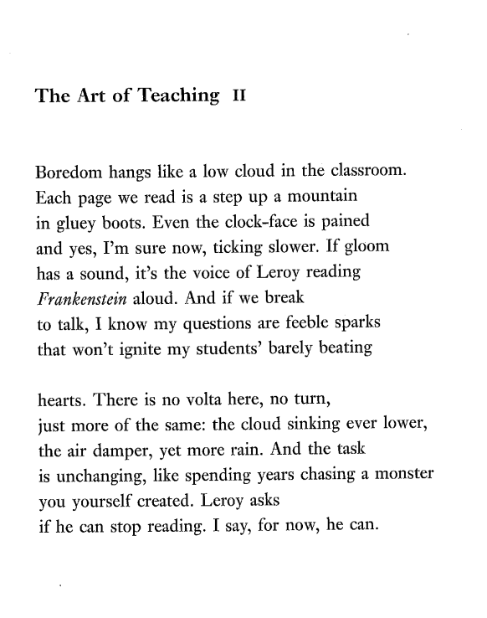
Hannah Lowe

