

Year 11 > 12 Bridging Work
Summer Term 2026

Subject | Film Studies
Course | A-Level
Awarding Body | Eduqas

Contents:
 |  | Page(s)
 | Course/specification overview | 3
 | Our department expectations | 4
 | Report task | 5-6
 | Watch & Listen | 6
 | Research & Read | 6
 | Complete | 7

Overview - A Level Film course

A Level Structure of Course
Component 1:
Varieties of film and filmmaking Written examination: 2½ hours 35% of qualification
This component assesses knowledge and understanding of six feature-length films.
Section A: Hollywood 1930-1990 (comparative study)
Section B: American film since 2005 (two-film study)
Section C: British film since 1995 (two-film study)

Component 2:
Global filmmaking perspectives Written examination: 2½ hours 35% of qualification
This component assesses knowledge and understanding of five feature-length films (or their equivalent).
Section A: Global film (two-film study)
Section B: Documentary film
Section C: Film movements – Silent cinema
Section D: Film movements – Experimental film (1960-2000)

Component 3:
Production Non-exam assessment 30% of qualification
Learners produce:
• either a short film (4-5 minutes) or
• a screenplay for a short film (1600-1800 words) plus
• a digitally photographed storyboard of a key section from the screenplay
• an evaluative analysis (1600 - 1800 words).

Our department expectations

Hayes School Sixth Form takes students from a wide range of schools, who have studied a variety of subjects at KS4. We want to ensure that everybody is equally able to access the content of the AS Level and so the following tasks give you a chance to ensure you are fully prepared.

At Hayes School we only offer Media courses at KS4, and don’t include GCSE Film Studies, but many of the skills learnt through GCSE Media or Btec Media are transferable to Film Studies.

However, it is not an issue if you haven’t studied either Media or Film before.

The Media Arts Department has three main aims that cover all our courses:
- To equip students with a critical toolkit for navigating and understanding the impact of mass forms of communication, including Film, on our world, both past and present.
- To make students aware of the potential that the media has for enriching our lives.
- To develop skills so that students can produce their own media and develop their own vision and creativity.

The key expectations of students taking up our A Level Film Studies course are:
- To turn up for lessons on time and with the proper equipment ready to learn, as when in uniform
- To fully engage and be willing to participate in all lessons
- To meet all deadlines for homework tasks set on Show My Homework and produce your best work at all times
- To put aside at least one study period, per teacher, per week to focus on your Film Studies work – this is the purpose of having non-teaching periods on your timetable

In addition, for the parts of the course that are practical, we advise all students to invest in a good quality SD card so that any filmed work can be securely looked after, and to have your own headphones for editing. The department has a range of SD cards for sale at cost.

We very much look forward to welcoming you onto our busy, challenging but highly rewarding course!

Report

To ensure you are ready to fully access the Eduqas A Level Film Studies Syllabus you should attempt the following tasks:

Click this link to look at IMDB’s top 250 films. You need to choose ONE film from the top 25 in the list and watch the film. Choose a film that you have never seen before.

Ceate a report on that film. This report could be presented in a range of different ways – Word or Powerpoint are the most common formats, but it’s your choice.

None of these films are the exam board’s set film texts. The purpose is to broaden your knowledge and understanding of American films. However, some of the Canon are by the same directors as exam board films. I will leave you to figure out which directors these are.

The report should focus on two main topics; how the film fits that film movement and how the film engages you as a spectator.

It should be at least 1000 words in length.

There should be no copy and paste from websites in your report.

The structure of the report is as follows:
- Introduce the chosen film
  - Film title, director, year, studio, genre
  - Other basic information such as names of stars, if appropriate, and a short summary of what the film is about
- Film Movement
  - Research and explain the film movement that your chosen film fits into
  - Explain how your film fits that movement
- Your Review
  - This should be the main part of your report – how well did the film engage or not engage you as a spectator? Aim to really unpick what you felt about; the storyline, the characters, the style of the film, the settings etc
- Research and summary of what the critical reaction was to your film.
  - Did the film receive any awards?
  - Can you quote a couple of lines from both positive and negative reviews from major film critics?
- Was the film a financial success or not?
  - Research whether the film made a profit or not
  - Try to explain why the film was a success or not

Extension:
There will be a future homework task to watch and review at least one film from each of the five American film movements.

You could anticipate this task and start to engage with other films on the Canon and create reviews.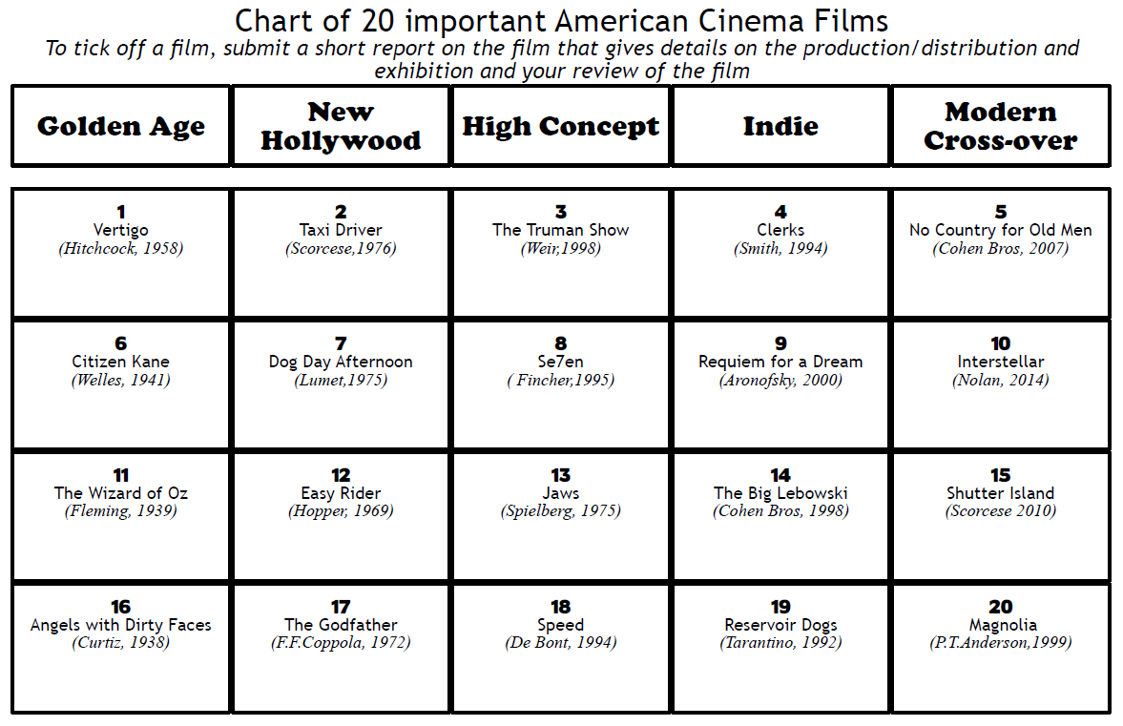

Watch & Listen

Clearly, you will need access to your chosen film.
We do have these films on DVD in school for loan, but they can all be accessed through Streaming services and other formats.
Do contact me if you are unable to access the film you want on; ddd@hayes.bromley.sch.uk
You will also find many online clips analysing most of these films

 | Research & Read

There are many online sources to help you investigate your chosen film and film movement.

Some key websites are as follows, but there are many more.
As with all online research, you need to check how reliable the source is. Information from academic sites will be the most trustworthy.

- Imdb.com
  - The main source of information on basic details about any film

- Boxofficemojo.com
  - The best place to get details on budgets and profits. It is an America website so when discussing home profits, it will be referring to America

- Rottentomatoes.com
  - The best place to find reviews. Ones with a red tomato are positive reviews and ones with a green tomato splat are negative

To help you research for this project and give you wider information about our courses we also have our Media Arts Guide, accessible through our website.

The MAD guide gives you access to:
- Further information on the structure of your course
- Recommended websites for researching into your report
- A suggested reading list to investigate Film Studies at A Level further
- Login details for accessing Media Magazine
Complete

Your Bridging Unit Report is normally due to be submitted by the end of your first month in the Sixth Form – end of September. However, you might well be able to complete this task during this term.
Please note, however, that the Bridging Unit is not only a way for you to start thinking about Film as an academic subject but is also a way to show your Sixth Form teachers that you understand the work demands of A Level subjects and are on the right courses. Therefore, it is very important that you complete this task to the best of your ability and meet any deadlines set.
Good luck to you and enjoy your first study of Film!
Kind regards
Mr Douglas
Head of Media Arts, Hayes School

 | Appendices/Resources
Media Arts Guide – click here to access on school website
Want to have a go at writing a screenplay and more? https://www.studiobinder.com/

