

Year 11 > 12 Bridging Work
Summer Term 2026


Subject | French
Course | A-Level
Awarding Body | Edexcel

Contents:
 |  | Page(s)
 | Course/specification overview | 3
 | Our department expectations | 4
 | Review/revise | 5
 | Watch | 6
 | Listen to | 7
 | Read | 8
 | Research | 9
 | Complete | 10-17
 | Appendices/resources | 18-20

Course/specification overview

Our vision is for all students to become ‘enthusiastic and confident communicators in a foreign language’. Our lessons are conducted in the target language and all our students end up speaking French fluently by the end of Year 13, even if they have not been used to speaking the language during lessons at GCSE.
The Modern Foreign Languages courses are designed for students interested in languages and communication who enjoy learning about other cultures and ways of life. An A level in languages challenges students to develop not only their ability to communicate effectively in the foreign language but also their ability to analyse information and apply knowledge.
A level - Paper 1 - Listening, reading and translation from the Target Language to English
Paper 2 – Translation from English to the Target Language, an essay on a piece of literature and an essay on a film
Paper 3 – Speaking - Discussion of a theme and a presentation and discussion on a topic of your choice

Units studied in Year 12: Les changements dans les structures familiales, L’éducation, Le monde du travail, La musique, Les médias & Les festivals et les traditions.

Units studied in Year 13: L’impact positif de l’immigration en France, Les défis de l’immigration et l’intégration en France, L’extrême droite, La France occupée, Le régime de Vichy & La Résistance.

Film studied in Year 12: Intouchables, Nakache et Toledano

Book studied in Year 13: Un sac de billes, Joseph Joffo

Our department expectations

As an A Level student of MFL, we expect you to have the following equipment:
- a plastic wallet with all the work from the Transition booklet in the first lesson of term
- a lever arch folder with dividers
- a bilingual dictionary
- lined paper & red/green/blue/black pens

A Level MFL students are expected to:
- attend all lessons punctually
- attend an hour a week in the languages computer room to complete independent study
- take part in weekly speaking sessions in small groups with the foreign language assistants
- submit all homework on time and ask for support when needed
- communicate all absences as soon as possible to the teacher and catch up on missed work
- take an independent approach towards their learning and invest time in DIRT
- review and organise their class notes regularly

Studying a language is a marathon, not a sprint and will require resilience and good organisation. It is definitely a subject where the more you put in, the more you will get out!

Review/revise
- Grammar essentials - To make a confident start in September, it is very important that your knowledge and application of verbs & tenses covered at GCSE is secure. This includes:

- The present tense (regular verbs & the following common irregular verbs – avoir, être, faire, aller, prendre, croire, savoir, prendre, voir & dire).
- Modal verbs - vouloir, pouvoir, devoir
- The past tense (perfect tense)
- The near future tense
- The simple future tense
You can revise and practise these tenses and verbs with the following websites:
- Languages Online – This link will take you to the grammar page of the French section. It has explanations of different grammar points & exercises to complete. https://www.languagesonline.org.uk/Hotpotatoes/frenchindex.html#Grammar
- BBC Bitesize - https://www.bbc.co.uk/bitesize/topics/zhh2gwx
- Tex’s French Grammar - https://www.laits.utexas.edu/tex/index.html
- Verbix – Use this website to check verb conjugations. https://www.verbix.com/languages/french.html
There are lots of activities to practise these in the ‘Complete’ section of this booklet.
- Vocabulary essentials

- Opinions https://quizlet.com/gb/504952618/transition-vocabulary-opinions-flash-cards/?new
- Important Adjectives - https://quizlet.com/gb/504954640/transition-vocabulary-adjectives-flash-cards/?new
- Quantifiers & Intensifiers - https://quizlet.com/gb/504956236/transition-vocabulary-quantifiers-intensifiers-flash-cards/?new
- Connectives - https://quizlet.com/gb/504959998/transition-vocabulary-connectives-conjunctions-flash-cards/?new
- Question words - https://quizlet.com/gb/504963443/transition-vocabulary-question-words-flash-cards/?new
Plus also, we are going to start with the family topic so please revise and make sure you’re confident with the vocabulary on this. All of the vocabulary for the new topic is in the appendices.
https://quizlet.com/gb/504964960/transition-vocabulary-membres-de-la-famille-flash-cards/?new
You will be tested on these in the first few lessons of Year 12.
Watch
Choose a film: don’t watch Intouchables! Here are some suggestions:
- Demain tout commence
- Samba
- Le Petit Nicholas
- Entre les Murs
- La Haine
- Bienvenue chez les Ch'tis
- Le chant du Loup
- Première Année
There are lots of French language films / series on Netflix & Amazon Prime. Here are some examples:
Netflix
- Call my Agent
- The African Doctor
- He even has your Eyes
- Chef’s Table France
- We are Family
- Parisian Agency
Amazon Prime
- Sink or Swim
- La Famille Bélier
- Lost in Paris
- A Season in France
Documentaries
- TV 5 Monde - https://revoir.tv5monde.com/toutes-les-videos/documentaires
Channel 4 - https://www.channel4.com/categories/world-drama
1 jour 1 actu – They have a website too, but their short videos on different topics (aimed at French children so the language is accessible) are also on YouTube: https://www.youtube.com/playlist?list=PL7h1upgZ_vhJxVyrZdqGryeJCFzThEejx
Linguo – videos on different topics with subtitles http://www.linguo.tv/videos
Ilini - videos on different topics with subtitles https://www.ilini.com/learn-french

Listen to

Podcasts – search on iTunes for a podcast in French.

French Radio
https://www.franceinter.fr/direct
https://www.radiofrance.fr/
https://www.nrj.fr/
https://www.funradio.fr/
https://www.nova.fr/musique
https://www.culturetheque.com/exploitation/GBR/accueil-portal.aspx

French Music:
- Spotify – look at the Top 50 songs in the chart currently in France and listen to some songs!

- Lyrics Training – Practise your listening skills and gain cultural knowledge by listening to French songs and filling in the lyrics - https://lyricstraining.com/fr/

Ted Talks:
https://www.ted.com/talks/erin_mckean_go_ahead_make_up_new_words
https://www.ted.com/talks/john_mcwhorter_4_reasons_to_learn_a_new_language#t-1094
https://www.ted.com/talks/lera_boroditsky_how_language_shapes_the_way_we_think
https://www.ted.com/talks/andreea_s_calude_does_grammar_matter

Read

Books - Here are some suggestions of ones you might read for pleasure in French:
- ‘Le Petit Prince’, Antoine Saint-Exupery
- ‘No et Moi’, Delphine de Vigan
Remember that you are not expected to look up every word you do not know when reading in French. It is about reading for gist. If you are able to read on a Kindle, you can install a French dictionary and look up new words as you read.

French News Websites (there is an activity in the complete section linked to reading the news):
https://www.lemonde.fr/
http://www.tv5monde.com/
https://www.liberation.fr/
https://www.lefigaro.fr/
http://www.leparisien.fr/
https://www.francetvinfo.fr/

French Magazines
https://www.elle.fr/
https://www.lexpress.fr/
https://www.letudiant.fr/
https://www.parismatch.com/
https://www.telerama.fr/
https://www.lequipe.fr/

Research

Les événements clés – Faites des recherches dur les événements qui ont eu lieu à ces dates. Prenez des notes sur leur importance pour l’histoire et la société français.
- 1789
- 1905
- mai 1968
- Le 7 janvier 2015
- 1998 & 2018 (the same event !)

Les personnages importants – Faites des recherches sur l’importance de chaque personnage et prenez des notes.
- Napoléon Bonaparte
- Jeanne d’Arc
- Claude Monet
- Coco Chanel
- Jean-Marie Le Pen

Presentation Research – Research a Francophone Country (not France!) of your choice and prepare a presentation about it. You could talk about:
- La nourriture
- La situation géographique
- Des festivals
- La musique
- Le tourisme
- La culture
- Le climat
- Des faits intéressants

General Culture:
- Find an advertisement for a product in a French-speaking country and answer – Qu’est-ce que c’est? Pourquoi doit-on l’acheter?
- Name a famous French person (not listed above!) and find 5 interesting facts about them
- Choose a city in France and find 5 interesting things about it.

Complete

Grammar
Translate the sentences for each verb into French to practise the different tenses you have revised.
Être
- I am the youngest in my family.
- My sister will be angry if I use her computer.
- When I was younger, I was very shy.
- Unfortunately, I am going to be late.
Avoir
- We have some yellow flowers in our garden
- She will have a baby next month.
- I had a lot of friends at primary school.
- I have not had the time to read the article.
Faire
- He always does his homework in the library.
- We made a cake last Saturday.
- I am going to go horse riding tomorrow.
- It was cold yesterday.
Aller
- My parents are going on holiday to Spain
- They will go to the shopping centre.
- We went to France to visit my grandmother.
- I am going to go to York next month.
Prendre
- They take the train to go to work.
- I took lots of photos in France.
- We will take the bus to town.
- She always takes her phone to school.
Pouvoir
- I can speak three foreign languages
- You will be able to earn lots of money.
- We will be able to continue with our studies.
- They can’t help me.

Adjective agreement
- Copy out the text & change the adjectives so that each one agrees with the subject.
Ma prof (préféré) s’appelle Madame Brown. Elle est (gentil) mais (sévère). Quand les élèves sont (méchant), elle devient (furieux). Mais quand un (nouveau) élève arrive, elle est toujours (compréhensif) et (sympa). Ma (nouveau) copine Betty n’est pas (travailleur) et notre prof la trouve (agaçant) et (impoli). Moi, je pense que Betty est (marrant) et (aimable). C’est une (joli) fille de taille (moyen) et elle a les yeux (marron) et les cheveux (brun).

- Translate the sentences into French. Think carefully about the position and agreement of the adjectives.

- We live in an old, blue house.
- We like new, French singers.
- I have a small, black dog.
- She has a beautiful, expensive dress.
- It is a big, modern house.

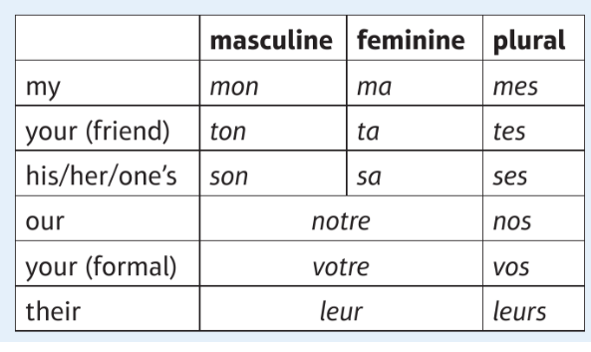
Possessive adjectives
Translate the below into French:
- My parents
- Our teacher
- Their problem
- His mother
- My town
- Her homework
- Your (formal) job
- Your (informal) results
- His trousers
- Their advice

Prepositions
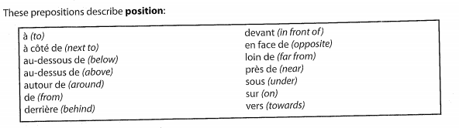
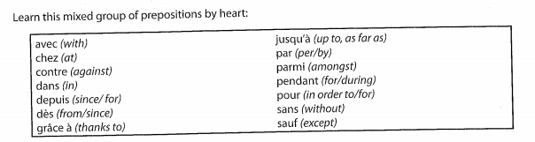
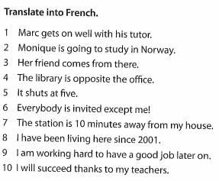
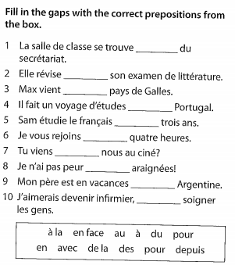

Listening
Festival à la plage 2m 16 (audio)
https://francebienvenue1.fr/2019/05/31/festival-a-la-plage-cest-bientot/#more-5281
Ecoutez et répondez aux questions suivantes en français :
- Depuis combien de temps est-ce que Jules travaille au Delta Festival ?

…………………………………………………………………………………………………
- Quel est son rôle ? Mentionnez trois détails.
…………………………………………………………………………………………………
- C’est quoi, la billetterie ?
…………………………………………………………………………………………………
- Être « polyvalent », cela veut dire quoi, alors ?
…………………………………………………………………………………………………
- A quelle tranche d’âge est-ce que le festival est destiné ? …………………………….

- Cela se déroule quand cette année ? …………………………………………………….

- A part la musique sur la plage, sur quels thèmes est-ce que le festival est axé ?
…………………………………………………………………………………………………
- Quelle sorte de compétitions y a-t-il ?
…………………………………………………………………………………………………
- Combien d’associations BDE y a-t-il en France ?
…………………………………………………………………………………………………

Reading Comprehension
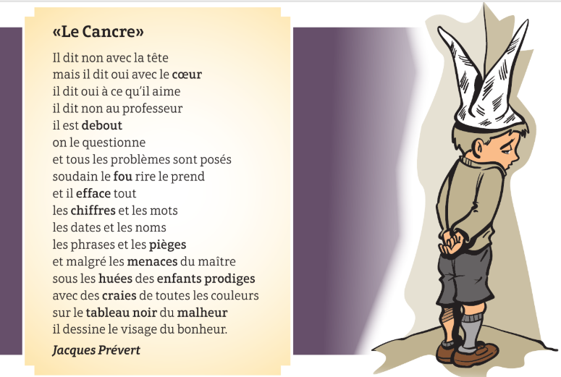
1.
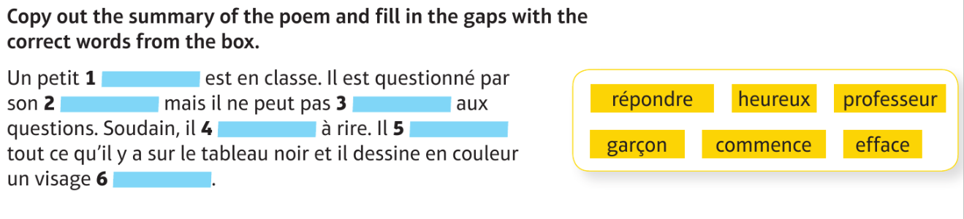
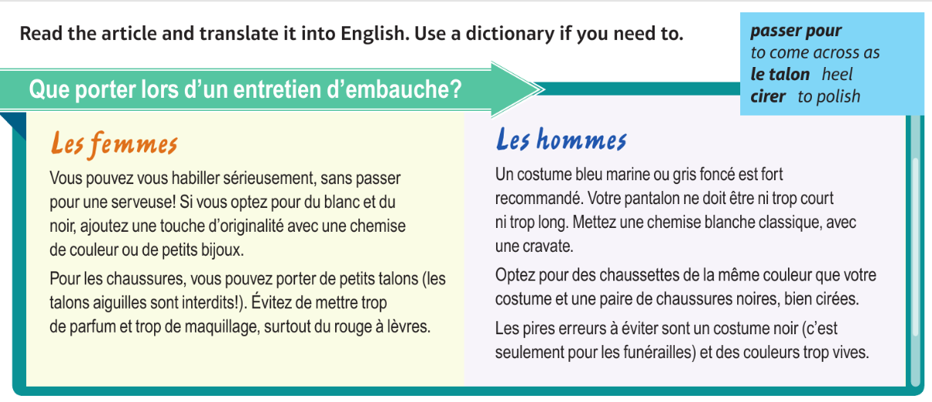
2.

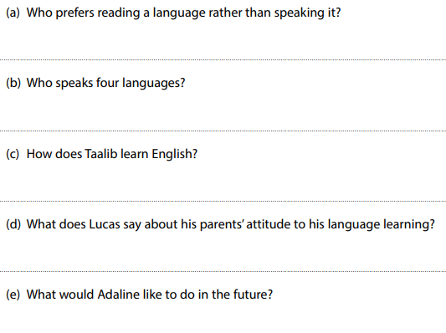
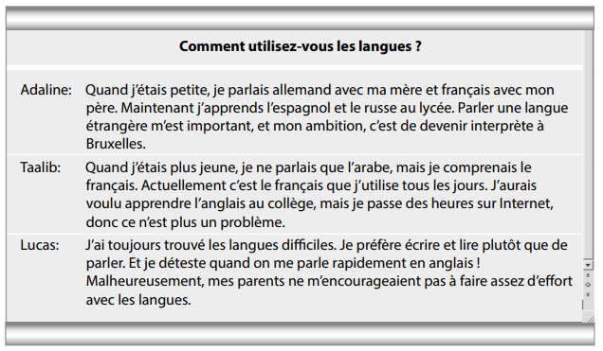

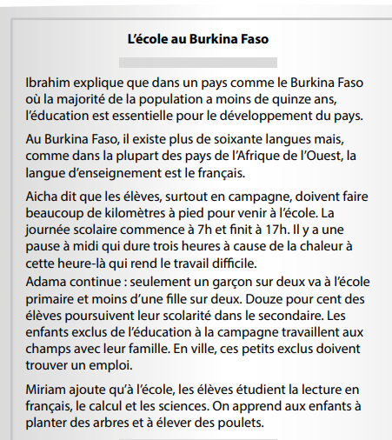

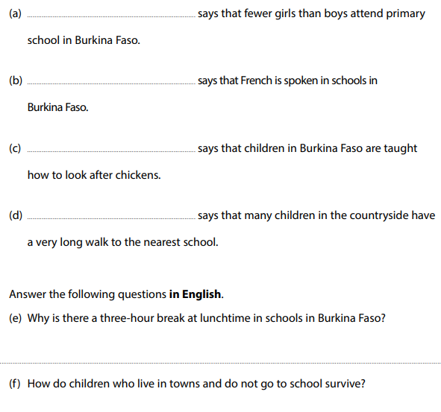

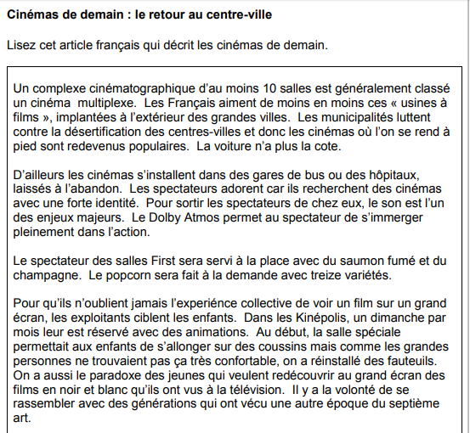
- Ecrivez les lettres des cinq phrases vraies.

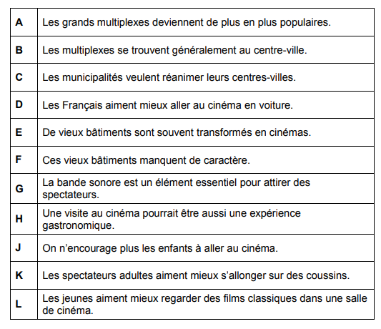

Please make sure that you have completed all the exercises in the table below before the start of the course.
TASKS | COMPLETED?
Grammar:
- Present
- Modals
- Past
- Future
Notes made / grammar activities completed
Vocabulary:
- Foundation Transition Vocab
- GCSE Family vocabulary reviewed
- New vocabulary learned (in the appendices)
Watch:
- Write about what film/series you watched in French
- Summarise the plot, give your opinion and describe the characters.
Listen:
- Summaries completed in English of 2 videos you have watched from the suggested websites.
- Complete the listening comprehension activity – Festival à la Plage
Read:
- Summarise 2 articles from different news websites in English and annotate with vocabulary
- Reading comprehension tasks completed.
Research:
- Prepare a presentation on your family to show off your GCSE and new vocabulary
- Prepare a presentation on the Francophone country you have researched

Appendices/resources

Online dictionaries / verb conjugators

- www.wordreference.com
- https://www.collinsdictionary.com/dictionary/english-french
- https://www.larousse.fr/dictionnaires/francais
- http://verbix.com/

Apps
- Quizlet
- DuoLingo
- Vocab Express
- You can get news sites on your phone e.g. le Monde
- Spotify

On the following page you will find all the vocabulary on the topic of family (the first topic studied at A Level).
