

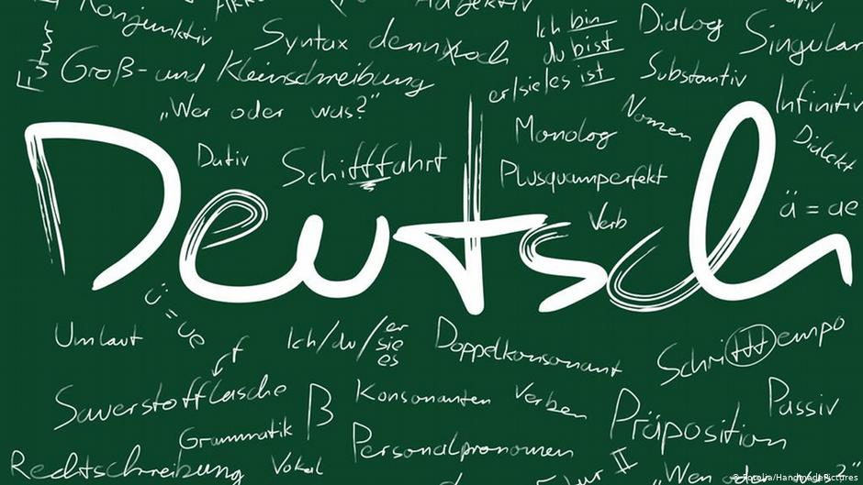
Year 11 > 12 Bridging Work
Summer Term 2026
Subject | German
Course | A-Level
Awarding Body | Pearson Edexcel

Contents:
 |  | Page(s)
 | Course/specification overview | 3
 | Our department expectations | 4
 | Review/revise | 5-6
 | Watch | 7
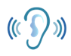 | Listen to | 8
 | Read | 9
 | Research | 10
 | Complete | 11-18
 | Appendices/resources | 19

Course/specification overview

Our vision is for all students to become ‘confident and enthusiastic communicators in a foreign language’. Our lessons are conducted in the target language and all our students end up speaking either French, German or Spanish fluently by the end of Year 13, even if they have not been used to speaking the language during lessons at GCSE.
The Modern Foreign Languages courses are designed for students interested in languages and communication who enjoy learning about other cultures and ways of life. An A level in languages challenges students to develop not only their ability to communicate effectively in the foreign language but also their ability to analyse information and apply knowledge.
A Level - Paper 1 - Listening, reading and translation from the Target Language to
English
Paper 2 – Translation from English to the Target Language, an essay on a piece
of literature and an essay on a film
Paper 3 – Speaking - Discussion of a theme and a presentation and discussion
on a topic of your choice

Units studied in Year 12:
Natur & Umwelt; Bildung; Die Welt der Arbeit; Musik; Die Medien; Die Rolle von Festen und Traditionen

Units studied in Year 13:
Die positive Auswirkung von Integration; Die Herausforderungen von Immigration und Integration; Die staatliche und soziale Reaktion zur Immigration; Die Gesellschaft in der DDR; Ereignisse vor der Wiedervereinigung; Deutschland seit der Wiedervereinigung

Two set texts/films studied:
Year 12: Der Besuch der alten Dame – Friedrich Dürrenmatt
Year 13: Goodbye Lenin! – Wolfgang Becker

Our department expectations

As an A Level student of MFL, we expect you to have the following equipment:
- a plastic wallet with all the work from the Transition booklet in the first lesson of term
- a lever arch folder with dividers
- a bilingual dictionary
- lined paper & red/green/blue/black pens

A Level MFL students are expected to:
- attend all lessons punctually
- complete an hour a week of independent study set by MFL staff
- take part in weekly speaking sessions in small groups with the foreign language assistants
- submit all homework on time and ask for support when needed
- communicate all absences as soon as possible to the teacher and catch up on missed work
- take an independent approach towards their learning and invest time in DIRT
- review and organise their class notes regularly

Studying a language is a marathon, not a sprint and will require resilience and good organisation. It is definitely a subject where the more you put in, the more you will get out!

Review/revise

- Grammar essentials – any Quizlets that won’t open, copy & paste into your browser!
VERBS
- The present tense (regular verbs & the irregular verbs – essen / lesen / fahren…..)
https://quizlet.com/505612434/irregular-present-tense-verbs-4-common-examples-flash-cards/
https://quizlet.com/505612727/haben-sein-werden-3-very-important-verbs-flash-cards/
- Modal verbs
https://quizlet.com/505613014/modal-verb-flash-cards/
- The past tense (perfect tense)
https://quizlet.com/505613428/past-tense-fundamentals-with-haben-flash-cards/
https://quizlet.com/505613849/past-tense-fundamentals-with-sein-flash-cards/
- The future tense
https://quizlet.com/505614097/future-tense-fundamentals-flash-cards/
WORD ORDER
- Inversion
- Subordinating conjunctions
See the Quizlet below for connectives.
There are grammar activities in the ‘Complete’ section of this booklet once you have done the Quizlets.
Need to revise? Remember to use your exercise books with notes, along with your Knowledge Organiser booklet. Still need more notes or want online practice? How about trying the following?
- www.languagesonline.org.uk
- https://www.bbc.co.uk/bitesize/topics/zk92tfr
- www.german.net
- www.verbix.com

- Vocabulary essentials

- Opinions https://quizlet.com/504259790/transition-vocabulary-opinions-flash-cards/
- Important Adjectives https://quizlet.com/505267717/transition-vocabulary-adjectives-flash-cards/
- Quantifiers & Intensifiers https://quizlet.com/505269907/transition-vocabulary-quantifiers-intensifiers-flash-cards/
- Connectives https://quizlet.com/505271466/transition-vocabulary-connectives-flash-cards/
- Question words https://quizlet.com/505272938/transition-vocabulary-question-words-flash-cards/
These are some foundation topics or elements of vocabulary that you need to be confident with before starting the A Level course.
- Preparation for the first topic
Family: https://quizlet.com/505410926/transition-vocabulary-family-extension-beyond-gcse-flash-cards/
You will be tested on all of the above (particularly the family extension section) in the first few lessons of Year 12.

Watch

Telenovela – Jojo sucht das Glück
https://www.dw.com/de/deutsch-lernen/staffel-1-fans/s-13358
Watch all the episodes in season 1. They’re only 3 minutes long each but they are at a great level for GCSE to A Level students and they have subtitles in German so you can read and listen at the same time. Under each episode there are a couple of activities to complete that help you understand the language better.
EBI : you get onto season 2!
Choose a film to watch
There are lots available on Amazon and Netflix. You can also access the Goethe Institut website called OnLeihe and sign up here to rent films for free with English subtitles. https://www.goethe.de/ins/gb/en/kul/ser/onl.html
BUT: don’t watch Goodbye Lenin!

Watch the news but in a digestible young adult format (like Newsround)
https://www.zdf.de/kinder/logo

Choose a series to watch
We would recommend Dark from Netflix (a bit like Stranger Things) or Deutschland 83 on All4 (if you like spy/historical dramas, set in former East Germany), or Kleo (if you like spy thrillers with lots of violence – like Kill Bill set in former East Germany!).

Watch a TED talk about language learning
https://www.ted.com/talks/erin_mckean_go_ahead_make_up_new_words
https://www.ted.com/talks/john_mcwhorter_4_reasons_to_learn_a_new_language#t-1094
https://www.ted.com/talks/lera_boroditsky_how_language_shapes_the_way_we_think
https://www.ted.com/talks/andreea_s_calude_does_grammar_matter

Listen to

Lyrics Training
https://lyricstraining.com/de
Podcasts
Slow German (German language): https://open.spotify.com/show/2rnCPyV8A9J80QtmGj2pAx
The Krauts (culture): https://open.spotify.com/show/5FIQMv5UURCbpRJ6FEfToC
Spotify
Top 50 tracks (charts) from the country to get the most up to date music
Search for German playlists and listen to a variety of music
- Wer singt? Wie heißt das Lied? Magst du das Lied? Warum?
Langsam gesprochene Nachrichten - news spoken slowly!
https://www.dw.com/de/deutsch-lernen/nachrichten/s-8030
Radio
Find a radio station from the country and listen!

Read

Try some online news or articles
- https://www.nachrichtenleicht.de/
- https://www.dw.com/de/deutsch-lernen/top-thema/s-8031
These ones often have a manuscript accompaniment so you can read along as you listen, as well as language exercises to try
- https://www.spiegel.de/deinspiegel/
We get a copy of this magazine delivered to school but have a look and see what you can understand of the articles

Read something in or translated into English that is about Germany
General
- The Shortest History of Germany – James Hawes
- Springtime for Germany – Ben Donald
Books about WWII
- The Book Thief – Markus Zusak
- Alone in Berlin – Hans Fallada
- All the Light We Cannot See – Anthony Doerr
Books about divided Germany
- Stasiland – Anna Funder
Books post the fall of the wall
- Russian Disco – Wladimir Kaminer

Research

Research Tasks:
Find:
- 1 advertisement in German and answer: Was ist das? Warum soll man das kaufen?
- 1 clothes website in German and find an item you like: Was möchtest du kaufen? Welche Farbe ist das? Was kostet das?
- 1 football team’s website and make a list of 5 of the male and female players
- Why these dates are important in German history?
1517 / 1871 / 1918 / 1933 / 1945 / 1949 / 1961 / 1989.
- 5 facts about Angela Merkel

Presentation:
Du musst eine Präsentation über deine Famile machen. Du musst für 2 Minuten sprechen.

Complete

TASKS | COMPLETED?
Grammar:
- Present
- Modals
- Past
- Future
- Word order
Quizlets used & learned/notes made / grammar activities (following this check list) completed
Vocabulary:
- Foundation Transition Vocab (all 5 categories) learned
- Family Vocabulary beyond GCSE learned
Watch:
- Write us something about what you watched (a film or series) from the Watch List in English

Listen:
- Choose 2 of the options from the Listening suggestions and either summarise or give your opinion on them in English
Read:
- Summarise 2 articles from any of the Reading suggestions in English and annotate with vocabulary, or write a summary about a book you chose to read
- Reading comprehension questions that follow this check list
Research:
- prepare a presentation on your family to show off your GCSE and new vocabulary
- make sure you have completed the other research tasks

GRAMMAR
Regular present tense verbs
Fill in the gaps below to form a correct description about how to formulate the present tense of regular en verbs.

Take the ___ ________ form of an en verb. Remove the _____ from the infinitive to form the _______. Then _____the following endings.

List the usual present tense verb endings, using gehen as your infinitive stem verb.

Ich ____________________________________________
du __________________________________________
er/sie/man/es ________________________________
wir ___________________________________________
ihr ____________________________________________
sie/Sie ________________________________________
Sie ___________________________________________________

Fill these boxes with the correct present tense verb form of the infinitives in brackets at the end of each sentence.

- Ich ___________in meinem Zimmer und ____________für die Schule. [sitzen / lernen]
- ____________du schon zu Hause? ____________du zum Essen? [sein / kommen]
- Er ___________lieber mit seinen Freunden. [machen / spielen]
- Meine Frau ___________ nach Hause und _________das Abendessen. [gehen / kochen]
- Meine Eltern ________ in Urlaub, _______ aber am Sonntag zurück. [fahren / kommen]

Irregular present tense verbs

Irregular present tense verbs don’t always follow the same patterns and often have changes in the stem for du and er/sie/es/man.

e.g. fahren – ich fahre / du fährst
lesen – ich lese / du liest
essen – ich esse / du isst

Sometimes they are completely irregular, such as ‘sein’.

Translate these irregular verb forms.

- I am: _______________________________________________________________
- You drive: ___________________________________________________________
- You are: ___________________________________________________________
- You (plural) have: ____________________________________________________
- You will / become: __________________________________________________
- He/she/one/it has:___________________________________________________
- You (plural) are: ____________________________________________________
- You (plural) have: ____________________________________________________

Try these explanations & activities to further support you
https://www.rocketlanguages.com/german/lessons/german-irregular-verbs

https://deutsch.lingolia.com/en/grammar/tenses/present-tense/exercises

Modal Verbs
Open the link and read about what these are:
https://www.bbc.co.uk/bitesize/guides/zgkhfrd/revision/1
Learn the present tense forms of these modal verbs. Write them below, from memory.
müssen | dürfen | können | mögen | wollen | sollen

Go to the website below and work through the various games and exercises on modal verbs.

https://quizlet.com/185937812/german-modal-verbs-flash-cards/

Past (perfect) tense
When do you use the perfect tense in German?

Revise how to form it:
Pronoun + Helper/Auxiliary Verb + Past Participle
Pronomen + Hilfsverb + Partizip ich + habe + gespielt
Write from memory the 2 auxiliary/helper verbs needed to form the perfect tense.
 | HABEN | SEIN
ich
du
er/sie/es
wir
ihr
sie/Sie

90% of verbs in German use ‘haben’ as their helper verb in the past tense.
Can you name 4 that don’t and use sein instead? Here’s one as an example.
INFINITIVE | PAST PARTICIPLE
fahren | gefahren

Correct the following perfect tense sentences. Deliberate mistakes have been made for you to correct.
- Letztes Wochenende bin ich Tennis im Park gespielt.
- Letztes Jahr haben wir nach Amerika in den Urlaub gefahren.
- Gestern hat sie ins Schwimmbad gegangen.
- Er ist sein Buch im Zimmer gelesen.
- Hast du ins Kino gegehen?
- Sie haben Pizza im Restaurant geessen.
- Ihr habt in der Schule gestudiert.

Translate the following into German using the past tense.

- Last year I went to Italy with my family. We travelled by plane and by train.
__________________________________________________________________________________________________________________________________________
- Yesterday I went to the cinema with my friends. We watched a science fiction-
film and we ate a lot of popcorn.
__________________________________________________________________________________________________________________________________________

- He went to town last weekend and bought a tee-shirt and some trainers.
__________________________________________________________________________________________________________________________________________

Want more practice of this?

https://german.net/exercises/tenses/perfect/

Future Tense

https://www.bbc.co.uk/bitesize/guides/zw23cwx/revision/1

Read about how you form the future tense – it’s not difficult in German!

- Fill in the gaps in these future tense sentences.

- Ich ___________ feiern, leider _____________du nicht kommen.
- Meine Eltern __________ morgen wandern gehen, ich _________ aber nicht mitgehen.
- Wir _________ uns wiedersehen. Weißt du schon, wann du hier sein ___________?
- Morgen ___________ ich früh _____________. [aufstehen]
- Wann ____________du nach New York ____________? [fliegen]

WORD ORDER

Inversion

https://www.bbc.co.uk/bitesize/guides/zxnkj6f/revision/7

Revise what this using the above website and then try the following activity.
https://german.tolearnfree.com/cgi2/myexam/voir2r.php?id=110073

Subordinating Conjunctions

You have a good explanation here, as well as some sentences to practise.
https://german.net/exercises/conjunctions/subordinate-conjungtions/

Rearrange these sentences:

- ins gern weil Kino, ich es macht Spaß gehe

__________________________________________________________________________

- haben neue obwohl teuer Wir Schuhe waren gekauft sie

__________________________________________________________________________

- es spiele wenn nie ich Tennis wenn regnet,

__________________________________________________________________________

Reading Comprehension Activities

TEXT 1 – Questions on the following page
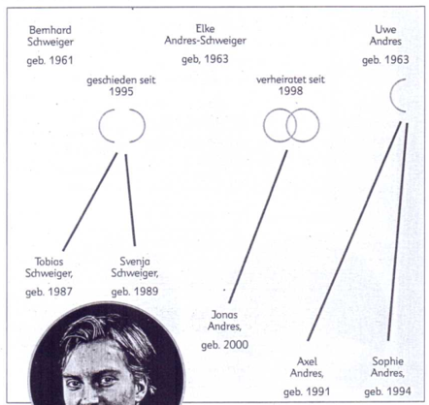
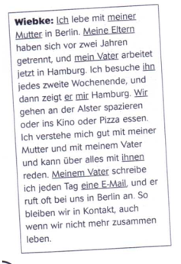
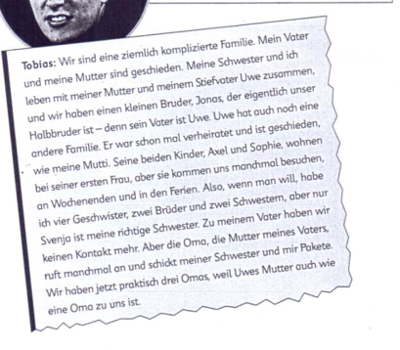
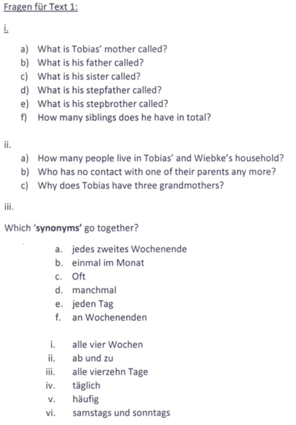

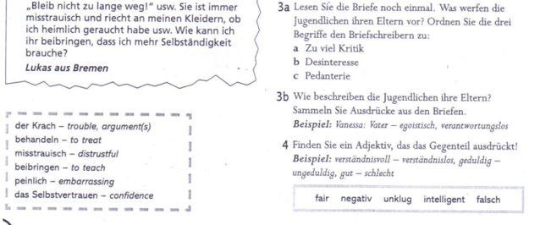
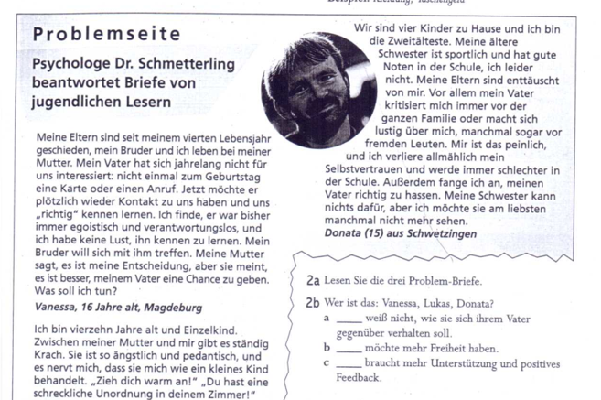
Task 2 – Text & Questions 2a, 2b

Appendices/resources

Online dictionaries
- www.dict.cc
- www.wordreference.com
- www.leo.org

Apps
- Quizlet
- DuoLingo
- You can get news sites on your phone e.g. Deutsche Welle
- Spotify

