

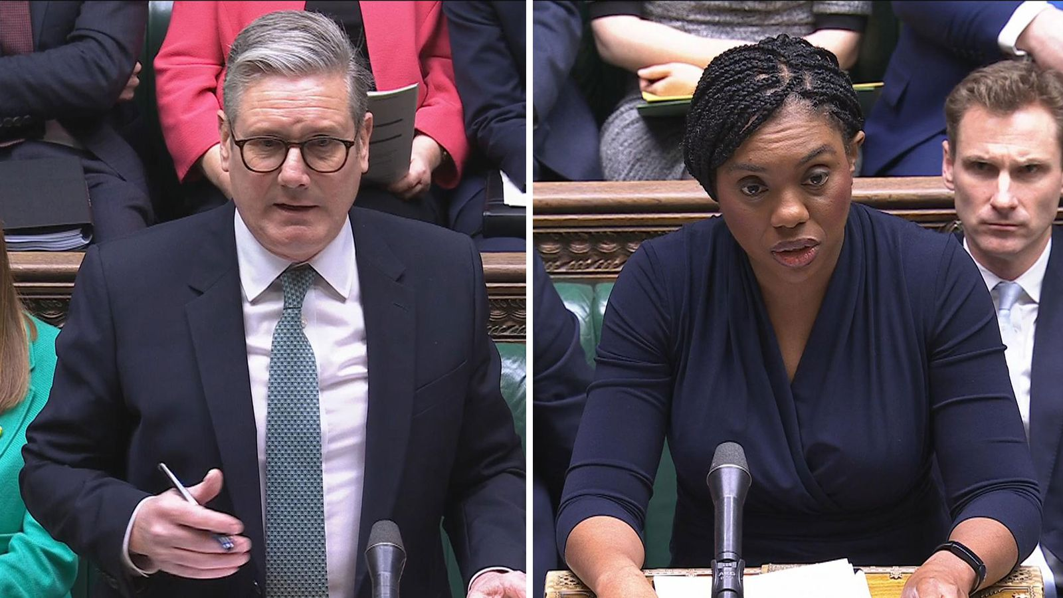Year 11 > 12 Bridging Work
Summer Term 2026
Subject | Politics
Course | A-Level
Awarding Body | Pearson

Contents:
 |  | Page(s)
 | Course/specification overview | 3
 | Our department expectations | 4
 | Review/revise | 5
 | Watch | 6
 | Listen to | 7
 | Read | 8
 | Research | 9
 | Complete | 10-14
 | Appendices/resources | 15

Course/specification overview
https://qualifications.pearson.com/en/qualifications/edexcel-a-levels/politics-2017.html
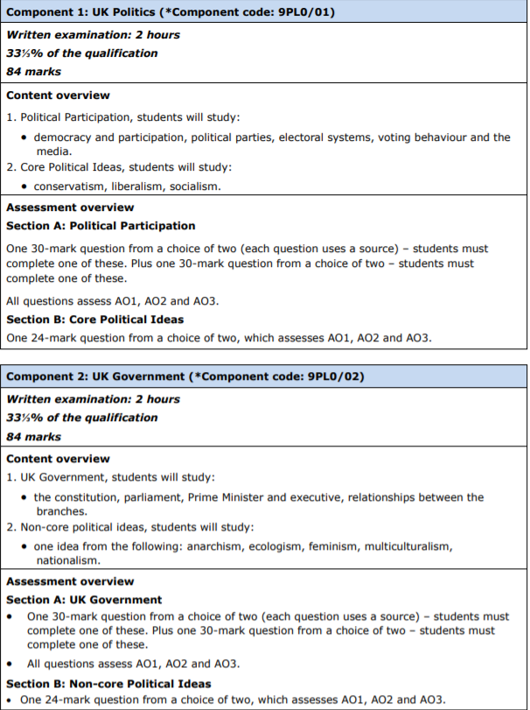
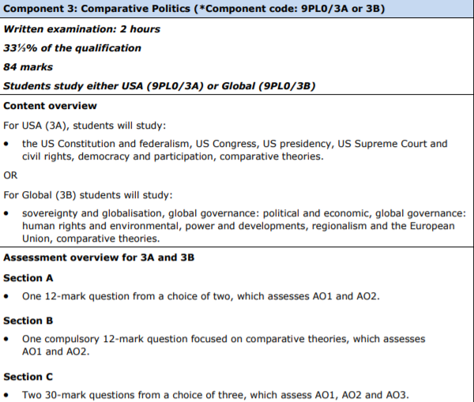

Our department expectations

As teachers we will: | We will expect of you:
- Provide you with well-planned, informative and well-resourced lessons | - Attend all lessons and ensure that where you are unable to that you have caught up ahead of the next lesson
- Support you to do well in your examinations and to meet your full potential in the course | - Have a positive and pro-active approach to study.
- Encourage and support you to do your very best | - Keep up to date with classwork and homework; a large part of the course involves independent study and discipline to stay up to date with this
- Provide opportunities, where possible, outside of lessons to enrich your knowledge | - Most importantly: a keen interest in current affairs and the news and a willingness to stay up to date with the news to bring this into your written work
- Provide you with detailed and informative feedback to support you to improve your exam technique. | - To be prepared to engage in debate and discussion in class and comfortable with the idea that there are no right or wrong opinions in Politics

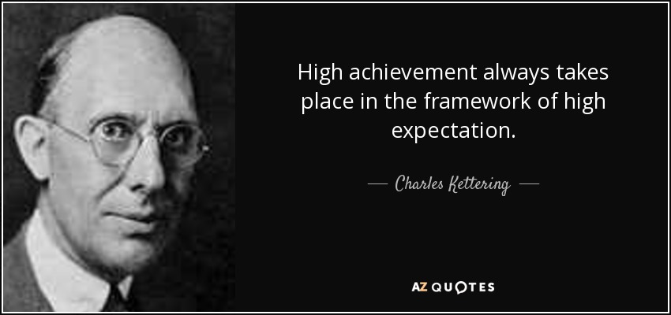

Review/revise

The aims and objectives of this qualification are to enable students to:
- develop knowledge and an informed understanding of contemporary political structures and issues in their historical context, both within the United Kingdom (UK) and globally
- develop a critical awareness of the changing nature of politics and the relationships between political ideas, institutions and processes
- develop knowledge and an informed understanding of the influences and interests which have an impact on decisions in government and politics
- develop knowledge and an informed understanding of the rights and responsibilities of individuals and groups
- develop the ability to critically analyse, interpret and evaluate political information to form arguments and make judgements
- develop an interest in, and engagement with, contemporary politics.

Skills
- Students must comprehend and interpret political information in relation to areas of UK politics and core political ideas.
- Students must fully understand, and critically analyse and evaluate areas of UK politics and core political ideas.
- Students must identify parallels, connections, similarities and differences between content studied, providing a basis for comparing the UK with the USA and appreciating the UK’s position in global politics.
- Students must construct and communicate arguments and explanations with relevance, clarity and coherence, and draw reasoned conclusions about UK politics and core political ideas.
- Students must develop knowledge and understanding of key political concepts. The content supports these skills by presenting the main content for learning in the righthand side of the content tables.
- Students must use appropriate political vocabulary.

Watch

This list is intended to be a suggested guide to films, documentaries and dramas which will enrich your subject knowledge ahead of starting the course. Do not feel you need to watch them all!

- BBC Documentary Series- Inside the Commons https://www.dailymotion.com/video/x6o8rtl
- BBC Documentary Series- Meet the Lords https://www.dailymotion.com/video/x6nz0qx
- BBC Documentary Series- The Cameron Years https://www.bbc.co.uk/iplayer/episodes/m0008kk7/the-cameron-years
- BBC Documentary Series- Thatcher: A Very British Revolution https://www.dailymotion.com/video/x7am1i8
- BBC Documentary Series- Andrew Marr’s The Making of Modern Britain https://www.youtube.com/watch?v=_tRJ1E9Ai2E
- BBC Documentary Series- The Wilderness Years Labour 1979-1995 https://www.youtube.com/watch?v=3XrO72C1WQ0
- BBC Drama Series- The Project (dramatization of New Labour) https://www.youtube.com/watch?v=gzO5Re9nwlo
- BBC Documentary Series- Steve Richard’s Reflections on British Prime Ministers https://www.youtube.com/user/steverichards14/videos
- BBC Documentary Cabinet Confidential https://www.youtube.com/watch?v=wdAhv0D1_hc
- Inside the White House (1995) https://www.youtube.com/watch?v=P1If5NvFjdM
- Fahrenheit 9/11 (2004)
- The Iron Lady (2011)
- The Queen (2006)
- BBC Question Time
- The Politics Show with Andrew Neill
- The Andrew Marr Show
- All the Presidents Men (1976)
- Get Me Roger Stone, Netflix Documentary (2019)
- Thirteen Days (2000)
- Selma (2014)

Listen to

This list is intended to be a suggested guide to podcasts which will enrich your subject knowledge ahead of starting the course. The suggestion is to listen to one or two episodes ahead of starting the course. Do not feel you need to listen to them all!

- Talking Politics
- Stitcher – A-level politics podcast
- Beyond Westminster
- BBC politics podcasts
- The Westminster Hour
- Politics.co.uk podcasts
- Guardian ‘politics weekly’ podcasts
- US – KCRW – Left, Right & Center

Read

This list is intended to be a suggested guide to some books which will enrich your subject knowledge ahead of starting the course. Do not feel you need to read them all!

- David Cameron, For the Record (2019)
- Anthony King, Who Governs Britain? (2015)
- Barack Obama, Dreams from My Father (1995) The Audacity of Hope (2006)
- James Poniewozok, An Audience of One: Donald Trump, Television and the Fracturing of America (2020)
- Karl Marx and Friedrich Engels, The Communist Manifesto (1848)
- Edmund Burke, Reflections on the Revolution in France (1790)
- Mary Wollstonecraft, A Vindication of the Rights of Women (1792)
- John Rawls, A Theory of Justice (1971)
- Anthony Giddens, The Third Way: The Renewal of Social Democracy (1997)
- Emma Goldman, Anarchism and other essays (1910)
- Reni Eddo-Lodge, Why I’m No Longer Talking to White People About Race (2017)

Research

This task needs to be completed and brought to the first lesson at the start of term
Complete this table researching the key details about the following general elections

 |  | Voter turnout % | Party which formed the government |  | No. of Conservative Seats | % Conservative Party share of votes | No of Labour Party Seats | % Labour Party share of Votes | No of Liberal Democrat Seats | % Liberal Democrat share of votes
2024
2019
2017
2015
2010
2005

2001
1997
 |  |  |  | Complete

This task needs to be completed and brought to the first lesson at the start of term
Your task is to read through the information below about direct democracy and representative democracy. In particular you are looking for the following information:
- What is direct democracy? How does it work? Where and when do we see it in the world today?
- What are the advantages and disadvantages of direct democracy?
- What is representative democracy? How does it work? Where and when do we see it in the world today?
- What are the advantages and disadvantages of representative democracy?
Then using the information that you have been given, we would ask that you write an essay of no more than two sides answering the question:
Evaluate the view that direct democracy is more desirable and effective than representative democracy
Essay Success Criteria
- Clear introduction where you outline the points you are going to be and give your judgement on the question.
- Balanced answer - look at both sides of the question
- Use PEEL paragraphs in your answer
- Conclusion where you return to your overall judgment and justify/explain it.
The essay needs to be brought to your first lesson of the new term- either typed or hand written is fine.
Reading to support written task
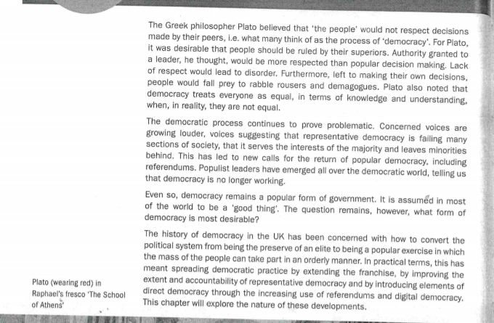

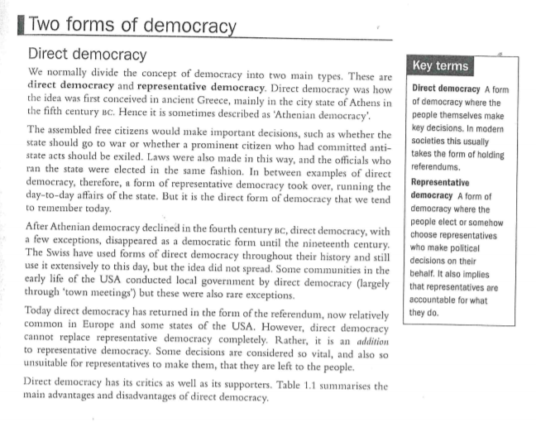
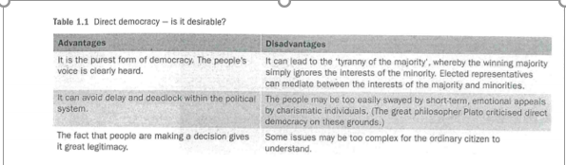
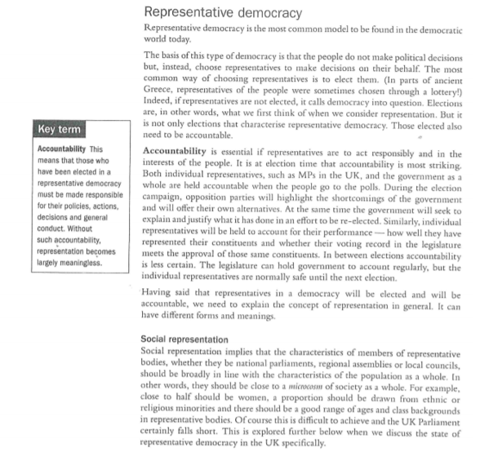
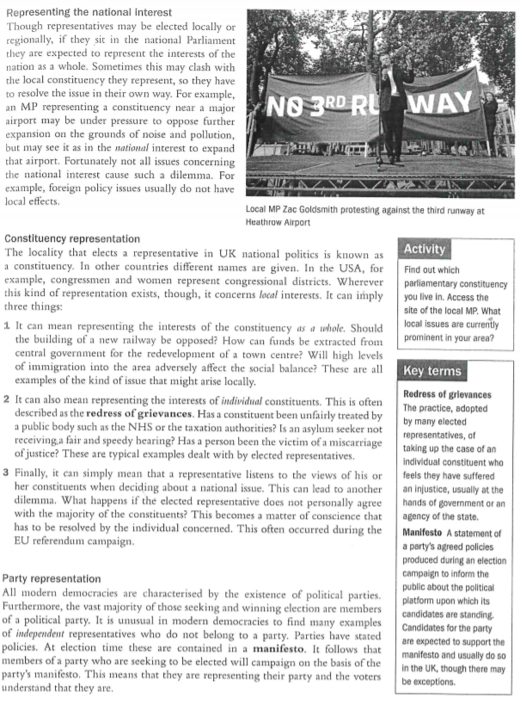

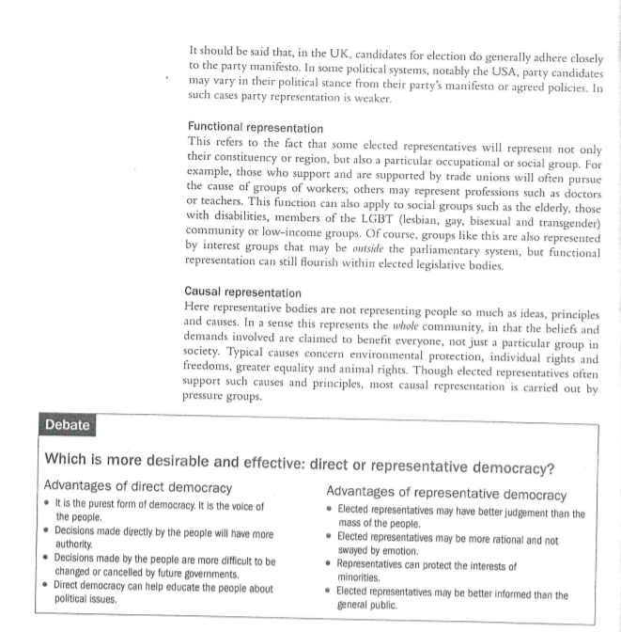

Appendices/resources

Learning Resources for Students
- https://learning.parliament.uk/resources/
- https://www.thestudentroom.co.uk/a-level/subjects/politics/
- https://www.tutor2u.net/politics

Free Online UK News
- https://www.bbc.co.uk/news
- https://www.independent.co.uk/
- https://www.theguardian.com/uk-news
- https://www.politico.eu/

