

Year 11 > 12 Bridging Work
Summer Term 2026
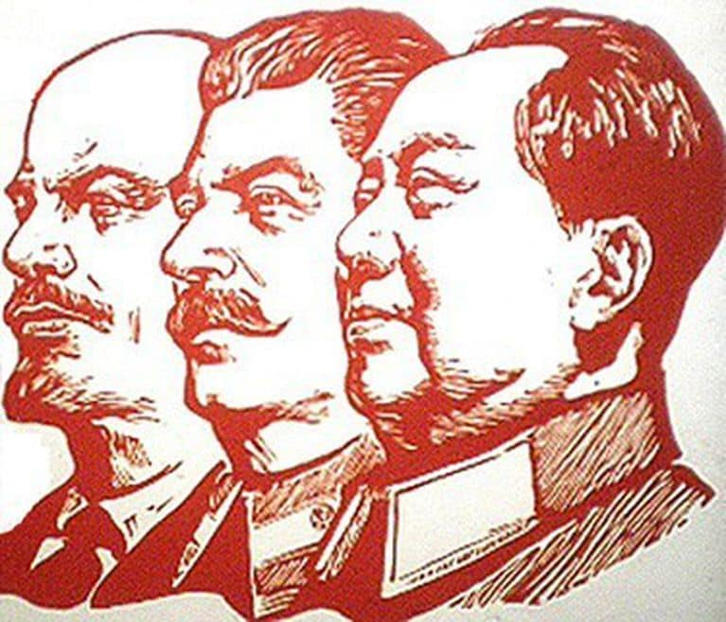
Subject | History
Course | A’ Level
Awarding Body | Edexcel

Contents:
 |  | Page(s)
 | Course/specification overview | 4-5
 | Our department expectations | 6
 | Review/revise | 7
 | Watch | 8-29
 | Listen to | 8-29
 | Read | 8-29
 | Research | 8-29
 | Complete | 8-29

Russia - specification overview
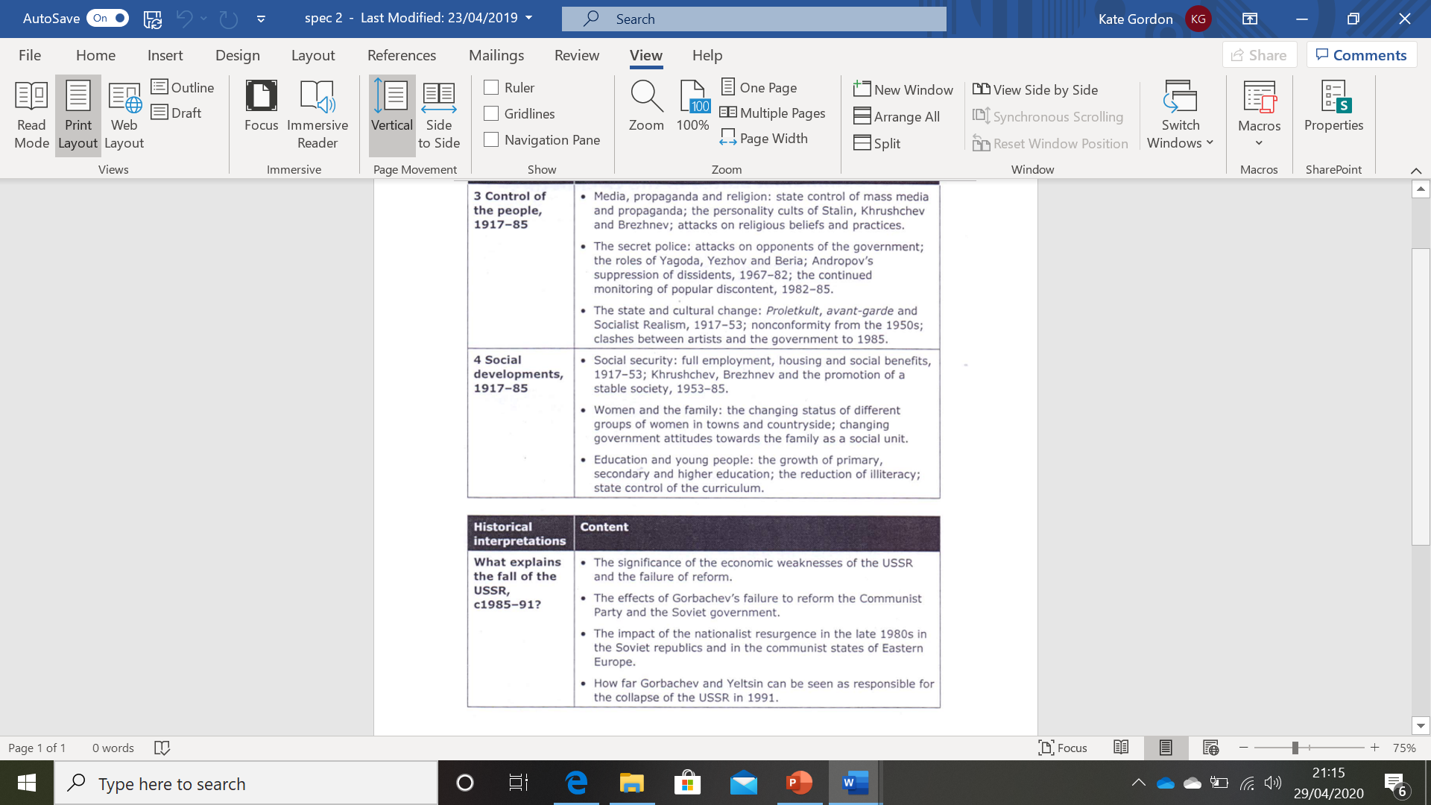
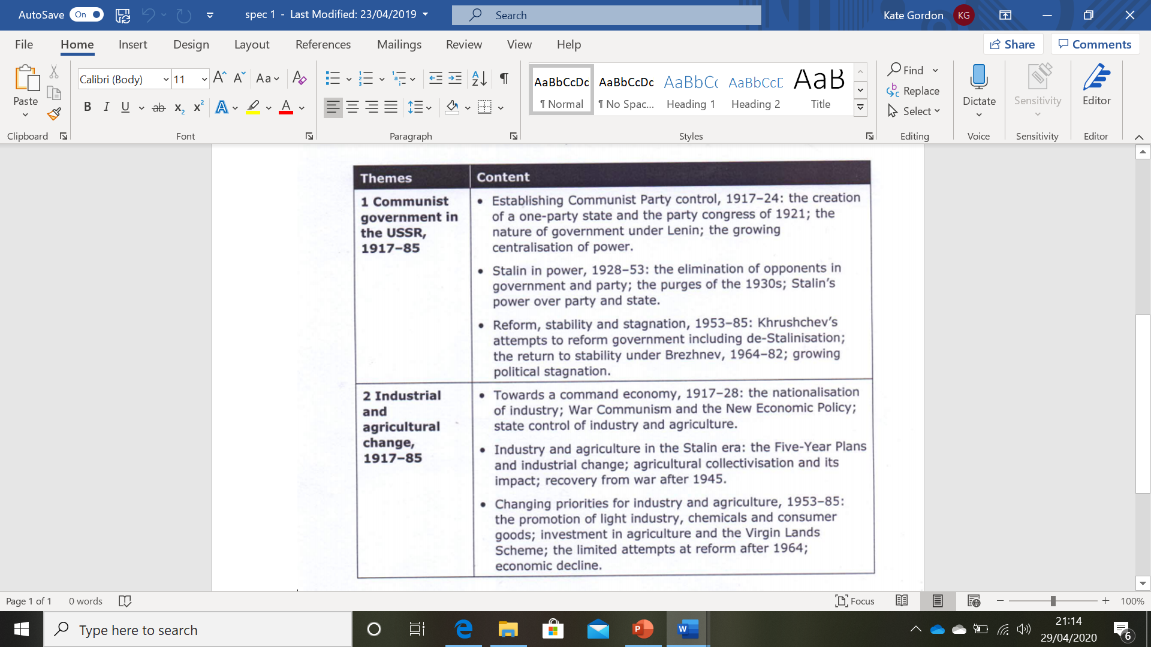
China/specification overview

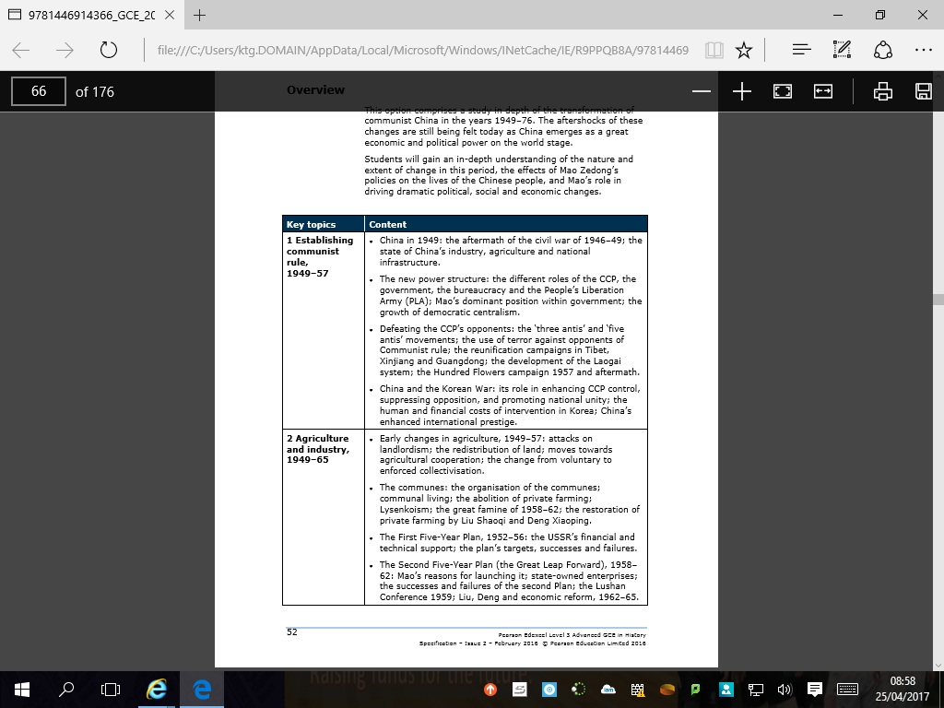

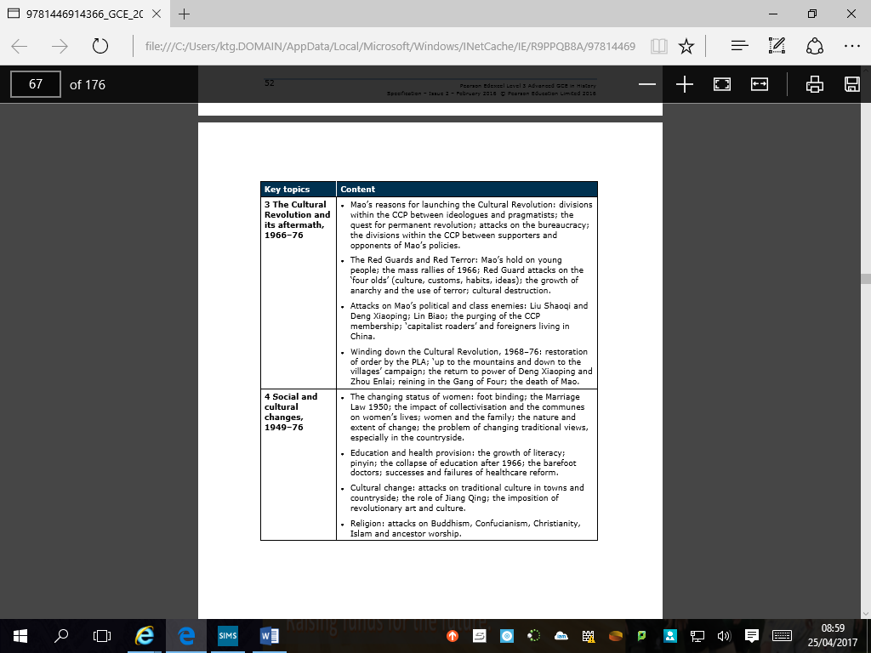

Our department expectations

- Attendance: You need to attend every lesson where possible. If you are unable to make a lesson, please email your teacher to let them know and ask for the work. You must catch up on all work you miss, including home work.
- Contribute: We expect you to actively engage in lessons by answering questions, remaining focused on all tasks and asking for clarification.
- Organisation: You will need to buy a separate folder and dividers for Russia and China. You will need to keep your work well organised in each folder.
- Homework: All homework needs to be completed on time and top the best of your ability. Homework will sometimes be an essay, but it will also be pre-reading, SMH quizzes, and articles to read.
- Acting on feedback: You will be expected to engage with the process of acting on your feedback, in order to make progress.
- Seating: Your teacher will ask you to sit in a seating plan. Please keep to this plan, as it helps us learn your names and keeps the atmosphere focused.
- Punctuality: Please arrive on time to lessons, especially period 5 and 6.
- Note taking: Make sure your notes are detailed enough to revise from. Use colours and underlining to organise your ideas.
- Wider reading: Read around the subject, in order to give you a wider understanding of the topic.
- Persevere: The jump from GCSE to A’ Level can be hard. Always ask for help when you need it.

Review/revise

Make sure you have a good understanding of the different ideologies of Communism and Capitalism from the start of your Cold War GCSE unit.

Remind yourself of key events:

Stalin: Berlin Blockade
Khrushchev: Berlin Wall and Hungarian Uprising
Brezhnev: Prague Spring

Complete

Russia: Complete the sheet titled “Background in Russia 1894”
Read through all the information carefully, highlighting key pieces of information and using the internet to research anything you are not sure about.
Then create a mind map / table / list of all the factors to take into consideration when looking at the type of country Russia was.
Your headings should be:
Geographical factors
Social Problems
Political Problems
Economic Situation
Russia: Read the sheet titled “Nicholas II: An overview of his Reign”
Read all the information and highlight anything relevant or interesting.
Then carefully read the sources and complete the source work activity
Russia: Read the sheet titled “Nicholas II: An overview of his reign”
Use the web and any other sources available to you to find an extra nugget of information that you can add to each event on this sheet. You can also find relevant pictures or clips of the events & people to develop your notes.

Background: Russia in 1894
Task
- Read through this handout. Highlight fresh information which you did not gather from the simulation.
- Now use the highlighted information in this handout to develop the mindmap you produced in the earlier lesson.
Introduction

"A riddle wrapped in a mystery inside an enigma " - Churchill on the USSR, 1939

- Even today, Russia remains mysterious, powerful and unstable.
- In the 1990's, it started its unfinished journey from communist dictatorship to liberal democracy.
- Before then, it lay at the heart of the USSR, whose superpower rivalry with the USA brought the world to the edge of nuclear annihilation.
- The USSR had been created following the Revolutions of 1917, and led by Lenin and the murderous tyrant Stalin, who killed over 20 million of his own people.
- And the Revolutions of 1917 had seen the overthrow of the Tsars (emperors), who had ruled Russia for 300 years.

- 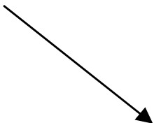Our first key question is whether the historical path outlined here was inevitable, or whether the Tsars could have peacefully modernised Russia and thereby avoided revolution and all of its attendant horrors.
1. Geographical factors

/
3. Political Problems
2. Social Problems

Economic/ Financial Backwardness

1. Fundamental Issue: Geography
a. Natural Resources
- Industry - Blessed with iron ore and coal and oil - but these are not well exploited
- Agriculture - Only 10% (the "Black Earth" regions of the south and north) are suitable for farming; the rest has a climate ranging from Arctic tundra to scorched desert, with everything in between.
b. Communications
- Chronic-
roads are mud tracks,
rivers often frozen;
none of her three great sea ports (Archangel, St Petersburg and Azov) are ice-free all year.
c. Topography & Population

- Largest country in the world: occupies 116th of the world's land surface, making it 91 times larger than Great Britain
- 6000 miles long from Baltic to the Pacific; 3000 miles from the Arctic to the Persian coast
- Not even European: most of 19th Century Russia lay in Asia.
- 60 million people in 1855; doubled by 1897
- Over 200 different nationalities , speaking c.100 different languages - less than half the population is ethnic Russian!
2. Social Results - Russification
- The Tsars dealt with the 200 or so nationalities within their empire with a policy of
"Russification"- Russian nobles are encouraged to settle in conquered territories and the Russian language is used in schools.
a. Alexander II: Ukranians and Poles
- Ukranians had their language banned from schools from 1863 after the interior minister said
that it "has not existed, does not exist and shall never exist".
- Poles experienced the same policy after 1866, following the assassination attempt and the Polish Revolt of that year.
b. Alexander Ill: The Jews
lgnatiev, the Minister of the Interior, informed Alexander in 1881 of a "diabolical combination
of Poles and Jews". Soon afterwards, the Holy League organised a wave of Pogroms which recurred for the rest of the Tsarist era. He also restricted Jews to the Pale of Settlement in the East and banned them from legal, medical and military professions . In 1891, two thirds of Moscow's Jews were expelled and 225,000 Jewish families as a whole left Russia during Alexander Ill's reign.
3. Social Results - Serfdom and the Mir
a. Peasantry

The harsh rule of the peasant class was the social consequence of the size and instability of Russia.
i. Before 1861: Serfdom
- 50% of the population were serfs - peasant farmers given a plot by their landowner in return for goods or services.
- Some paid their owners each year with money or produce (these people were called Obrok);
others gave labour services to the lord for 30-40 days a year ( Barschina ).
- In effect, they were slaves. They could be sold, married and flogged at will by their masters; average life expectancy was only 35, with only 50% of children surviving beyond the age of 5
- The Mir was the village commune which was the lifeblood of a peasant community - it organised farming activity and had its own assembly; peasants could not even leave the estate without its written permission!

Effects on the army
- The army was 1,400,00 strong in 1855 and the bedrock of the country's stability.
- Officers were from the nobility, but the ranks were conscripted from the serfs for 15 years compulsory service - wives declared widows and allowed to remarry!
- Soldiers were given freedom when service completed; but not given a pension or land!
- As a result, morale was low throughout the army
- Crimean War highlighted its terrible lack of morale and organisation
- Any reform of the army would require a reform of the Serf system
ii. 1861: Emancipation of the Serfs
- In 1861, Alexander 11, the "Tsar Liberator" issued the Edict of Emancipation: "the serfdom of
peasants ... is abolished forever". The gentry had to give up to 50% of their land to the Mir, depending on the amount of peasants in the area.
- However, the peasants had to pay the government for their land with a 49 year mortgage at 6% interest. This was crippling and the peasants bitterly resented having to pay for land which they thought had always been theirs. Moreover, the serfs could not leave without the permission of the Mir, who gave out local passports.
b. Nobility
- 1 million. Most powerful are the top 1000, called the Grand Seigneurs.
- Not as powerful as could be imagined - estates were divided on death between all male heirs, which ruined estates
- Loyalty to the Tsar undermined following his Emancipation of the Serfs in 1861.
c. Bourgeoisie (middle class)
- Small, due to backwardness of the economy
- Only 1% of population in school; only 3,500 in university; illiteracy ran at 95%
d. Proletariat (industrial working class)
- Only 3% of the population lived in cities in 1894. Forced off the land due to population
growth, exploited.
4. Political Result: Autocracy

An autocratic military state was the political consequence of the size and instability of

Russia.
- Ruled by the Tsars, of whom the following concern us:
Alexander II | "Tsar Liberator" | 1854-1881
Alexander | Reactionary | 1881-1894
Ill
Nicholas II | Reaction and  Revolution | 1894-1917
a. The Tsar as Head of Church
- Orthodox Church not independent of state - controlled by the Holy Synod, headed by a government minister
- Twice a year the Church declared a curse on those who did not acknowledge that Tsars were divinely appointed!
- Tsar has absolute power over appointments
- A powerful form of control - promotes blind obedience
- 90 or so religious holidays a year - helps keep support high with the serfs!
Any attempt to convert someone from Orthodox religion punishable by exile to Siberia
- these policies associated with Russification and were resented
b. The Tsar as Head of State
i. Central Government

- The Tsar was described in the "FundamentalLaws" of 1832 as an " autocratic and unlimited monarch". This meant that he ruled as sole and supreme leader, appointed by God.
- To help him do this, Russia was divided into 50 provinces, each subdivided into 20 districts.
- At the centre (St. Petersburg) sat the Senate. This supervised both the Imperial Council (a weak Parliament which could comment on but not initiate legislation) and the Committee of Ministers (a cabinet whose members could be hired and fired at will by the Tsar).

- The Third Section was the secret police which turned Russia into a police state. Even the phrase "free air" was banned as it sounded too revolutionary!

- Alexander II was assassinated by political terrorists in 1881 and replaced by Alexander 111, who cancelled the plans for a new liberal constitution and declared his intention to have "full faith in the justice and strength of the autocracy" that he had been entrusted with. His motto was the half-forgotten motto of the reign of Nicholas I, "autocracy, orthodoxy and nationality," which is the Russian version of the old principle "one king, one law, one faith." Alexander was determined to strengthen autocratic rule as a God given right. He tightened censorship of the press and sent thousands of revolutionaries to Siberia. His reign is often referred to as the Age of Counter Reform.

- Under Alexander 11, the Emancipation of the Serfs meant that the Lords could no longer be expected to maintain community justice and facilities. The Zemstvos (in the country) and the Dumas (in the cities) were local councils set up to serve this purpose. However, although everyone had a vote, the voting system was structured to heavily favour the nobility. In 1866, 74 per cent of all delegates in Zemstvos were nobles.
ii. Local Government
- Under Alexander 111, Local Government Acts (1890 / 92) changed election procedures to
give lower classes less influence in Zemstva and Dumas
iii. The Court System
- Before 1864 the courts in Russia were very corrupt and bribery was common. They were
often staffed by judges who had no legal training and who were even illiterate!
- The corruption of the system was summed up in the phrase "no grease, no motion"
- Alexander II introduced new principles such as equality before the law, jury trials and appeal courts; but these were largely cosmetic changes. The police remained powerful and acted outside of the law; Government officials could only be put on trial with the permission of the government and Political radicals were not given the opportunity for a fair trial, and were still subject to arrest without cause.
5. Overall Effect - Economic and Financial Backwardness
- Geographic problems, backward social and political structures and a massively expanding
population made the economy backward and stagnant.
- Russia remained very much an agrarian economy.
- Nobility and clergy exempt from direct taxation; peasantry carries 90% of the burden.
- Expenditure on military and on servicing loans totalled 62% of total expenditure
a. Industry
- Russia was not only backward, but going backwards. In 1800 she was the biggest producer of pig iron; by 1855 Britain was producing 10 times as much
- Under Alexander 11, Finance Minister Reutern oversaw some improvements:
  - Transport: Between 1861 and 1880 railway track grew from 1,000 miles to more than 14,000 miles
  - Heavy Industry: This can be seen in a sixteen fold in coal production, a ten fold rise in steel, and a 50% rise in iron in the period from 1860 to 1876
  - Finance: the State Bank was founded in 1860, which made it easier to raise money for business enterprises; Jews allowed to trade throughout the Empire
b. Agriculture
- In 1891, so much grain was exported to raise money for industrialisation ("We shall go hungry but we must export" - Vyshnygradsky) that a terrible famine resulted. Up to a million people died of starvation, cholera and typhus. The government banned the word 'famine', but newspapers published reports of peasants eating "hunger bread" made of substitutes such as straw, leaves, bark and ground acorns. Criminally, the government postponed a ban on grain exports until August 1891!

Nicholas II: An Overview of the Reign
Main Task: Use the web or any other sources available to you to find one extra nugget of relevant information to add under each heading after you have read through it as a class. Extension: Find relevant pictures of some of the events and individuals described to develop your notes.
Industry and Witte

- Reluctantly, Nicholas allowed Sergei Witte to continue to expand Russia's
industry in the 1890s. This created much-needed economic growth but also led to serious social dislocation in the new overcrowded cities. This led to strikes, demonstrations and political opposition, but Nicholas rejected the suggestion that the zemstva (local government councils) should participate in his government.
Extra point of information:
The Russo-Japanese War

- With tension rising, the Tsar embarked on what his foreign minister Plehve
described as a "Short victorious war to stem the revolutionary tide".
- Nicholas declared war on Japan over control of parts of Korea in 1904. He hoped that this would unite the people behind his regime.
- Unfortunately for Nicholas, the Russian navy was defeated at the Battle of
Mukden in 1905. This further damaged his reputation.
Extra point of information:
The 1905 Revolution

- In 1905 Nicholas ordered his troops to fire on a peaceful demonstration of St.
Petersburg workers led led by Father Gapon.
- "Bloody Sunday" sparked off a spontaneous wave of revolution which swept across Russia and for a time it looked as though Nicholas would be toppled.
- Nicholas was saved by the continued support of the Army and his own reluctant agreement to introduce reforms.
- In the October Manifesto, He promised Russia a Duma, an elected parliament which would have some say in the government of the country.
Extra point of information:

The Dumas
- However, as soon as things had calmed down Nicholas went back on his
promises and introduced the "Fundamental Laws" giving him complete power.
- In 1906 when the first Duma, elected on a fairly wide franchise, began to demand immediate reforms to autocracy, Nicholas dissolved the parliament and demanded new elections. The franchise for each of the next three elections became narrower and soon only the wealthy and educated had the right to vote in elections. This gave Nicholas, by 1907, a Duma which would mostly do what he wanted it to do.
Extra point of information:
Agriculture and Stolypin

- Whereas problems in industry had been created by things moving too quickly,
problems in agriculture were caused by things moving too slowly.
- Although the peasants had been given the right to buy their own land in the 1860s, the mortgage loans they had taken out left them on the poverty line and unable to improve the land.
- Various reforms were carried out by Peter Stolypin after 1906, but he was assassinated in 1911.
Extra point of information:
Rasputin and Alexandra

- After the assassination of Stolypin, Nicholas became more reliant on the advice
of his loving, but not wise, wife and her adviser Rasputin.
- Rasputin was a peasant "Holy Man" who used hypnotism on Tsarevich Alexis, the sick heir to the throne, whenever he fell ill with haemophilia. This brought down his blood pressure and gave his body the chance to heal.
- Understandably, Alexandra adored Rasputin, but his sordid sex life and drunken antics brought the monarchy into terrible disrepute. Rumours abounded that the Tsarina had been bewitched by Rasputin and was even his lover.
Extra point of information:

World War One
- In 1914, the outbreak of World War I briefly united the country behind the Tsar,
but the war placed intolerable strain on the economy, transport and communications which left the cities starving and the army poorly supplied.
- In 1915, the Tsar made the disastrous decision to take personal control of the army and headed off to the Front. From this point on, government was left in the hands of Alexandra and Rasputin, and the Tsar was personally associated with all of the massive defeats which the army suffered.
- In 1916, Rasputin was murdered by a group of noblemen in a desperate but unsuccessful attempt to restore the reputation of the monarchy.
Extra point of information:
The February Revolution

- A revolution fuelled by hunger and despair broke out in St Petersburg in
February 1917. This time the army did not support the Tsar, and neither did he show any willingness to compromise.
- Nicholas was forced to abdicate the throne and a Provisional Government
was set up to rule Russia until democratic elections could be held.
- In October 1917, the Provisional Government was overthrown by the Bolsheviks, who ordered the execution of Nicholas and his family during the civil war in 1918.
Extra point of information:

Nicholas II: An Overview of the Reign

Introduction
- Nicolas II was Russia’s last Tsar who ruled from 1894 until his overthrow in 1917. He was executed along with his wife and children the following year.
- Nicholas was deeply suspicious of political opponents: his grandfather had been killed by terrorists, and his father died shortly after an assassination.
- Although by nature a shy, nervous man, Nicholas believed that strong, autocratic rule was the only way to rule a huge multi-national empire.
- Nicholas said in his coronation speech (1895) that he was determined to uphold autocracy ‘as unswervingly as did my father’ and dismissed the ‘senseless dreams of democrats.
- Like his predecessors, Nicholas ruled with support of the army and the Orthodox Church. He also had a system of secret police (the Okhrana).
Alexandra and Alexis
- Nicholas married his cousin, the German Princess Alexandra. She was strong-willed, deeply religious woman who had a strong influence over the Tsar.
- The marriage was a very happy one and they had five children, four daughters and one son, Alexis. Alexis suffered from haemophilia, a disease of the blood which was untreatable. The family tried to hide this illness from the Russian people.

SOURCEWORK
Source A:
“What is going to happen to me, to all Russia? I am not prepared to be the Tsar. I never wanted to become one. I know nothing of the business of ruling”.
An extract from Nicholas’ diary written in 1984

Source B:
“We talked for two hours. He shook my hand, he wished me all the luck in the world. I went home happily and found a written order for my dismissal [as Prime Minister] on my desk!”
A comment by Count Sergei Witte, Prime Minister of Russia in 1906

Source C:
“The daily work of a ruler he found terribly boring. He could not stand listening long or seriously to minister’s reports, or reading reports. He liked those ministers as could tell an amusing story and did not weary him with too much business”.
Written by Alexander Kerensky, a member of the Russian parliament before the revolution in 1917 in his memoirs

Source D: A Historians opinion of Nicholas
“Unlike his father Nicholas was weak in character and intellect, and politically naïve…He did not trust his ministers and preferred to rely on advisers of dubious ability and reputation. His dislike of government business prevented him from understanding the complexity of problems and his poor understanding of affairs of state encouraged intrigue (scheming) within the bureaucracy”.
Philip Cummins, Russia 1800-1914, published Sydney 1996

Source E:
“He felt at ease only among completely mediocre and brainless people…His ancestors did not bequeath him one quality which would have made him capable of governing an empire…he was not fit to run a village post office”.
L Trotsky: The History of the Russian Revolution, published 1932

TASK: Complete this table.
Assertion | Evidence (quote) | Inference (interpretation)
Nicholas was NOT WILLING to be the Tsar
Nicholas was NOT ABLE to be the Tsar

CHINA:
Bridging Unit Reading for China tasks.pdf

Read through the pages on China and complete the following:
Study Source 1:
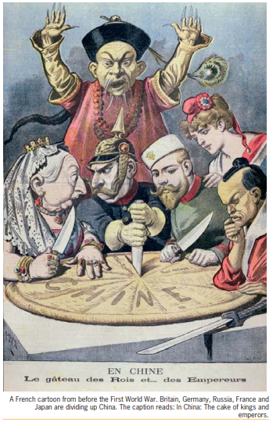
Explain what point the cartoonist is making

What does this tell us about China’s relations with western countries at the time of the Qing Dynasty (when this cartoon was published)

Read the Section on the Guomindang
Who were the Guomindang and what were their achievements

Read the Section on the Long March
What was the Long March?

Despite the loss of 90% of the Red Army it has been described as a success. Can you explain why?

A long with Mao Zedong. Who else in the Communist Party emerged in leadership role?

Read the section on the Impact of the Second World War on China and complete the diagram

Actions of the Guomindang which helped the Communists

How did the Second World War help the Communists?

Actions of the Communists
Actions of the Japanese which helped the Communists

Watch https://www.youtube.com/watch?v=1Wb6P8lI8xY How did Communism start in China? The war that changed the world.
Complete the activity below as you watch.
Explain how the war with Japan impacted each of the following. Try and give specific examples where possible.
Chang Kai-shek and the Guomindang/Nationalists

Mao and the Chinese Communist Party

China and the Chinese people

Chinese views of western countries

