

Year 11 > 12 Bridging Work
Summer Term 2026
Subject | Physical Education
Course | A-Level
Awarding Body | Edexcel
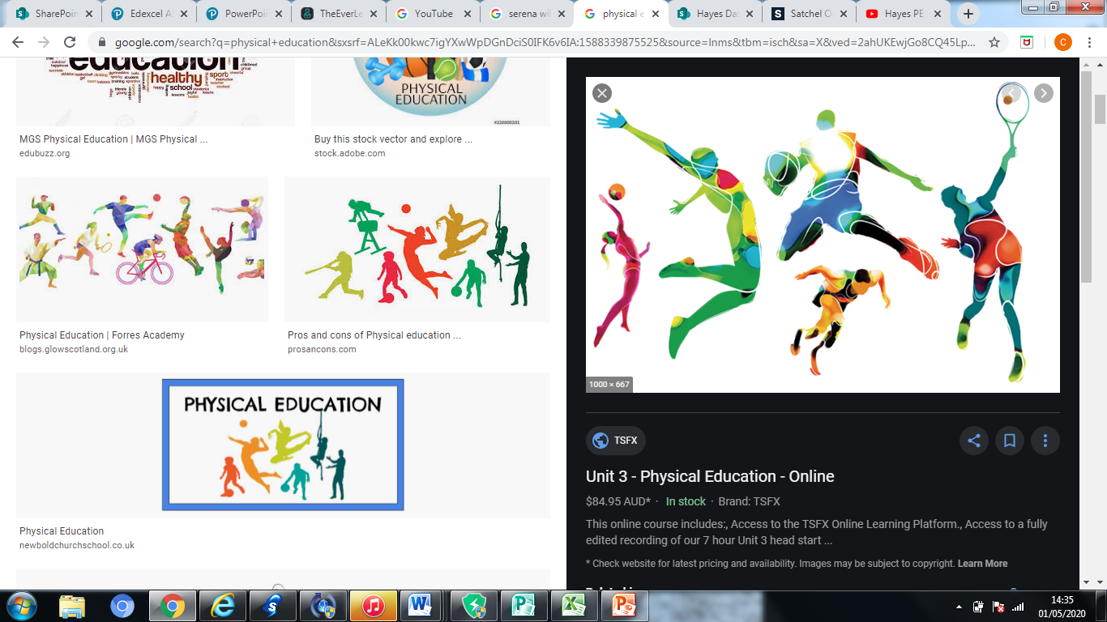

Contents:
 |  | Page(s)
 | Course/specification overview | 3-5
 | Our department expectations | 6
 | Watch | 7-8
 | Listen to | 9
 | Read | 10
 | Research | 11-13
 | Complete | 14-15

Course/specification overview

A Level PE is a linear course and will be studied over two years. Below is the specification overview. If you click on the links it will take you to the AQA specification online.

Subject content (click on links below)
- 1. Applied anatomy and physiology
- 2. Skill acquisition
- 3. Sport and society
- 4. Exercise physiology
- 5. Biomechanical movement
- 6. Sport psychology
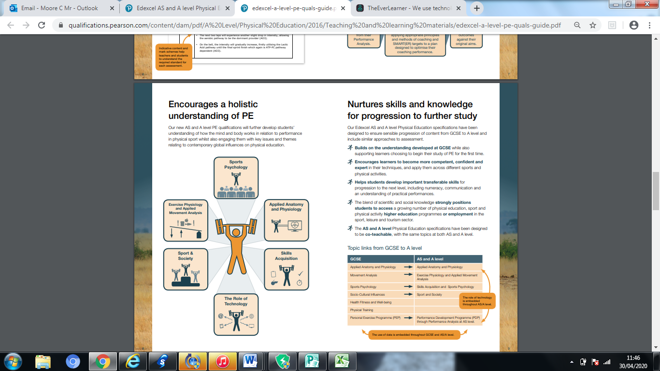
- 7. The role of technology in physical activity and sport
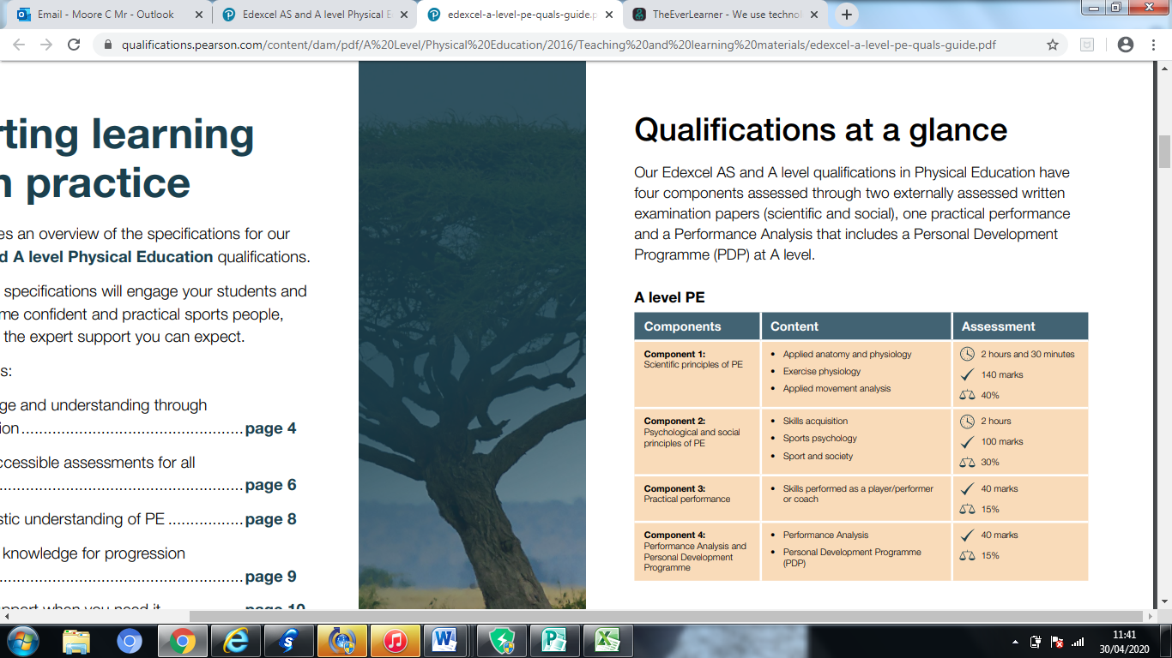
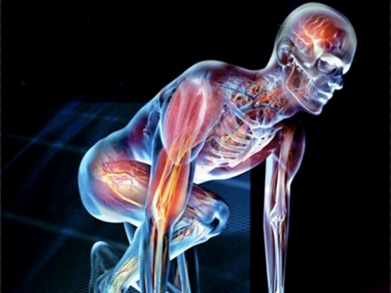
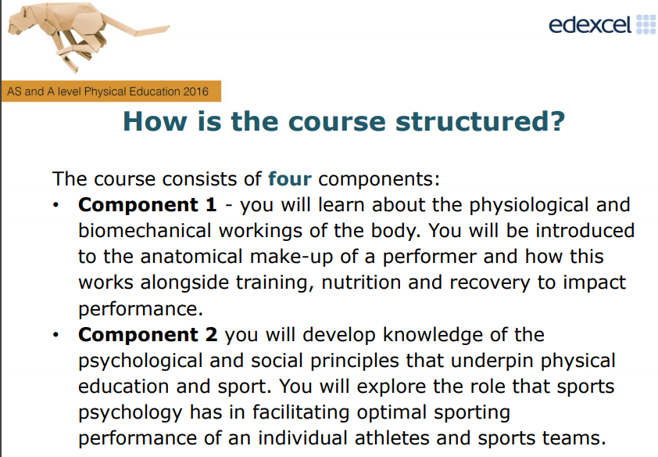
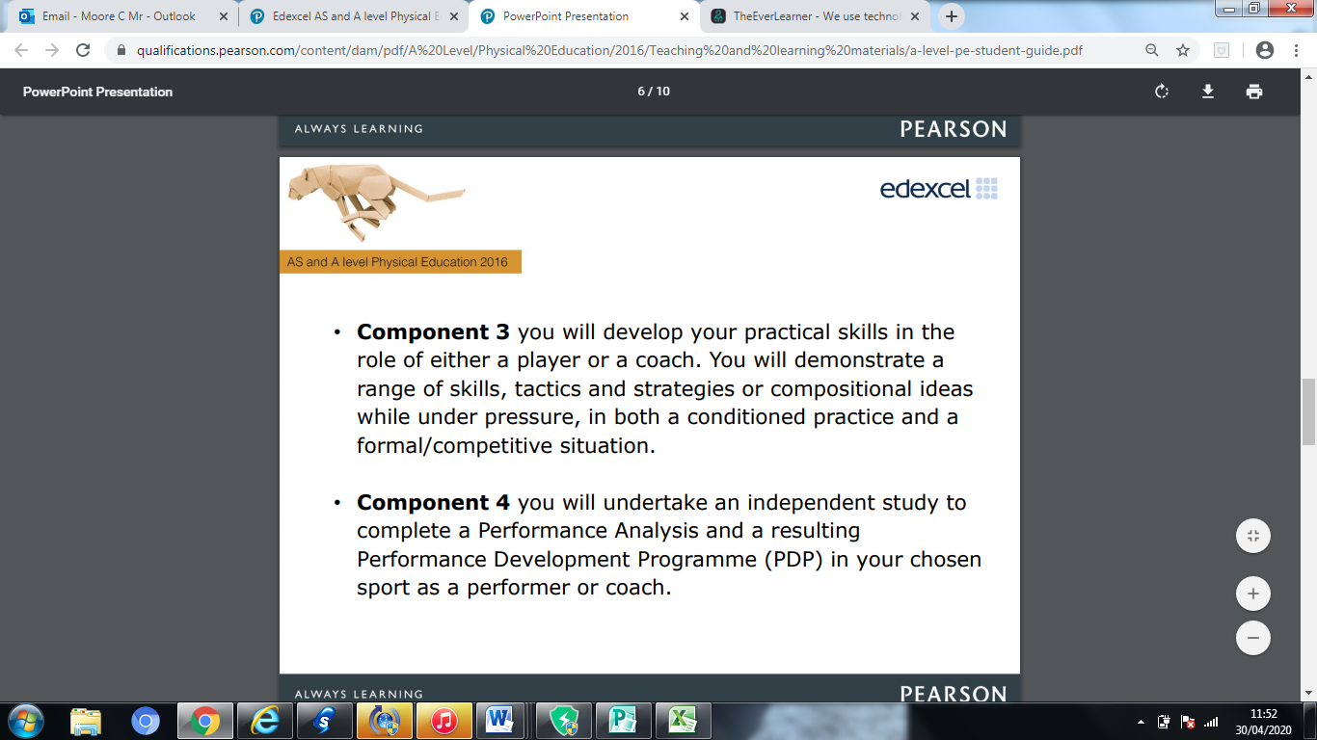

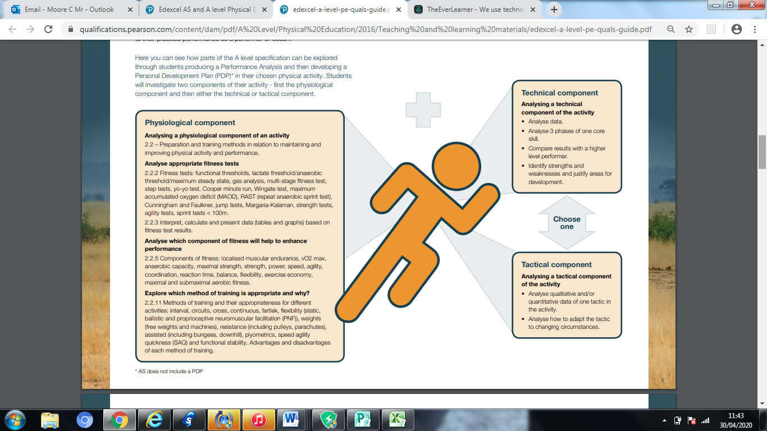

Our department expectations

Have at least a 97% or higher attendance to lessons.
It is important that you attend all lessons as this will allow you to gain the knowledge you need to complete the course. Reading around the subject to develop your knowledge is also recommended.

Work at or above your target grade in homework and module tests.
Complete work set on the Everlearner. You will need to also ensure you use the Everlearner effectively for independent learning
Complete ALL homework and classwork even if you are absent from lessons.

Participate in extra-curricular sport and have a commitment to an active healthy lifestyle.
It is vital that you take part in a sport on a regular basis, at least once a week. This will help with your final assessment and it shows your commitment to sport. Your final assessment will either involve video evidence or a live moderation of one sport looking at skills in isolation and competitive performances
Attend PE moderation if called by exam board. Moderation of your practical is compulsory and part of your exam. It is a requirement of the exam board that you attend.
Attend mock and final practical assessments.

Read around the subject. It is vital that you not only complete the work you are set but you read about each of the topics you are working on. This will not only help you understand the work being covered it will also give you valid examples to use in your answers. See possible articles to read below.

The following pages outline several resources that you can use to start your knowledge for the topics covered in A Level PE. You will find podcasts to listen to, YouTube clips and TED talks to watch and books/articles to read. It is not vital that you complete them all, but it will help with information and knowledge relating to A Level PE before you start the course in September. You should be able to click on the link and this will take you to the relevant resource.

Watch

TED Talks

Watch this TED talk with Martin Hagger who is a Professor of Psychology at Curtin University.
Martin will provide an overview of the kinds of techniques that elite athletes use to prepare psychologically for their sport, give details of the scientific research into these techniques and how they work, and how the techniques might be used by competitive athletes and coaches to maximise performance.
https://www.youtube.com/watch?v=yG7v4y_xwzQ

Watch this TED talk in which Valorie Kondos Field, long-time coach of the UCLA women's gymnastics team, shares the secret to her success. Hint: it has nothing to do with "winning."
Why Winning doesn’t always equal success
https://www.youtube.com/watch?v=JJyeKiT8g4g

Watch this TED talk in which Diana Nyad tells her inspirational story.
In the pitch-black night, stung by jellyfish, choking on salt water, singing to herself, hallucinating ... Diana Nyad just kept on swimming. And that's how she finally achieved her lifetime goal as an athlete: an extreme 100-mile swim from Cuba to Florida at age 64. Hear her story.

Watch this TED talk in which David Epstein discusses the role of technology in sport and how the sporting body type and shape has evolved.
When you look at sporting achievements over the last decades, it seems like humans have gotten faster, better and stronger in nearly every way. Many factors are at play in shattering athletic records, and the development of our natural talents is just one of them.
https://www.youtube.com/watch?v=8COaMKbNrX0

Television
Gamechangers (Netflix) – A really interesting film which looks at uncovering the truth about meat, protein and strength, showcasing elite athletes and cutting edge science.
Icarus. 2017- A film around doping within sport and current issues surrounding the use of drugs within sport.
Stop at Nothing 2014 – Filmmaker Alex Holmes creates an explosive portrait of disgraced cyclist Lance Armstrong.
Live Sporting Events- This will support how you show your understanding by using current examples from sport.
YouTube Clips
- Venous Return https://www.youtube.com/watch?v=J80hhCkLuaA

- Stages of Learning https://www.youtube.com/watch?v=n7UcobScnck

- The ancient origins of the Olympics https://www.youtube.com/watch?v=VdHHus8IgYA

- Diet and Supplements https://www.youtube.com/watch?v=pBAPapMCRIo

- Newton’s Laws https://www.youtube.com/watch?v=08BFCZJDn9w
https://www.youtube.com/watch?v=e1lzB36aHD4
https://www.youtube.com/watch?v=qu_P4lbmV_I

- Aggression in Sport https://www.youtube.com/watch?v=DlrTha8cbAI

- Doping in athletics https://www.youtube.com/watch?v=NLfbqqAEKwo

- BBC Lionesses World Cup 2019 https://www.youtube.com/watch?v=y_OaFsaY-ck

- "Is Professionalism Killing Sport?" https://www.youtube.com/watch?v=h8eKMdHxig8

- The Kobe Bryant short animated film - https://www.youtube.com/watch?v=8Q1LSZc4hDg
https://www.youtube.com/watch?v=J3N5HewglNs

- Tom Browns School days https://www.youtube.com/watch?v=-jXaGC4Ta_4

- Addicted to Protein https://www.youtube.com/watch?v=sxy6mYW94ws

Listen to


Listen to this radio programme from the BBC World Service. Sports Hour is a lively Saturday morning sports show with reports, debate and humour. There are over 280 shows available covering all world sport.
BBC World Service: Sports hour

Listen to this radio programme.
This is a daily podcast bringing you the latest from the Premier League, EFL, European football and more.
BBC Radio 5 live
Talksport radio

Listen to this podcast with ex professional footballer Peter Crouch which documents his experiences as a professional footballer

The Peter Crouch Podcast

Listen to this podcast from the British Journal of Sports Medicine. It covers all sorts of aspects of Sports Medicine, from the science behind running shoes to the power of sleep.

BJSM Podcast

Read
Reading List
Books
Clegg, C. 1995. Exercise Physiology and Functional Anatomy. Feltham Press
Walder, P. 1998. Mechanics and Sport Performance. Feltham Press
Honeybourne, J. 2006. Acquiring Skill in Sport: An Introduction. Routledge
Bean, A. 2017. The Complete Guide to Sports Nutrition. Bloomsbury Publishing.
Gareth Thomas Proud – Autobiography of Britain’s first openly-gay professional rugby player
Tyson Fury Behind the Mask – Tyson opens up about his life, career and struggles with mental health. A real inspirational story
Serena Williams My life – Story of arguably the greatest female tennis players of all time. An inspirational story.

Read this article which explores the impact that coronavirus has had on global sport
https://www.weforum.org/agenda/2020/04/sports-covid19-coronavirus-excersise-specators-media-coverage/
Read this article which explores the science behind wearing a helmet in sporting activities and how helmets are there to stop brain fracture and not concussion.
Football helmets don't protect against concussion - and we're not sure what does

Read this article
which explores some of the key gender issues in sports.
Sports are designed around men - and that needs to change
Ideas TED

Read this article
Which looks at the 6 technological advancements that have changed the face of sport
https://www.workinsports.com/blog/six-technological-advancements-that-have-changed-sports/
Research

Scholarly Articles
Polley, M. 2008. ‘The amateur rules’: Amateurism and professionalism in post-war British athletics. Contemporary British History, pages 81-114.

Quennerstedt, M. Ohman, M & Armour, K. 2014. Sport and exercise pedagogy and questions about learning. Sport, Education and Society, pages 885-898.

Alexandris, K. Tsorbatzoudis, C. & Grouios, G. 2017. Perceived Constraints on Recreational Sport Participation: Investigating their Relationship with Intrinsic Motivation, Extrinsic Motivation and Amotivation, Journal of Leisure Research, pages 233-252.

Zaichkowsky, L. 2004. Arousal in Sport. Applied Psychology.

Weinberg, R. S. (2002) Goal setting in sport and exercise: Research to practice. Exploring sport and exercise psychology, pages 25-48.
Tomas M and Burns P (2016)The effect of strength training on muscle mass (hypertrophy)
https://www.ncbi.nlm.nih.gov/pmc/articles/PMC4836564/

Moraska A (2005) A comprehensive look at sports massage
https://www.researchgate.net/profile/Albert_Moraska/publication/7535422_Sports_massage_A_comprehensive_review/links/0912f5093f2c326722000000.pdf

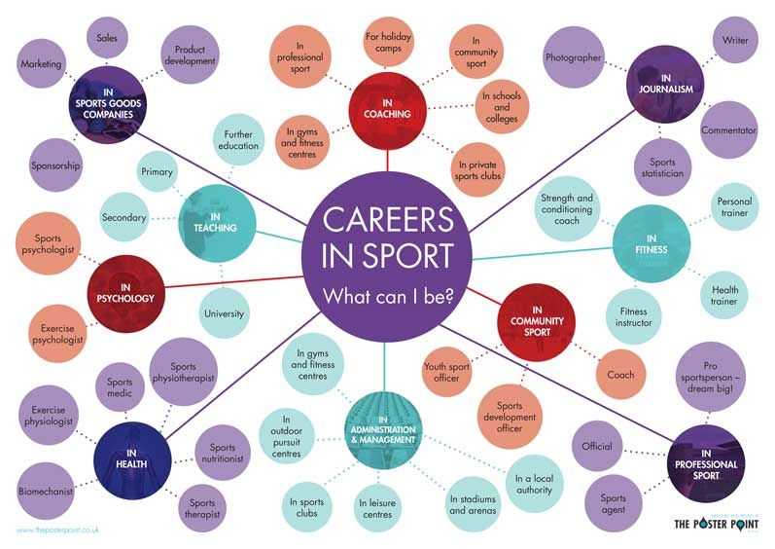
Career opportunities – Have a look through some of these articles and prospectuses to see where a career in sport could take you.

Information and research on sports related careers

https://www.bachelorsportal.com/articles/606/bachelors-degrees-in-sports-and-related-careers-are-a-slam-dunk-for-future-professionals.html

Example of Sports Science degrees at Leeds University -
https://www.youtube.com/watch?v=aaP1PF5Btq8
What is Sports Management? –
https://www.youtube.com/watch?v=of-poWTX5NQ
Working alongside the Manchester City Physiotherapist -
https://www.youtube.com/watch?v=Zu1EKF_dNVk
A day in the life of a Sports Psychologist -
https://www.youtube.com/watch?v=C1K1ySWCS6s

Meet the strength and conditioning coach for Harlequins –
https://www.youtube.com/watch?v=VXv3UAfZ4m4
Sports Nutritionalist and Personal Trainer -
https://www.youtube.com/watch?v=kO6Y9ZXpsGY
Sports Coaching and Physical Education -
https://www.youtube.com/watch?v=v5fdXdgC6tY
BSC Sports Therapy at the University of East London -
https://www.youtube.com/watch?v=bRY9nhPWfU8

Complete

Tasks – to be completed and brought with you to the first lesson in September.
Task 1- Anatomy and Physiology task
Levers in Sport- using the YouTube clip below for background information and recapping from GCSE level, complete a table to demonstrate knowledge and understanding of levers within sport.
https://www.youtube.com/watch?v=d1wS_OlJzmI
Lever Type | 1st class lever | 2nd class lever | 3rd class lever
Diagram of lever

Where it can be found in the body – provide two examples
Give 2 examples of where the lever system can be used in sport
What is the mechanical advantage of the lever system
What is the mechanical disadvantage of the lever system

Task 2 – Skill Aquisition
Theories of Learning- research the following four theories of learning. Create a power point presentation highlighting the key features of the theory, how this might relate to learning within sport and the positives and negatives of the theories application within sport.
- Operant conditioning
- Observational learning
- Social development theory
- Insight learning

Task 3 – Sport in Society
Increasing participation in sport- create a promotional video/advert for one of the national partners aiming to increase participation in sport. In the video/advert include the aims of the partner, the benefits to increasing participation and outline strategies already in place.

Task 4 – Exercise physiology
Design 3 different training programs; one for a marathon runner, one for a long jumper and one for a shot putt thrower. Justify your choices of the key training methods you have applied within the program.
- You will need to research and include the components of fitness for each athlete
- You will need to research and include the different principles of training that you would use
- You will need to select the fitness tests most appropriate for your athlete and discuss when you would test their fitness in your plan

Task 5 - Biomechanics
Calculate the speed of Usain Bolt in the 100m.
Time= 9.58 seconds
Calculate the speed of Mo Farah in the 5000m.
Time= 12 minutes 53 seconds
Calculate the speed of Allyson Felix in the 400m
Time= 49.26 seconds

Task 6 – Sports Psychology
Complete the personality test.
https://www.quietrev.com/the-introvert-test/
Explain the role personality plays on sporting performance.

Task 7 – Performance analysis
Watch a sporting match of your choice. Create a notational analysis table including the keys skills demonstrated within the game. Tally the number of times each skill is completed within a game by one of the individual performers.

