
Year 11 > 12 Bridging Work
Summer Term 2026
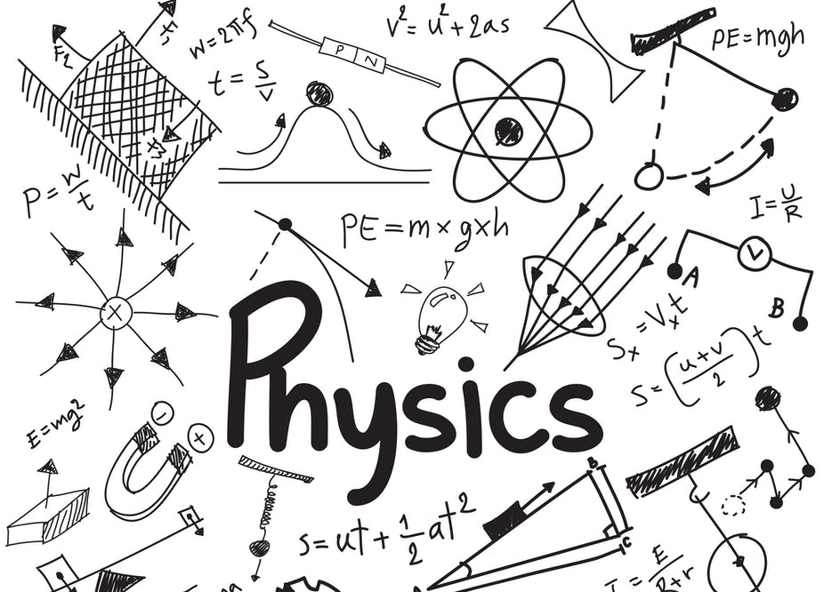

Subject | Physics
Course | A-Level
Awarding Body | OCR (Specification A)

Contents:
 |  | Page(s)
 | Course/specification overview | 3-4
 | Our department expectations | 5-6
 | Review/revise | 7-8
 | Watch | 9-10
 | Listen to | 11-12
 | Read | 13
 | Research | 14
 | Complete | 15
 | Appendices/resources | 16-17

Course/specification overview
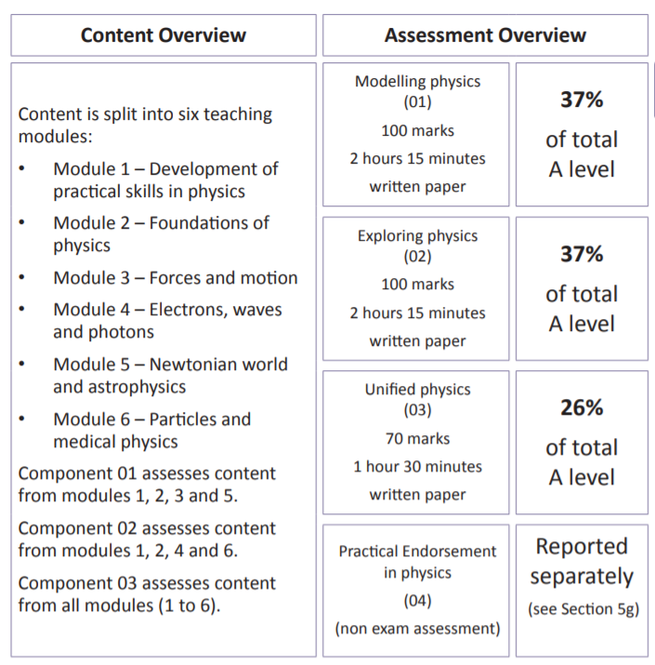
In year 12 you are taught Modules 1, 2, 3, and 4
In year 13 you are taught Modules 5 and 6.
The practical endorsement is covered throughout the 2 years, with the practical tasks being taught where they fit into the content being taught.
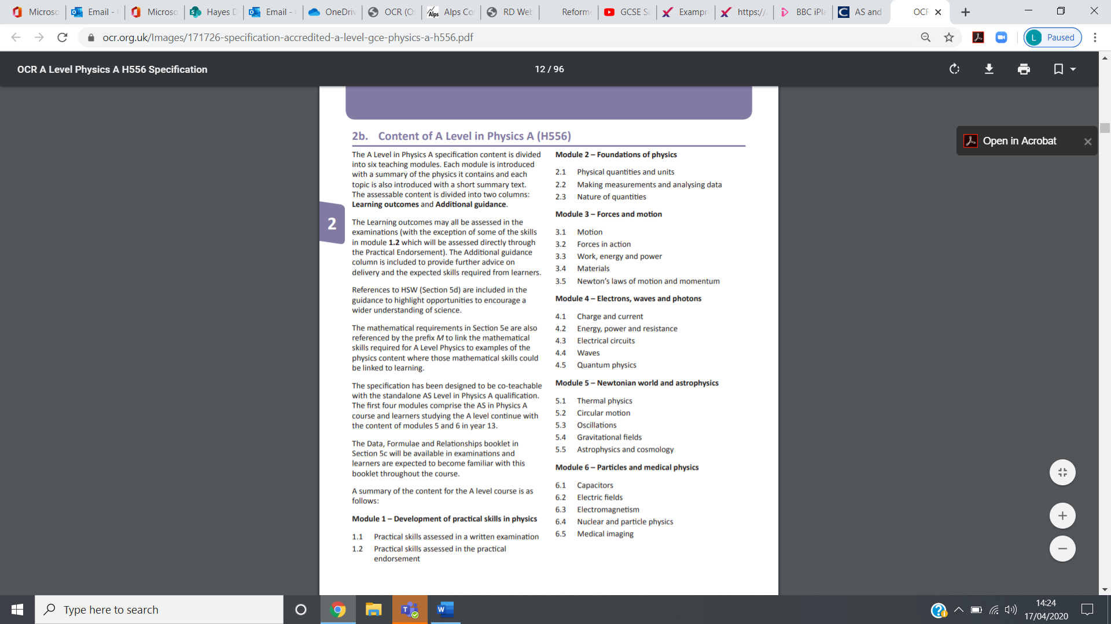
Our department expectations
Lesson expectations and preparation
- Bring an A4 folder with dividers to lesson to organise your work.​
- Print the relevant information to put in your folders.​ This includes
  - The formula booklet
  - The practical handbook
  - Personalised Learning Checklists (PLCs) for the modules they are learning
- Purchase a textbook so they can practice questions (if you receive a bursary use this to purchase the textbook)
- Use the textbook to complete the pre-reading tasks before the lesson.

Required Practicals (‘PAGs’)
- Complete practical preparation work (using checklist), including:
  - Write up practical / PAG plan before coming to the lessons (method can then be amended from experience of the practical)
  - Include risk assessment
  - Include labelled apparatus diagrams (where appropriate)
  - Identified potential sources of error and uncertainty (where appropriate)
- Complete the method amendments, analysis and evaluation of practical tasks in PAG books after the lesson.

Independent study
- Review the topic covered in class and make a set of condensed class notes. ​
- Practice questions on the topics they have covered using the textbook and the practise in physics book.
- Check SMHW and emails regularly and complete tasks set.
- Attend Physics problem solving sessions if stuck or advised to.

Assessments
- Develop effective study habits and revise efficiently for your assessments, so you show your true capability in the assessment
- Evaluate their performance on tests and use this to identify areas of improvement. ​
- You will have a bridging unit assessment in September. Part of the assessment will include content covered in your Physics studies at GCSE paper.

Working as a scientist
- Log ins and subscriptions – Isaac Physics, and, eg, New Scientist and similar online magazines
- Reading around subjects and topics / having a wider interest in your field of study
- Read / research about possible careers

Review/revise
GCSE topics covered in more depth in year 12 (from the AQA GCSE Specification)
topics for Separate GCSE Physics shown in red
- Energy
  - Energy Stores and Transfers
  - Kinetic, Gravitational Potential, and Elastic Potential Energy
  - Power
  - Efficiency
- Electricity
  - Current (in series and parallel circuits)
  - Potential Difference (in series and parallel circuits)
  - Resistance (in series and parallel circuits) LDRs and thermistors
  - Power and energy transfer
- Particle Model of Matter
  - Density
- Forces
  - Weight, Mass and Gravity
  - Resultant Forces
  - Work Done
  - Forces and Elasticity
  - Moments
  - Fluid Pressure
  - Upthrust
  - Scalars and Vectors
  - Acceleration
  - Motion Graphs
  - Newton’s Laws of Motion
  - Momentum (including changes in momentum and momentum calculations)
- Waves
  - Transverse and Longitudinal Waves
  - Features of a Wave
  - Wave Speed
  - Refraction
  - Electromagnetic Waves
GCSE topics covered in more depth in year 13 (from the AQA GCSE Specification)
topics for Separate GCSE Physics shown in red
Energy
  - Specific Heat Capacity
- Electricity
  - Electric Fields
- Particle Model of Matter
  - Internal Energy
  - Specific Latent Heat
  - Particle Motion in Gases
- Waves
  - Black Body Radiation
  - Ultrasound
- Atomic Structure
  - Radioactivity
  - Activity and Half-life
  - Nuclear Fission and Fusion
- Magnetism and Electromagnetism
  - Magnetic Fields
  - Electromagnetism
  - The Motor Effect
  - The Generator Effect
  - Transformers
- Space Physics
  - Life Cycles of Stars
  - The Solar System and Orbits
  - Red-shift and the Big Bang

Watch
Hopefully you’ll get the opportunity to soak up some of the sun’s rays over the summer – synthesising some important Vitamin D – but if you do get a few rainy days where you’re stuck indoors here are some ideas for films to watch or clips to find online.
Science fiction and other science genre films (in no particular order)
1. Moon (2009)
2. Gravity (2013)
3. Interstellar (2014)
4. The Imitation Game (2015)
5. The Prestige (2006)
6. 2001: A Space Odyssey (1969)
7. The Martian (2015)
8. Apollo 13 (1995)
9. Hidden Figures (2016)
10. The Theory of Everything (2014)
11. Primer (2004)
12. Contact (1997)
13. The Day After Tomorrow (2004)
14. Sunshine (2007)
15. Arrival (2016)
16. Copenhagen (BBC production, 2002)
17. Einstein and Eddington (HBO production, 2008)
18. Radioactive (2019)
19. Chernobyl (HBO series, 2019)
20. Don’t Look Up (2021)
21. WALL-E (2008)
22. Particle fever (2013)
23. The Expanse (Prime, 2016-2022)
Online Clips / Series
1. Minute Physics – Variety of Physics questions explained simply (in felt tip) in a couple of minutes. Addictive viewing that will have you watching clip after clip – a good one is “Why is the Sky Dark at Night?” https://www.youtube.com/user/minutephysics
2. The Universe – Available on Netflix as of 19/04/20. Documentary series featuring computer-generated imagery and computer graphics of astronomical objects in the universe plus interviews with experts who study in the fields of cosmology, astronomy, and astrophysics.
3. The Most Unknown – Available of Netflix as of 19/04/20. Documentary that sends nine scientists to extraordinary parts of the world to uncover unexpected answers to some of humanity's biggest questions. How did life begin? What is time? What is consciousness? How much do we really know?
4. The Sky at Night - Available on BBC iPlayer from April 2020. Monthly episodes on space and astronomy, discussing what you can see in the sky, astrophysics and cosmology. https://www.bbc.co.uk/programmes/b006mk7h
5. Shock and Awe, The Story of Electricity – A 3 part BBC documentary that is essential viewing if you want to see how our lives have been transformed by the ideas of a few great scientists a little over 100 years ago. The link below takes you to a stream of all three parts joined together but it is best watched in hourly instalments. (alternatively watch any Horizon documentary – look for on Netflix and the I-Player) https://www.youtube.com/watch?v=Gtp51eZkwoI
6. NASA TV – Online coverage of launches, missions, testing and the ISS. Plenty of clips and links to explore to find out more about applications of Physics in Space technology. http://www.nasa.gov/multimedia/nasatv/
7. The Fantastic Mr. Feynman – I also recommend the book. See the life’s work of the “great explainer”, a fantastic mind that created mischief in all areas of modern Physics. https://www.youtube.com/watch?v=LyqleIxXTpw
8. Light and Dark – the programme shows how light has been used to uncover the secrets of the universe. https://www.youtube.com/watch?v=yNntDhr2n4g
9. Sci-Show – General science on a range of very interesting topics https://www.youtube.com/user/scishow
10. Sixty symbols – A whole range of interesting numbers based phenomena explained. https://www.youtube.com/user/sixtysymbols
11. The world according to physics – Lecture that attempts to explain how physics plays a role in everything we do https://www.youtube.com/watch?v=gKrjOD3ZeO0
12. Why dark matter matters! – An attempt to explain why we cannot see the majority of our Universe https://www.youtube.com/watch?v=gE9aFOF-Od8
13. The “WOW” signal – The best evidence that intelligent life exists outside of Planet Earth. https://www.youtube.com/watch?v=x67K-Vq1KWk
14.The secrets of Quantum Physics – the programme investigates the most accurate and yet perplexing scientific theory – quantum physics. https://www.youtube.com/watch?v=voUi8RtmVRw&list=PLL4WDrq7vmPFyJKVgIfYL9ZRNhsvNZwFQ&index=11
15. Various videos explaining Physics phenomena, by Derek Muller on his channel Veritasium: https://www.youtube.com/playlist?list=PLkahZjV5wKe9q3K-nk82kVD_pNfPZ140i

Listen to
Podcast list Royal Institution science podcasts: https://soundcloud.com/royal-institution/sets/ri-science-podcast
Mars Exploration: Curiosity and Beyond, with aerospace engineer Anita Sengupta https://soundcloud.com/royal-institution/mars-exploration-curiosity-and-beyond-with-anita-sengupta-ri-science-podcast-2
Catching Gravitational Waves https://soundcloud.com/royal-institution/catching-gravitational-waves o How does science actually work? https://soundcloud.com/royal-institution/how-does-science-actually-work-ri-science-podcast-xx
Moon, Mars and beyond https://soundcloud.com/royal-institution/moon-mars-and-beyond
The Order of Time, with Carlo Rovelli https://soundcloud.com/royal-institution/the-order-of-time-ri-science-podcast-x
Naked Scientists Astronomy podcasts: https://www.thenakedscientists.com/podcasts/astronomy-podcasts
Remarkable Women: A hidden history https://www.thenakedscientists.com/podcasts/astronomy-podcasts/space-boffins/remarkable-women-hidden-history
Magnificent Mercury: https://www.thenakedscientists.com/podcasts/astronomy-podcasts/space-boffins/magnificent-mercury-bepicolombo
Nature podcasts (from the premier science journal): https://www.nature.com/nature/articles?type=nature-podcast
BBC Science & Nature podcasts: https://www.bbc.co.uk/podcasts/category/scienceandnature
BBC The Life Scientific: https://www.bbc.co.uk/programmes/b015sqc7/episodes/downloads
BBC Inside Science: https://www.bbc.co.uk/programmes/b036f7w2/episodes/downloads
Donna Strickland (the first women to win a Physics Nobel Prize): https://www.bbc.co.uk/programmes/m0002z2z
Clive Oppenheimer on volcanoes: https://www.bbc.co.uk/programmes/m0001hvs
Caroline Hargrove (Formula One engineer): https://www.bbc.co.uk/programmes/m00017s6
Carlo Rovelli on why time is not what it seems: https://www.bbc.co.uk/programmes/b0b1r1cw
Eben Upton about designing the Raspberry Pi: https://www.bbc.co.uk/programmes/b09ly60f
Physics Central: www.physicscentral.com/explore/multimedia/podcasts.cfm
Star-chaeology: the Next Stellar Generation https://www.physicscentral.com/explore/multimedia/podcast.cfm?uid=20160428010716
The Physics behind the Silver Screen https://www.physicscentral.com/explore/multimedia/podcast.cfm?uid=20150225072329
New Scientist (weekly science magazine) podcasts: https://www.newscientist.com/podcasts/
Scientific American (premier science journal) 60-second science podcasts: https://www.scientificamerican.com/podcast/60-second-science/
Talk Nerdy with Cara Santa Maria (US-based science interviewer): https://www.carasantamaria.com/podcast/
Story Collider (explores everyday experiences of science): https://www.storycollider.org/podcasts

Read (GCSE level/A-level)
A Short History of Nearly Everything - Bill Bryson

Storm in a Teacup - Helen Czerski

What If - Randall Munroe

Thing Explainer - Randall Munroe

Forces of Nature - Brian Cox

How to Teach Quantum Physics to your Dog - Chad Orzel

Seven Brief Lessons on Physics - Carlo Rovelli

6 Easy Pieces - Richard Feynman

A Brief History of Time - Stephen Hawking

Physics of the Impossible - Michio Kaku

In Search of Schrodinger's Cat - John Gribbin

Relativity Made Relatively Easy - Andrew M.Sterne

Alex's Adventures in Numberland - Alex Bellos

Why do Buildings Fall Down - Mattys Levy and Marto Salvadori

Paradox - Jim Al-Khalili

The Joy of Science - Jim Al-Khalili

The Matter of Everything – Suzie Sheehy (very good on the history of particle physics)

Subscribe to New Scientist (they have digital and print editions).

Research
To get the best grades in A Level Physics you will have to get good at completing independent research and making your own notes on difficult topics. Below are links to 7 websites that cover some interesting Physics topics.
Using the Cornell notes system: http://coe.jmu.edu/learningtoolbox/cornellnotes.html make 1 page of notes for 3 of the sites below covering topics of your choice.
- http://home.cern/about
CERN encompasses the Large Hadron Collider (LHC) and is the largest collaborative science experiment ever undertaken. Find out about it here and make a page of suitable notes on the accelerator.
- http://joshworth.com/dev/pixelspace/pixelspace_solarsystem.html
The solar system is massive and its scale is hard to comprehend. Have a look at this award winning website and make a page of suitable notes.
- https://phet.colorado.edu/en/simulations/category/html
PhET create online Physics simulations when you can complete some simple experiments online. Open up the resistance of a wire html5 simulation. Conduct a simple experiment and make a one page summary of the experiment and your findings.
- http://climate.nasa.gov/
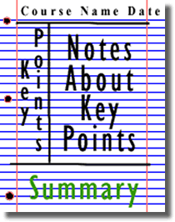
NASA’s Jet Propulsion Laboratory has lots of information on Climate Change and Engineering Solutions to combat it. Have a look and make notes on an article of your choice.
- http://www.livescience.com/46558-laws-of-motion.html
Newton’s Laws of Motion are fundamental laws for the motion of all the object we can see around us. Use this website and the suggested further reading links on the webpage to make your own 1 page of notes on the topics.
- https://physicsworld.com/ The Institute of Physics online magazine, with the most up to date research and articles on Physics. Make notes on one article.
- https://www.sciencedaily.com/news/matter_energy/physics/ Science Daily – a website that keeps you up to date with developments in the physics world.

Complete
Task 1: Issac Physics
Task 2: Book review
Task 3: Cornell notes on Physics topics
Task 4: Careers in Physics

Task 1: Isaac Physics
Use the link below to sign up to Isaac Physics and join the class. https://isaacscience.org/account?authToken=B8U36E

Complete all the questions set for you in this class. You need to complete 5 tasks per week. They are on the following topics​
​
GCSE Revision Topics
- Mechanics (Forces)
  - Speed, distance, and time
  - Motion graphs
  - Acceleration
  - Resultant Force
  - Terminal Velocity
  - Moments
  - Pressure in fluids
  - Momentum
  - Circular Motion
- Electricity
  - Current and charge
  - Potential difference
  - Resistance
  - I-V Characteristics
  - Power
  - Transformers
- Energy
  - Thermal Energy
  - Work, gravitational potential energy, and power
  - Kinetic energy
  - Efficiency
  - Elastic potential energy
- Waves
  - Wave properties
  - Reflection
  - Refraction

Maths Revision Topics
- Using and Re-arranging equations
- Standard Form and Prefixes​
- Gradients and Intercepts of Graphs
- Equations of Graphs​
- Area Under a Line Graph
- Factor and Percentage Changes​
- Proportionality​
​
This part is not compulsory, but I also highly recommend that you sign up to the year 12 mentor scheme (https://isaacscience.org/pages/mentoring). Sign up and you'll get the following:​
- work set each week, relevant to your level;​
- fortnightly tutorials covering this work with an online tutor from the University of Cambridge.​
- the chance to ask our tutors to cover a specific problem you've been having;​
- a certificate at the end of the course if you've attempted at least 60% of the problems set;​
- all work for Year 12s can go towards your application for the Senior Physics Challenge.​

Task 2: Book Review
Pick one of the books from the reading list, read it, and write a book review for the book. This should include the following points and be between 1 and 3 paragraphs long.
- why you enjoyed reading this book
- any interesting facts/insights you have learned/gained from this book
- the people you would recommend this book to e.g. this would be a good book for you if you like…

Task 3: Cornell Notes
Using the Cornell notes system: http://coe.jmu.edu/learningtoolbox/cornellnotes.html make 1 page of notes 3 of the sites in the research section covering topics of your choice.

Task 4: Careers in Physics
Using the careers sites (https://nationalcareers.service.gov.uk/job-categories/engineering-and-maintenance , https://nationalcareers.service.gov.uk/job-categories/science-and-research ,and other reliable sources) to find a in physics career option that interests you, and fill in the Careers Research Template (found in the resources/appendices section) for your chosen career.

Appendices/resources
Good places for resources are:
Headstart to A-level Physics: Useful transition book introducing one of the content for the A-level
https://www.amazon.co.uk/Head-Start-level-Physics-Level/dp/1782942815
Revision Guides and textbooks:
https://www.amazon.co.uk/level-Physics-Student-ActiveBook-Science/dp/144799082X/ref=sr_1_5?dchild=1&keywords=a+level+physics+ocr+a&qid=1587585661&sr=8-5
https://www.amazon.co.uk/New-Level-Physics-2018-Complete/dp/1789080398/ref=sr_1_3?dchild=1&keywords=ocr+a+revision+guide+physics+a+level&qid=1587585746&sr=8-3
A-Level Physics Online: https://www.alevelphysicsonline.com/ocr-spec-a
This site has videos on all the A-level topics for our specification (OCR A), and the year 12 content (Modules 1-4) is free.
Physics and Maths Tutor: https://www.physicsandmathstutor.com/ and https://www.physicsandmathstutor.com/physics-revision/a-level-ocr-a/
This site has GCSE and A-level sections with revision notes on topics, and practice questions. You can pick GCSE topics you need to brush up on, or try some of the A-level questions using the revision notes to help you.

Careers Research Template
Name:

Career of Interest:

Explanation of the Career: What does these people do as there day to day role.

Qualifications for this career:
e.g. Degree in ….
For this degree I need A-levels in … and …
If I study this degree at … University I will need to achieve the grades XXX.

Skills for this career:

What attributes would make you good at this career?

Why does this career interest you?

