

Year 11 > 12 Bridging Work
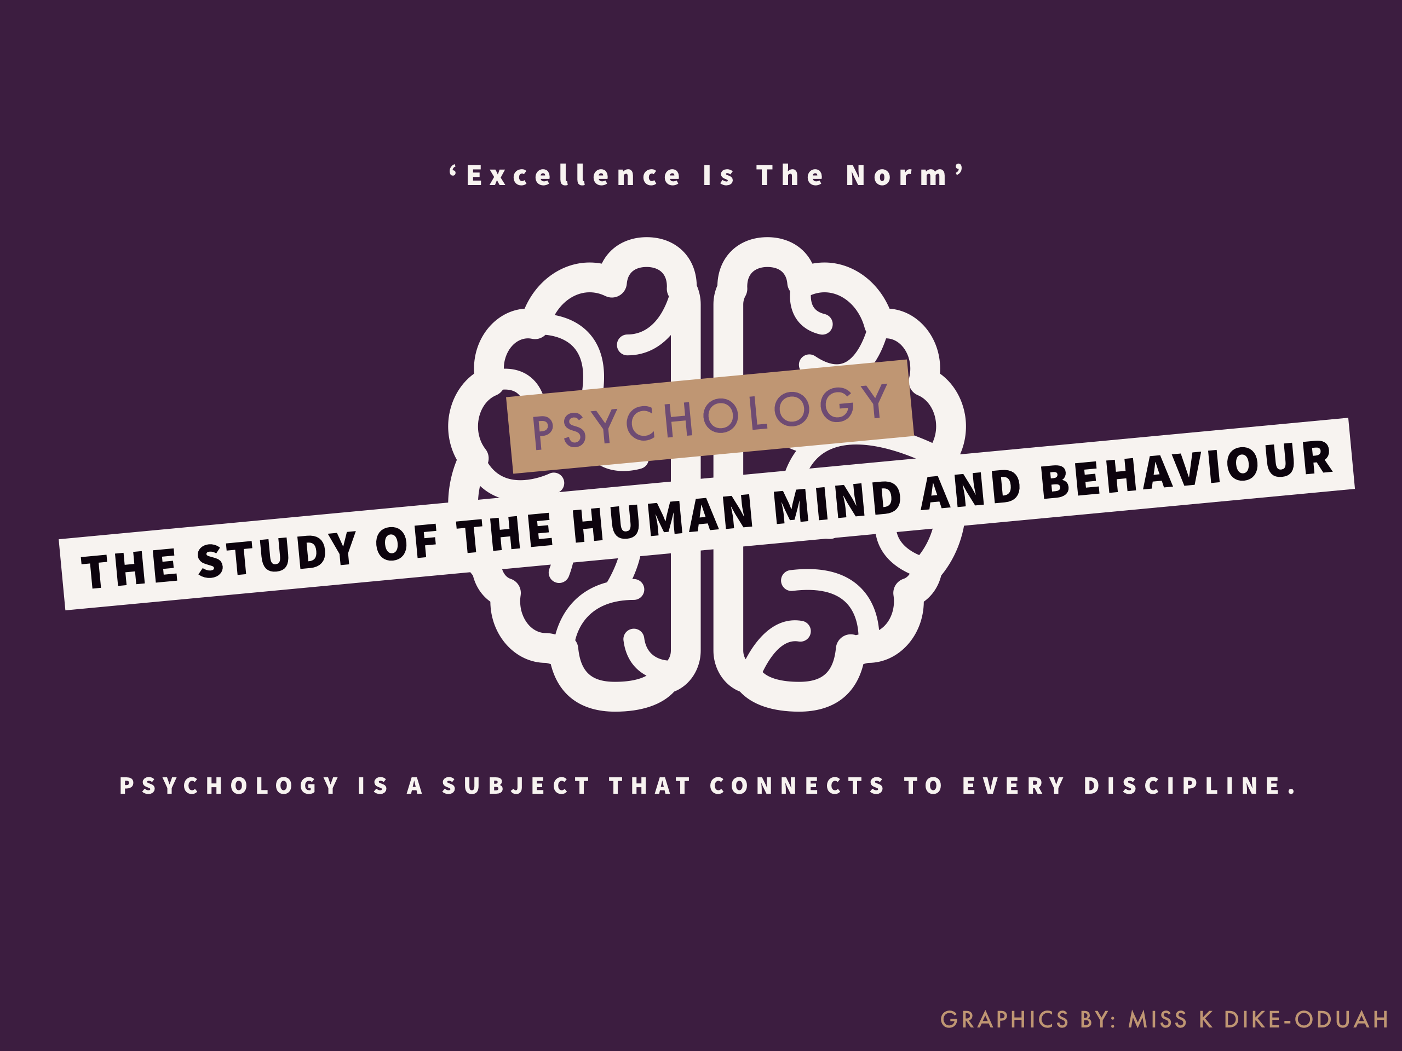
Summer Term 2026
Subject | PSYCHOLOGY
Course | A-Level
Awarding Body | AQA

Contents:
 |  |  | Page(s)
 | Course/specification overview |  | 3
 | Our department expectations |  | 4
 | Compulsory pre-course bridging tasks |  | 5
 | Watch (optional) |  | 7
 | Listen to (optional) |  | 9
 | Read (optional) |  | 10
 | Research (optional) |  | 10
 | Task Check |  | 11
 | Appendices (optional) |  | 12
 |  | Course/specification overview

Why study Psychology?
Psychology is the scientific study of the mind and behaviour. Psychologists develop explanations and theories to help them to predict people’s behaviour in different situations. These theories or explanations are tested by psychologists using research studies. You will learn to develop a keen grasp for the scientific nature of psychological research, including how it should be conducted, analysed and reported.
Summary of Curriculum
Year 1:
You will sit 2 formal internal mock examinations during year 12, both of which will be 1 hour and will be combined to produce a final grade for Year 12. The exams will contain a mixture of multiple choice, short answer and extended writing questions, up to 16 mark answers.

In year 1 we will study all of the topics examined in papers 1 and 2.
Year 2:
For the full A Level in psychology, which is sat at the end of year 13, students will sit 3 exams, each for 2 hours and each worth 33.3% of the final grade. These will be written exams with a mixture of multiple choice, short answer and extended writing questions. There will be one formal period of mock examinations in year 13 where you will sit two papers.

In year 2 we will study all of the topics examined in paper 3.

Paper 1 topics - Introductory topics in psychology:
Students will be assessed on Social influence, Memory, Attachment and Clinical Psychology.

Paper 2 topics - Psychology in context:
Students will be assessed on Approaches in psychology, Biopsychology and Research methods.

Paper 3 topics - Issues and options in psychology:
In this paper you will be assessed on Issues and Debates in psychology, Relationships, Schizophrenia and Forensic Psychology.

Our department expectations
The Psychology department aims to develop courageous, intellectual, contemporary psychologists.
We expect the following from all students of Psychology:
- Respect
  - Respect must be given to both teachers and students in the department.
  - Respect is displayed in how you communicate with teachers via email and in person. We expect good manners in all interactions.
  - Respect is seen in how you interact with students in class, including listening and respecting all views when engaging in class discussions.
- Organisation and time management: You must have the following equipment for this course:
  - A copy of the course textbook (see ‘Read’ section)
  - An A4 lever arch file to store completed topics at home
  - A small A4 ring binder/ Folder which must be brought to school everyday to hold your current topic work
  - Subject dividers for EACH topic in Psychology (11 needed in total)
  - Lined Paper
  - Plastic wallets
  - A Calculator
  - Pens, pencils, ruler, eraser and highlighters
- Excellence
  - Excellence is seen in the EFFORT you put into your work in psychology. This includes the time that you give to your studies and the quality of the work that you produce.
  - Mediocrity is not an option in psychology. Doing the bare minimum is not an option. Choose to be excellent.
  - Hayes School’s slogan is ‘Excellent through endeavour’ – the Psychology department’s slogan is ‘Excellence Is The Norm’.
- Engagement
  - Complete ALL classwork to a high standard
  - Complete ALL homework to a high standard and submit on time
  - Participate in all class activities

- Be a Psychologist
  - Take psychology into every area of your life. Once you start psychology, you should actively use it in your everyday life.
  - Use the specialist terminology in your everyday conversations.
  - Share what you have covered in psychology with those outside of your course.
4 Compulsory pre-course bridging tasks

Below are 3 compulsory tasks to complete to help prepare you for the Psychology A Level course. These should be hand-written (unless you have access to a computer for exams).
They will take approximately 3 hours.
You must bring all 4 tasks to the first Psychology lesson in September
- Research Task: How do Psychologists explain behaviour?
Over the summer investigate the following key figures from five different Approaches in Psychology (Approaches are different ways of explaining human behaviour and are covered extensively in the course):
1. Sigmund Freud (Psychodynamic Approach)
2. B.F. Skinner (Behaviourist Approach)
3. Elizabeth Loftus (Cognitive Approach)
4. Hans Selye (Biological Approach)
5. Abraham Maslow (Humanistic Approach)
(a) Write a 150 word summary on each Psychologist, explaining what and how they have contributed to our understanding of human behaviour. Do not use chat GPT, research it carefully and pick out only the key points on each – summarising is an important aspect of this course.
Challenge – for each approach can you give an example of how one key concept can be applied to your own life?
(b) Your next part of the task is to analyse the case of ‘K’ below using these different psychological approaches. Begin by reading the extract below:
Here is an extract from a brief psychological assessment made by a psychiatrist:
‘K’ is a 30-year old man who has had a long history of violence. He was most recently arrested (for the fifth time) for an attack on another man in a crowded pub. ‘K’ claimed that the man had knocked his drink and laughed about it. At the time of the arrest, ‘K’ was found to have abnormally high levels of testosterone (as well as high blood alcohol level). He reported many experiences of seeing his father being aggressive and suffered himself in the form of beatings. ‘K’ said very little about his mother, who appeared to have been absent during this time, although this did not seem to be a concern for ‘K’. ‘K’ was excluded from school on many occasions for bullying other children. If ‘K’ had a philosophy on life, and it is ‘never show weakness to others’.
Then state how at least 2 of the approaches/ psychologists would explain the causes of K’s behaviour and give evidence from the extract to support your point e.g. ‘The biological approach would suggest that K’s aggression is due to an imbalance of hormones as in the extract it states …’
2. Introducing Research Methods part 1: Ethics mind map
Ethical issues arise when studying the human mind. Investigate these and create a mind map of the main ones (deception, confidentiality, informed consent, right to withdraw, protection from harm) – giving a sentence on each explaining why they are of concern for psychologists conducting research. Use the following websites:
https://www.tutor2u.net/psychology/reference/ethical-issues-of-psychological-investigation
https://www.simplypsychology.org/Ethics.html
3. Introducing Research Methods part 2: Psychological Methods
Psychologists do not draw conclusions about human behaviour based on their personal experience or subjective opinion. They conduct research studies. However, there are flaws to every piece of research. Unlike in other sciences, we cannot control every part of our experiments in Psychology because we are dealing with humans, which makes it hard to be robustly scientific.

Form a table like the one below summarising some of the main research methods used by Psychologists, give one strength and one weakness of each method. The study notes on tutor 2 U website are a good starting point for this, they are at the bottom of the page so scroll down and click on the orange icons that look like this:



https://www.tutor2u.net/psychology/collections/a-level-psychology-study-notes-research-methods

Method | Brief description | Strength/ advantage | Weakness/ disadvantage
Lab experiment | Conducted under controlled conditions,  researcher deliberately changes IV to see the effect of this on the DV | High level of control | Lacks ecological validity – findings may not be generalised to real life
Field experiment
Natural observation
Interview
Questionnaire
Case study

Watch (optional)
Netflix
There are some really great Psychology series on Netflix, perhaps have a look at the following: (1) Babies (2) The Mind, Explained (3) 100 humans, life’s questions, answered, (4) Babies (5) Mindhunter (6) The murder of Rachel Nickell
TED talks
There are many, many TED talks on Psychology, but here are some of my favourites. Try to watch a few of them to spark your interest in Psychology:
- Steven Pinker – Human nature and the blank slate
- Oliver Sacks – What hallucination reveals about our minds
- Philip Zimbardo – The psychology of evil
- Scott Fraser – why eyewitnesses get it wrong
- Andrew Soloman – The struggle of mental health

- Elyn Saks – A tale of mental illness from the inside
- Read Montague – what we’re learning from 5000 brains.
- Ben Ambridge - 10 myths about Psychology, debunked.
- Jon Ronson - Strange answers to the psychopath test
- Ben Goldacre - Battling Bad Science
- Keith Barry – Brain magic
- Carol Dweck - The power of believing that you can improve

Movie recommendations:

We need to talk about Kevin (2011)
Based on the novel by Lionel Shriver (which you could read instead), the film focuses on the mother of Kevin who is struggling to come to terms with her son and the mass school shooting that he has committed. An interesting consideration of nature vs nurture.

Girl, Interrupted (1999)
Based on writer Susanna Kaysen's account of her 18 month stay at a mental hospital in the 1960s. This film questions what it means to be sane.

As good as it gets (1997)
Looks at what life is like when you live with OCD.
The Stanford Prison Experiment (2015)
Film that is based on Philip Zimbardo’s research, which you will be briefly studying in year 12. Twenty-four male students were selected to take on randomly assigned roles of prisoners and guards in a mock prison situated in the basement of the Stanford psychology building.
Good Will Hunting (1997)
Will Hunting, a janitor at M.I.T., has a gift for mathematics, but needs help from a psychologist to find direction in his life. Considers the impact of attachment problems in later life.
Memento (2000)
A man with total memory loss creates a strange system to help him remember things; so he can hunt for the murderer of his wife without his short-term memory loss being an obstacle.
12 Angry Men (1957)
A jury member holds out in his attempt to prevent a miscarriage of justice by forcing his colleagues to reconsider the evidence. Demonstrates the qualities necessary for persuasion and influence which is considered within the field of Social psychology.

Listen to (optional)

A COLLECTION OF PODCASTS FOR LEARNING ABOUT PSYCHOLOGY

All in the Mind (BBC)
This occasionally updated podcast explores "the limits and potential of the human mind." Recent topics include sibling rivalry, schizophrenia, sleep paralysis, and personality change.
All in the Mind (ABC)
A weekly podcast from Australia that explores the brain and behaviour.
Personality Hacker
This podcast focuses on personal growth by understanding how your mind and personality work and using this understanding to nurture personal relationships.
Psychology In 10 Minutes
This podcast, hosted by Santa Clara University professor David Felman, does exactly what the title implies—presents a quick lesson on a psychology topic in just 10 minutes.
PsychCruch
Episodes focus on how recent findings from psychological studies can make a difference in real-life.
Invisibilia
Invisibilia (Latin for all the invisible things), from NPR, is about the invisible forces that control human behaviour – ideas, beliefs, assumptions and emotions.
60-Second Mind
Minute-long commentaries on the latest news in behaviour and brain research, from Scientific American.
Psychology of attractiveness podcast
“a monthly science show that covers the most interesting and cutting-edge research on the psychology of attraction and relationships.” Produced by Dr. Rob Burriss, a research fellow at Northumbria University in Newcastle, UK

Read (optional)

Recommended introductory reading
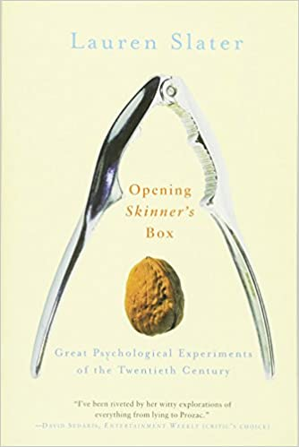
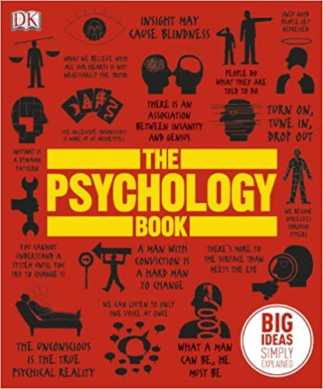
If you want to read a really interesting book which documents some
Some of the most significant (and inspiring) studies conducted in
Psychology try ‘Opening skinners box’ by Lauren Slater. Her book
details many of the most famous studies in Psychology,
investigating the motivations behind the authors and how the
studies were done. A really engaging read.
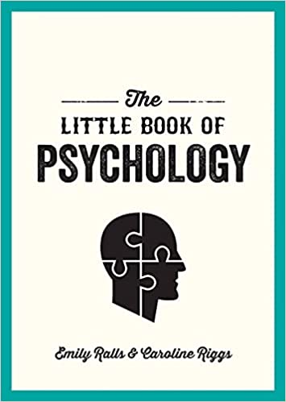

Alternatively try ‘The Psychology Book’ by Richard Benson, which
gives a guide to over 100 Ideas and studies including the
collective unconscious, the “selfish” gene, false memory,
psychiatric disorders, and autism or ‘The little book of
psychology’ which will introduce you to early thinkers who
have shaped Psychology, key studies and recent developments.

Psychology textbook
The class textbook we will be using is ‘AQA Psychology A Level year 1 & AS Student Book’ by Cara Flanagan et al. (2025) which is published by Hachette.
You will need a copy of this and eventually the year 2 book. It costs c. £26.00 for the paper version and £8.50 for the eBook (one year’s subscription which you download via an app on a phone, tablet or computer). I will write to parents in September regarding this.

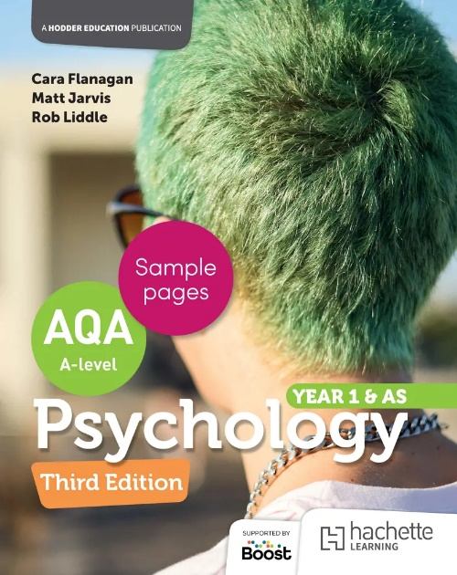

Note: If you are applying for the bursary fund you should use this to purchase the textbook
Research (optional)
Online courses
You might like to complete one (or more) of the following free courses:
Tutor 2 U offer a free course that takes 6-8 hours introducing topics and themes from the AQA A-Level Psychology course, including key approaches and research methods.
https://ondemand.tutor2u.net/students/transition-to-aqa-alevel-psychology-skills-booster?fbclid=IwAR26QWyHVC4CBP1Z7qXgcfclPeP012NhzvvBAmXz5StVXvzaKwkpWPCwT5E
This one is through the open university. It takes around 3 hours to complete:
https://www.open.edu/openlearn/health-sports-psychology/investigating-psychology/content-section-overview-0
Or complete one of the Future learn courses (some of the courses are free), try the ‘Introduction to Psychology’ one to start:
https://www.futurelearn.com/subjects/psychology-and-mental-health-courses/psychology
or Seneca learning has summer prep courses including an introduction to Psychology:
https://app.senecalearning.com/classroom/course/1b7f46e7-060b-4cf7-922b-1829a0013079/section/ee834043-e51b-4897-b5f0-679101e8a929/session
Task check

Before you come to your first lesson in September check you have completed all 4 compulsory tasks and bring them with you (they will be taken in):
- Summary of the 5 Psychologists and used them to explain the case of K
- Mind map of key ethical issues
- Table summarising the main research methods
Ensure you have the following equipment with you so that you are ‘Ready to Learn’:
- An A4 lever arch file to leave at home
- A small A4 ring binder to bring current topic notes to every lesson (Day Folder)
- Subject dividers for EACH sub-topic in Psychology (11 needed in total) – put these in your ‘day folder’
- Lined Paper
- Plastic wallets
- A Calculator
- Pens, pencils, ruler, eraser and highlighters
Appendices/optional activities

Museum Trips

The Science Museum
Exhibitions cover all areas of science and technology, including Psychology. Includes online exhibits and a learning area. Exhibition Rd, SW7 2DD.

The Freud Museum.
Step into the world of Sigmund Freud, and see his iconic couch. 20 Maresfield Gardens, NW3 5SX.

The Wellcome Collection.
Explores the connections between medicine, life and art in the past, present and future. Exhibitions constantly change but are often linked to Psychology. 183 Euston Road, London NW1 2BE.

The Museum of the Mind
The Bethlem Museum of the Mind records the lives and experience and celebrates the achievements of people with mental health problems. Bethlem Royal Hospital, Monks Orchard Road, Beckenham, Kent BR3 3BX. (Note: We try to organise a trip here in year 13)

