

Year 11 > 12 Bridging Work
Summer Term 2026
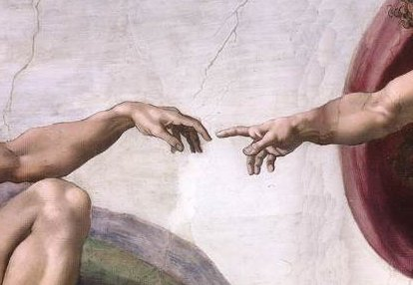
Subject | Religious Studies
Course | A-Level
Awarding Body | OCR

Contents:
 |  | Page(s)
 | Course/specification overview | 3-4
 | Our department expectations | 5
 | Review/revise | 6
 | Watch | 7-8
 | Listen to | 9-10
 | Read | 11-12
 | Research | 13-14
 | Complete | 15-18
The purpose of the bridging unit and set activities is to help you prepare for studying these three areas at A-Level. There will be some gaps in your knowledge from GCSE about some key areas surrounding Christianity and so it is really important that we ‘fill’ these gaps so that you are fully prepared for your RS A-level.

Course/specification overview

You will be studying the OCR GCE Religious Studies A-Level (H573). The three units you are studying are:
- Philosophy of religion - 33.3%
- Religion and ethics – 33.3%
- Developments in Christian thought – 33.3%
The exam for each of these components will be worth 120 marks and represent 33.3% of the total marks for A Level. These exams will last two hours each and assess both A01 and A02 skills.
The website link to the OCR A Level Specification/Examination board website:
https://www.ocr.org.uk/qualifications/as-and-a-level/religious-studies-h173-h573-from-2016/
Course Content Overview:
 | Year 1 | Year 2
Philosophy of Religion  2 hour exam | - Ancient Greek philosophers (Plato and Aristotle)  - Soul/mind and body debate  - Classical arguments for the existence of God (design, cosmological and ontological)  - Religious experience (nature of these experiences and whether they are reliable evidence for the existence of God)  - The problem of evil and Christian responses | - The nature of God and His attributes  - Religious language (can we use everyday language to describe God?)
Religion and Ethics  2 hour exam | - Natural Law  - Situation Ethics  - Kantian Ethics  - Utilitarianism  - Euthanasia  - Business Ethics | - Meta-ethics  - Conscience  - Sexual Ethics
Developments in Christian thought  2 hour exam | - St. Augustine’s teaching on human nature (original sin, the Fall)  - Death and the Afterlife  - Knowledge of God’s existence (how can humans know God?)  - The person of Jesus Christ (who was He, how should we view Him?)  - Christian moral principles  - Christian moral action (studied through case of Dietrich Bonhoeffer) | - Religious pluralism  - Gender and society (feminism)  - The challenge of secularism  - Liberation theology and Marxism

Course textbooks:
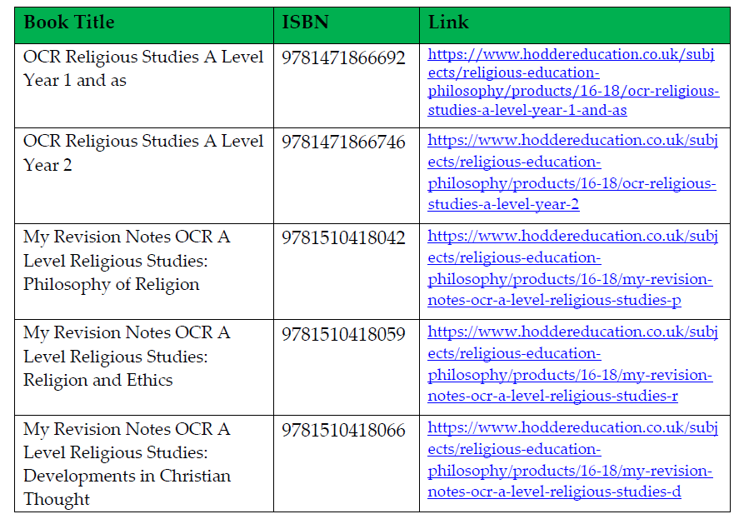

Our Department expectations

- You come equipped to lessons, with exercise books and appropriate resources; including highlighters, pens, pencils and books.

- You read outside of lessons and review class notes regularly to support independent learning

- You present and keep your notes in an organised manner

- You are punctual to lessons and arrive on time, ready to learn greeting your peers and teacher

- You engage with class discussion and ask thoughtful questions.

- You respect and listen to your peers when involved in class discussion and be thoughtful and tolerant to different views and opinions.

- You complete timed essays on a regular basis in order to prepare effectivity for essay writing across the course

- You have strong writing skills to apply to lengthy essay writing across the two years

- Thinking skills - Try to take a questioning attitude to the things you watch, hear and read. Do you agree with what’s being said? If you watch/hear/read something where people have different attitudes towards something, which do you agree with most, or least, and why?

- Carry out wider reading to extend your subject knowledge and promote excellence

- You complete ALL the activities in the ‘complete’ section of the Bridging unit booklet. There are 4 lessons with activities in them. You must complete All prior to starting the course and hand to your teacher.

- You respect your peers and teachers and allow others to learn and make progress in their studies.

- Ensure you have coloured highlighters for the following topics; Ethics (Green), Philosophy (Orange), DCT (Blue) as you will colour conduct your notes and books accordingly.

Review/revise
Some parts of this course you may not be familiar with, which is of course expected and also exciting. However, there are some elements that you may have covered in one way or another at GCSE. If you studied GCSE RS (Particularly AQA), it would be useful for you to go back and briefly review/revise over the following areas;

Linking to DCT;
- What made Jesus divine/The Son of God?
- The Trinity and its different parts
- How Jesus helped those in need e.g. The poor and The Marginalized
- What different sources of authority Christians use to help them with moral decision making (E.g. The Bible, The Church and their reason)

Linking to Ethics;
- What Jesus used to make moral decisions (agape/love) and what scripture shows this?
- Different views for and against Euthanasia (including religious and non-religious views)
- Different types of Euthanasia – E.g. Passive, Voluntary, Non-voluntary etc..

Linking to Philosophy;
- The Nature of God – The Omni attributes and religious scripture to support each these
- The Problem of Evil – How evil and suffering challenge Gods omnipotence and Gods Omni-benevolence
- The Problem of Evil – How Christians respond to this – e.g. Part of his plan etc
- Miracles – What miracles has God/Jesus performed – What types of miracles are these?
- What do Miracles show us about Gods nature?

Watch
When watching films/documentaries/programmes, try to take a questioning attitude to the things you watch. Do you agree with what’s being said? If people have different attitudes towards something, which do you agree with most, or least, and why? We call this A02 skills at A Level, and you will use these skills in essay writing.
Films:
- The Matrix – excellent parallels with Plato’s philosophy (can we trust our senses?)
- Life of Pi
- Memento – (Links Philosophy of the mind and personal identity)
- The Adjustment Bureau – interesting film that deals with fate and determinism
- ‘Run Lola Run’ (Relates to the topics of Religious experience and problem of evil)
- American beauty (relates to topics of sexual ethics/meta ethics/conscience and all of Ethics)
- Forrest Gump (relates to problem of evil and suffering/meta ethics)
- Inside Out (conscience)
- Boy in striped pyjamas (Links to the problem of evil in Philosophy and also links to meta ethics in year 13 ethics)
- The Purge 2
- Schindler’s List’ (Links to problem of evil in the Philosophy unit and meta ethics/conscience in year 13 Ethics).
- Truman Show (Links to conscience/meta ethics/all of Ethics)
- Horton Hears a Who (Links to Philosophy and the existence of God)
- It’s a wonderful life – (all of Ethics, especially year 12 business ethics and year 13 conscience and meta-ethics)

RS on the TV – Useful and interesting programmes and documentaries:
- The Good Place – Netflix series – Links very much to the Ethics side of the course.
- Unorthodox – Netflix Series
- Twelve Angry Men
- Big Questions

Ted Talks and debates:
There are plenty to stimulate your questioning and reasoning skills. There are loads of talks on here, so use the search engine to find topics that interest you.
Practise note-taking; write notes as you listen, just as you would if you were listening to a real-life lecture, and practise the skill of jotting down key points at speed. Ask yourself questions when you get to the end: what were the speaker’s key messages? Do you agree with the speaker? What might someone who disagreed say, and what might their reasons be?
Some favourites:
- Dan Gilbert – why we make bad decisions
- Richard Dawkins – militant atheism
- Elizabeth Loftus – how reliable is your memory?
- Chimamanda Ngozi Adichie – We should all be feminists
- Damon Horowitz – Philosophy in prison

- https://www.ted.com/talks/damon_horowitz/transcript Ted Talk by Damon Horowitz – We Need a Moral Operating System

- https://www.ted.com/talks/tom_honey_on_god_and_the_tsunami/transcript Ted Talk by Tom Honey – Why Would God Create A Tsunami?

Listen to

When listening to the podcasts - Try to take a questioning attitude to the things you hear. Do you agree with what’s being said? If you listen to a podcast where people have different attitudes towards something, which do you agree with most, or least, and why? We call this A02 skills at A Level, and you will use these skills in essay writing.

Podcasts and videos:
- University of Oxford podcasts - Theology & religion (Links to development of Christian Thought Unit) - https://podcasts.ox.ac.uk/uni…/faculty-theology-and-religion

- University of Oxford podcasts - Philosophy - https://podcasts.ox.ac.uk/units/faculty-philosophy

- University of Oxford podcasts - Practical ethics - https://podcasts.ox.ac.uk/…/oxford-uehiro-centre-practical-…

- BBC - podcasts & programmes - Ethical theories - https://www.bbc.co.uk/programmes/topics/Ethical_theories?fbclid=IwAR1bowymJUmq1stCD343tPB8f4vaoS8S7CO9Si4E0b8CM2yXzL6iuqyBuSU

- BBC - podcasts & programmes – Emotions -https://www.bbc.co.uk/programmes/topics/Emotions?fbclid=IwAR3eX2GnSPUjaDLNZLCJfkl68U6S4bVlIjoJ-kYfwtWrbcXo-J-rg3HvYBQ

- BBC - podcasts & programmes - Virtue https://www.bbc.co.uk/programmes/topics/Virtue?fbclid=IwAR1emTCBGY4iVEKsDy30KCV6jD9n3hib5y240-Xvxvu-iT9yXm4JO_C6kPQ

- BBC - podcasts & programmes - Ethical concepts https://www.bbc.co.uk/programmes/topics/Concepts_in_ethics?fbclid=IwAR3sXzqZTkhr3aFub7ItRKiGf9m-7fAO0a-7-8R5fAbuFYmGlr7EAXqqoSE

- BBC - podcasts & programmes - Philosophical concepts https://www.bbc.co.uk/programmes/topics/Philosophical_concepts?fbclid=IwAR1d2rriQ9IKhFa3Qey3_d8j0sJhHWmRa_83r7NxsHTEr6AhFL_q8OgxeSs

- BBC - podcasts & programmes - History of philosophy https://www.bbc.co.uk/programmes/topics/History_of_philosophy?fbclid=IwAR2EXdw0C4A2dv0lfAVOxypgWuS3H2CUEB1tjemeVj4zbAykqf0axLZ1LwU

- BBC - podcasts & programmes – Ethics - https://www.bbc.co.uk/programmes/topics/Ethics?fbclid=IwAR3BGqxtWZwOjTxeNER4ZFi2KtSAFCpXlQJPEF3gKhIGzn2hS87som_N_us

- Crash Course Philosophy https://www.youtube.com/playlist?list=PL8dPuuaLjXtNgK6MZucdYldNkMybYIHKR

- The Panpsycast Philosophy Podcast - https://thepanpsycast.com/home

MrMcMillanREvis - A Level Revision - The Existence of God - https://www.youtube.com/user/MrMcMillanREvis/playlists

- BBC - In our time - Religion https://www.bbc.co.uk/programmes/p01gvqlg

- BBC - In our time - Philosophy https://www.bbc.co.uk/programmes/p01f0vzr

Other audio Resources:

- The Moral Maze on BBC Radio 4. (Available programmes vary over time) https://www.bbc.co.uk/programmes/b006qk11

- In Our Time. http://www.bbc.co.uk/programmes/b01mwx64
- Think based on these arguments, is it possible to argue that God necessarily exists?

- Thinking Allowed. https://www.bbc.co.uk/programmes/b099ypqf Think about how should we help people who are dying?

- Podcast from Philosophy Now. https://philosophynow.org/podcasts/Free_Will_and_the_Brain To what extent can we exercise free will?

Read
When reading these books, try to take a questioning attitude to the things you read. Do you agree with what’s being said? If you read a book where people have different attitudes towards something, which do you agree with most, or least, and why? We call this A02 at A Level, and you will use these skills in essay writing.

Brief Introductory Reading:
- Blackburn, S. Think, OUP 2001
- Craig, E. Philosophy: A Very Short Introduction, OUP 2002
- Law, S. The Philosophy Files, Orion 2002; The Outer Limits, Orion 2003; The Philosophy Gym, Hodder Headline 2003
- Nagel, T. What Does It All Mean?, OUP 1987 (reprinted 2004)
- Warburton, N. Philosophy: The Basics (5th ed.), Routledge 2012

Philosophy:
- Gaarder, J. (1995) Sophie’s World , London : Phoenix House
- Davies, B. (1993) An Introduction to the Philosophy of Religion, Oxford: Oxford University Press
- Annas, J. (1998) An Introduction to Plato’s Republic, Oxford: Oxford University Press, (particularly Chapters 9-10)
Ethics:
- Vardy, P.(1999) The Puzzle of Ethics, SCM Press
- Norman, R. (1998) The Moral Philosophers, Oxford: Oxford University Press

Development of Christian Thought:
- McGrath, A. (2015) Christianity: An Introduction, Blackwell Publishing.

Other books to read:
- The problems of philosophy – By Bertrand Russel
- Sophie’s world: a novel about the history of philosophy, Jostein Gaardner
- The Republic, Plato
- A Little History of Philosophy, Nigel Warburton
- The God Delusion, Richard Dawkins
- The Dawkins Delusion? Atheist fundamentalism and the denial of the divine, Alister McGrath and Joanna Collicutt McGrath
- Plato: Five Dialogues by Plato.
- The Emperor's New Mind by Roger Penrose.
- Meno by Plato.
- Republic by Plato.
- Symposium by Plato.
- The Selfish Gene by Richard Dawkins.
- Meditations on First Philosophy by Rene Descartes.
- What Is This Thing Called Science by Alan F. Chalmers.
- The Shack, William P Young – an interesting Christian novel about loss and faith in God
- His Dark Materials trilogy, Phillip Pullman – excellent set of books that cover a lot of themes to do with religion and philosophy
- Do Androids dream of electric sheep – Philip K Dick
- Life of Pi – Yann Martel

Books you can access for £1.00 or less on Kindle:
- Nausea – Jean Paul Satre
- The outsider – Albert Camus
- Discourse on the Method and the Meditations – Rene Descartes
- Philosophy: The basics – Nigel Warbuton
- Tractatus Logico Philosophicus – Ludwig Wittgenstein
- The second sex – Simone de Beauviour
Essays to read:
- Defence of Abortion – Judith Jarvis Thomson
- Euthanasia – Phillipa Foot

Research
There are lots of resources online and in books to help you, if you want to start to learn a little more about some of the philosophers and scholars you come across at A Level. You can use Wikipedia/google as a starting point and follow some of the links in the articles. You could do some research about:
- Plato
- Aristotle
- Aquinas
- Bentham
- Mill
- Hume
- Kant
Practice using a range of sources to find out about a single person.
The BBC has some great podcasts available - https://www.bbc.co.uk/programmes/p01f0vzr. (They are quite long and heavyweight, so don’t worry too much if this activity isn’t for you). When listening, practice your note-making skills by pausing and writing a summary of what you’ve heard so far. Think about whether you agree with what the philosopher is saying (A02 skills).
You can listen to the following ones below that are focused on the A Level content you will come across;
Philosophy:
- St Thomas Aquinas
- Augustine
- The Ontological Argument
- The Soul
- Nietzsche
- William James
- David Hume
- Empiricism
Ethics:
- Kant
- Relativism
- Utilitarianism
- Duty
- Good and Evil
- Altruism
- Mill
DCT:
Feminism

Useful research links for subject knowledge:
- REonline DCT - Christianity https://www.reonline.org.uk/subject-knowledge/16-plus-christianity/
- REOnline Ethics https://www.reonline.org.uk/subject-knowledge/16-ethics/
- REOnline Philosophy https://www.reonline.org.uk/subject-knowledge/16-plus-philosophy/
- Guardian online - Religion https://www.theguardian.com/world/religion (news/current religious issues)

Essays to read:
- Defence of Abortion – Judith Jarvis Thomson
- Euthanasia – Phillipa Foot

Complete
You MUST complete ALL of the following ‘lesson activities’ in the appropriate order in preparation of the course. There are 4 ‘lessons’ for you to complete tasks for which are focused on bridging the gap in knowledge from GCSE to A Level – specifically in the area of Christianity to prepare you for the DCT unit of the course.

Lesson 1: How did the Bible come about?
Lesson 2: Key books and writers in the Bible
Lesson 3: What is theology?
Lesson 4: Key developments in Christian theology

Lesson 1: How did the Bible come about?

It might not really make sense to talk about the Bible as if it was one book as really it is a collection of lots of different books. These different books have different styles; some are written as letters, songs, historical records and poetry. For this course, it’s really essential that you are able to talk about the Bible in an informed manner and that you are able to cite from scripture and know something about the book or part of the Bible that quotation is from.
Tasks:
Use the suggested resources below (as a starting point) to help you to complete the following tasks:
- http://www.dummies.com/how-to/content/the-bible-for-dummies-cheat-sheet.html
- http://www.bbc.co.uk/religion/religions/christianity/texts/bible.shtml

- Research how the Christian Bible came to be in its current form. Present the information either as a list, flow-diagram or paragraph of writing.
- List the different books of the Bible. Identify which ones are in the Old and the New Testament.
- The books of the Bible are grouped together and named because they share a similar theme, style or author. Find out which books belong to each of the following and any other details about what they are like.
  - The Law
  - The Pentateuch
  - The Prophets
  - The Writings
  - The Letters
  - The Gospels
- Explain how the Bible links Christianity with Judaism.
- Why are Judaism, Christianity and Islam known as the Abrahamic religions

Lesson 2: Key books and writers in the Bible

Knowledge of some key stories and books within the Bible will help you hugely when discussing certain scholars’ ideas as they will often cite the Bible to support their arguments. Some stories you may already be familiar with because you studied them in KS3 or KS4, however, it is important that everyone re-acquaints themselves with these pivotal parts of the Bible.
Tasks: Use the following suggested resources to help you complete these tasks:
- A copy of the Bible, either hard-copy or online at https://www.biblegateway.com/
- http://www.dummies.com/how-to/content/eleven-important-people-in-the-bible.html
- http://www.dummies.com/how-to/content/who-is-st-paul.html
- http://www.bbc.co.uk/religion/religions/christianity/history/paul_1.shtml
- http://christianity.about.com/od/oldtestamentbooks/qt/exodusintro.htm

- Read Genesis chapters 1-3. Summarise the key events of each chapter.
- What differences do you notice between Genesis chapter 1 and 2?
- Why do you think Genesis 3 is so significant?
- Research the story of Abraham and outline the key events (birth of Ishmael, promise of Isaac, changing of name from Abram to Abraham, sacrifice of Isaac)
- Look up Genesis 22:15-18. How does what is said by God to Abraham link to something called the covenant?
- Research the key events of the book of Exodus. Outline these events as a flow-diagram, list or paragraph. How do these events link to the covenant?
- What are the gospels?
- Who was St. Paul? Research his story and summarise it. Research some of his key teachings.

Lesson 3: What is theology?

Our third unit, Developments in Christian Thought (DCT) is largely the study of theology. Before you start the course, it’s really important for you to understand what theology is.
Task 1:
Read through these various definitions of theology and use these to come up with your own definition of what theology is:
- “The science of God or of religion; the science which treats of the existence, character, and attributes of God, his laws and government, the doctrines we are to believe, and the duties we are to practice. . . the science of Christian faith and life.” Webster’s dictionary
- “Rational discussion respecting the deity.” Saint Augustine 5th Century
- “the Science of God and of the relations between God and the universe.” A. H. Strong 20th Century
- “thinking about God and expressing those thoughts in some way.” Charles Ryrie 1986
- “the study or science of God.” Millard Erickson 2001
Task 2:
Watch this video and make notes on what theology is and how it is different to Religious Studies.
https://www.youtube.com/watch?v=LxMNtNhNr_Q
Task 3:
Why might the understanding of God be challenged? Why might theology develop?
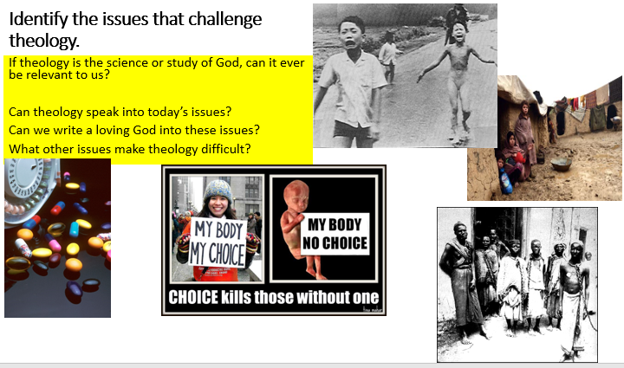
Have a look at these pictures below and identify reasons why theology may develop over time…

Lesson 4: Key developments in Christian theology

As we have seen in lesson 3, ideas about God can be challenged not only by things such as evil and suffering but also key events in history, politics and society. It is really important that you have a general understanding of some of these changes. We would like you to research some of these key events and to create your own ‘theology timeline’.
Use the following suggested resources, as a starting point, to help you complete the tasks below
- http://www.bbc.co.uk/religion/religions/christianity/history/history_1.shtml
- http://www.theopedia.com/great-schism
- https://en.wikipedia.org/wiki/Patristics
- http://www.britannica.com/event/Western-Schism
- http://www.britannica.com/event/Reformation
- http://www.bbc.co.uk/history/british/tudors/reformation_overview_01.shtml
- http://www.bbc.co.uk/religion/religions/christianity/ (subdivisions)
Task 1: Research the following key theological developments/eras:
- Patristic theology/Early Church Fathers
- Great Schism 1054
- Reformation
- Counter-reformation
- Liberation theology (example of a modern movement)
For each of the above key developments, find out the following:
- key people
- key events,
- key ideas about God/the Trinity
- relevant dates

Task 2: Research the Apostles and Nicene creed. What are they? When were they written? How are they different?

