

Year 11 > 12 Bridging Work
Summer Term 2026


Subject | Sociology
Course | A-Level
Awarding Body | AQA

Contents:
 |  | Page(s)
 | Course/specification overview | 3-4
 | Our department expectations | 5
 | Review/revise | 6
 | Watch | 7
 | Listen to | 8
 | Read | 9
 | Research | 10
 | Complete | 11-16

Course/specification overview

You will be studying the AQA Sociology A Level course. You will study a number of units over the two years and these include: Research Methods, Families and Households, Education, Crime and Deviance and Beliefs in Society.
The exam for each of these components will be worth 80 marks and represent 33.3% of the total marks for A Level. These exams will last two hours each and assess A01, A02 and A03 skills.
In total you will have three exams:
- Education with Theory and Methods – 80 marks – 2 hours
- Topics in Sociology – 80 marks – 2 hours
- Crime and Deviance with Theory and Methods – 80 marks – 2 hours
The website link to the AQA A Level Specification:
https://www.aqa.org.uk/subjects/sociology/as-and-a-level/sociology-7191-7192/introduction
Course Content Overview:
 | Year 1 | Year 2
Education with Theory and Methods  2 hour exam | - Perspectives of education  - Social class, gender and ethnicity differences in achievement.  - Quantitative methods  - Qualitative methods  - Sociological theory | - All content covered in year 12
Topics in Sociology  2 hour exam | - Families and households  - Perspectives of families  - Demography  - Childhood studies  - Social policy  - Relationships  - Resources and decision making | - Beliefs in Society  - Theories of religion  - Religion and social change  - Secularisation  - Religion and development  - Religion, renewal and choice  - Ideology and Science
Crime and deviance with theory and methods  2 hour exam | - The research methods content from exam one appears in this exam and is outlined above. | - Crime and deviance  - Labelling and crime  - Functionalism and crime  - Marxism and crime  - Relationship between crime gender, class and ethnicity  - Religion and the media

Our Department expectations

- You come equipped to lessons, with exercise books and appropriate resources

- You have strong writing skills to apply to lengthy essay writing

- You read outside of lessons and review class notes regularly to support independent learning

- You present and keep your notes in an organised manner

- You are punctual to lessons and arrive on time, ready to learn

- You engage with class discussion and ask thoughtful questions

- You complete timed essays on a regular basis in order to prepare effectivity for essay writing across the course

- Thinking skills - Try to take a questioning attitude to the things you watch, hear and read. Do you agree with what’s being said? If you watch/hear/read something where people have different attitudes towards something, which do you agree with most, or least, and why?

- Carry out wider reading to extend your subject knowledge

- You complete ALL the activities in the ‘complete’ section of the Bridging unit booklet. There are 4 lessons with activities in them. You must complete All prior to starting the course and hand to your teacher.

- You respect your peers and teachers and allow others to learn and make progress in their studies.

Review/revise

We as a department understand and recognise that some students will have studied Sociology as a GCSE already. However, because it is an option subject some of you would not have chosen it or your schools may not have offered it. Sociology however has clear links with some subjects you have already studied in some way (but they will explore these issues in very different ways). By its very nature you have come into contact with the course. For example, you all live in a family, therefore have some experience of families and households, likewise you have all attended some form of school so have links to the Education unit.

Watch
When watching films/documentaries/programmes, try to take a questioning attitude to the things you watch. Do you agree with what’s being said? If people have different attitudes towards something, which do you agree with most, or least, and why? We call this A03 skills at A Level, and you will use these skills in essay writing.
Films:
- Crash – excellent to show different cultures mixing with each other.
- I, Daniel Blake – interesting film that explores poverty and how it can impact life chances.
- Pride – shows how attitudes towards certain norms and values have changed surrounding marriage and relationships
- Made in Daggenham – good film to show social class dynamics
- The Big Short – excellent investigation into corporate crime
- American History X – a brutal look at ethnicity and racism in America
- City of God – a look at ethnicity and poverty in Brazil
- This is England – a look at social class and ethnicity in England
- Kes – an examination of social class in England.
- Sorry we missed you - an examination of life chances.
Sociology on the TV – Useful and interesting programmes and documentaries:
- Louis Theroux – most of the documentaries by him are accessible and all have links to Sociology. You can find lots of his programmes on BBC Iplayer, Netflix and Amazon Prime.
- Stacey Dooley - most of the documentaries by her are accessible and have links to Sociology. You can find lots of het programme on BBC Iplayer.
- The UP series. A longitudinal study about social class and development.
- Rich house poor house - Available on Channel 5
- Benefits street
- Educating Essex / Yorkshire/ Greater Manchester - Available on 4OD
- Harrow a very British School
- Accidental Courtesy: Daryl Davis, Race and America
- Hello, privilege - It's Me, Chelsea - Available on Netflix
- Girlhood
- Can’t pay? We’ll take it away - Available on Channel 5

Ted Talks and debates:
There are plenty to stimulate your questioning and reasoning skills. There are loads of talks on here, so use the search engine to find topics that interest you.
Practise note-taking; write notes as you listen, just as you would if you were listening to a real-life lecture, and practise the skill of jotting down key points at speed. Ask yourself questions when you get to the end: what were the speaker’s key messages? Do you agree with the speaker? What might someone who disagreed say, and what might their reasons be?
Listen to

When listening to the podcasts - Try to take a questioning attitude to the things you hear. Do you agree with what’s being said? If you listen to a podcast where people have different attitudes towards something, which do you agree with most, or least, and why? We call this A03 skills at A Level, and you will use these skills in essay writing.

Podcasts and videos:
- The Annex Podcast - http://sociocast.org/annex/
- The shortage of marriageable men - http://sociocast.org/podcast/a-shortage-of-marriageable-men/
- A masculine cure for toxic masculinity - http://sociocast.org/podcast/a-masculine-cure-for-toxic-masculinity/
- Thinking allowed- https://www.bbc.co.uk/programmes/b006qy05
- ‘TED’ talks- https://www.youtube.com/user/TEDtalksDirector

Other audio Resources:

- Serial season 1 – a series based on real life events of a murder case. The introductory line is: A high-school senior named Hae Min Lee disappeared one day after school in 1999, in Baltimore County, Maryland. A month later, her body was found.
- Serial season 2 – a series based on a US armed forces soldier who goes missing on the front line and is found six years later.
- Serial season 3 – not one I have listened to yet, but focuses on court houses in America and the Criminal Justice System. If you are interested in crime, law or courts, this will be for you.
- S Town – difficult to explain but explores social class, sexuality and inequality.

Both of which can be found online in podcast form.

Read
When reading these books, try to take a questioning attitude to the things you read. Do you agree with what’s being said? If you read a book where people have different attitudes towards something, which do you agree with most, or least, and why? We call this A02 at A Level, and you will use these skills in essay writing.

Brief Introductory Reading:
- Ritzer. (2002) Contemporary sociology and its classical roots
- Webb R. (2015) AQA Sociology Book 1 Including AS Level
- Webb R. (2015) AQA Sociology Book 2 Including A Level

Other works you could engage with:

• Power – Naomi Alderman
• 1984 – George Orwell
• Infomocracy – Malka Ann Older
• Why I’m No Longer Talking To White People About Race – Renni EddoLodge
• Chavs – Owen Jones
• The Unit – Ninni Holmqvist
• The Handmaid’s Tale – Margaret Atwood
• Animal – Sarah Pascoe
• Eve of Man – Tom and Giovanna Fletcher
• The Catcher in the Eye – J. D. Sallinger
• Something Happened – Joseph Heller
• The Book Theif – Markus Zusak
• A Farewell to Arms – Ernst Hemmingway
• Wuthering Heights – Emily Brönte
- The London School of Economics- Blogs on Politics /Economics and Sociology

Research
There are lots of resources online and in books to help you, if you want to start to learn a little more about some of the Key Thinkers and Sociologists you come across at A Level. You can use Wikipedia/google as a starting point and follow some of the links in the articles.
https://www.aqa.org.uk/subjects/sociology/gcse/sociology-8192/appendix-b-texts-and-summaries
You could do some research about:
- Durkheim
- Karl Marx
- Max Weber
- Talcott Parsons
- Murdock
- Ann Oakley
- Young and Willmott
- Bowles and Gintis
- Davis and Moore
- Peter Townsend
Practice using a range of sources to find out about a single person.
This website has some great podcasts available - http://sociocast.org/annex/. (They are quite long and heavyweight, so don’t worry too much if this activity isn’t for you). When listening, practice your note-making skills by pausing and writing a summary of what you’ve heard so far. Think about whether you agree with what the sociologist is saying (A02 skills).

Complete

You MUST complete ALL of the following ‘lesson activities’ in the appropriate order in preparation of the course. There are 5 ‘lessons’ for you to complete tasks for which are focused on bridging the gap in knowledge, they will provide you with a foundation in sociology.

Lesson 1: What is Sociology?
Lesson 2: Nature versus nurture
Lesson 3: What is socialisation?
Lesson 4: What do we mean by culture?
Lesson 5: What are norms and values?

Lesson 1: What is Sociology?

So you have chosen to take sociology… chances are that you probably have not studied the subject yourself or it might have been a while since you have been in real contact with anything sociological. The first thing to do is to get to grips with the basics and the most fundamental building block is to understand just what exactly the subject is. Your task will be to discover what sociology actually means, what it involves and what sociologists actually do.
Tasks:
Use the suggested resources below (as a starting point) to help you to complete the following tasks:
- https://www.dummies.com/education/science/sociology-for-dummies-cheat-sheet/
- https://www.bbc.co.uk/bitesize/subjects/z33d7ty

- Create a definition of the word ‘Sociology’.
- List some of the different topics that Sociologists would want to study.
- Using the BBC link watch the clips on Families and Education. Once you have done that write a summary of what they are about. These are the types of topics that sociologists would be interested in.
- Use Google to find meanings for the words questionnaire and interviews. These are just two of the many possible research methods that a sociologist might use.
- Which of the two research methods would be best for researching racism in schools? Explain why.

Lesson 2: Nature versus nurture
Have you ever thought to yourself that you have a similar trait (e.g. anger) to your parents? Or do you think that you are the way you are due to your upbringing and surroundings (e.g. your friends)? The nature versus nurture debate is one of the oldest discussions.
Tasks:
Using Google, explain the nature versus nurture notion.
Exploring the nurture notion in more detail
Sociologists believe that our behaviour is not fixed biologically. They believe that our behaviour is learned.
Have you ever watched jungle book? Believe it or not, this was based on a true story. There are children who were been neglected by their family and who have been raised by animals. These children are referred to as a feral child.
The link below are examples of feral children who have been raised by animals such as wolves and chickens. Pick one study and explore this is more detail.
https://www.bbc.com/culture/article/20151012-feral-the-children-raised-by-wolves
Abandoned toddler rescued and raised by feral dogs | 60 Minutes Australia

Another example is the story of Genie, a modern-day feral child. A girl who was imprisoned in her room until the age of 13. There is a movie based on Genie’s abuse. Caution: this is a sad story.
Mockingbird Don't Sing | Full Drama Movie

Lesson 3: What is socialisation?

Have you ever wondered why you are the way you are? Well, in sociology we explain it via a term called socialisation. This term focuses on the experiences that you have had to explain why you are the way you are.
Use the following suggested resources to help you complete these tasks:
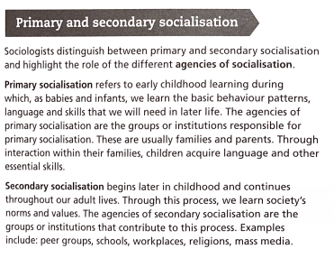
1. Define the term socialisation.
2. Spider diagram all the different ways that we are socialised?
4. How important is primary socialisation in order for us to live in society as normal people? Explain two different arguments for this question.

Lesson 3: What do we mean by culture?

Culture is all around us. It is everywhere we go. But most importantly it is unique. What it means to be British is very different than what it means to be American or French. There may well be some similarities but there will also be a lot of differences as well.
Task 1:
1. Define the term culture.
2. Spider diagram all the things that could make up someone’s culture. If you are stuck think about things that make people British, food, dress etc.
3. Watch the clip on the BBC news article from the link below (it is about half way down, don't watch the first clip it is the second one)
https://www.bbc.co.uk/news/world-us-canada-52314866
4. What is the connection between Corona Virus and Culture? What is demonstrated as being essential in this clip and how does this demonstrate that culture is not shared everywhere but is different in place to place.

EXT: What is a subculture and what subculture do you belong to?

Lesson 4: What are norms and values?

Norms and values are key concepts in sociology that help govern society and everyday life. They help us to make sense of situations and events that are happening in the world. An important thing to remember is that they are not fixed, they evolve and change with society. If society changes in the way it works, so will the norms and values of that society. Below are a series of tasks that are designed to help you understand these concepts and the ways they work.
Use the following suggested resources, as a starting point, to help you complete the tasks below
https://courses.lumenlearning.com/culturalanthropology/chapter/values-norms/
https://www.tutor2u.net/sociology/topics/norms-and-values

1. Define the term norms and values.
2. Spider diagram all the things that could are part of people's norms? (Read the top of the handout to help you)
3. Spider diagram all the things that could are part of people's values? (Read the bottom of the handout and the yellow box to help you)
4. Watch the clip on the BBC news article from the link below on "Coronavirus: lockdown to continue with outbreak at “delicate and dangerous stage - moving to the normal"
https://www.youtube.com/watch?v=YcaRfDqH0zA
5. What kinds of norms and values have emerged since the outbreak of coronavirus e.g. holidays, not going out, restrictions, lockdown, PPE, NHS, etc.
EXT: What is the connection between coronavirus and norms and values?

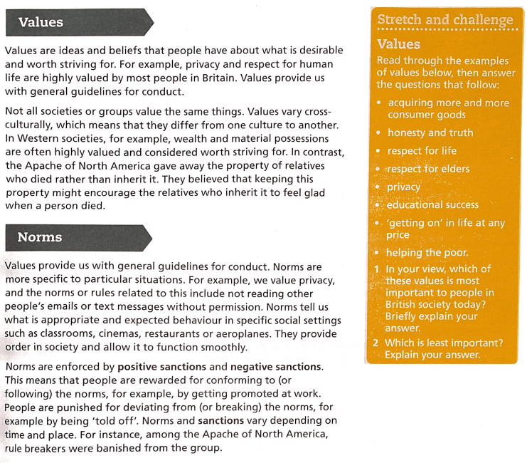
Challenge: Fill in the blanks
Using the word list below, fill in the blanks in the following passage, each dash represents one word.
Identity | Social structure | Values
Social control | Norms | Social mobility
Status | Working class | Role conflict
Value freedom | Ascribed status | Status
Social class | Positive | Upper class
Achieved status | Socialisation | Objectivity
Ethnicity | Roles | Underclass
Minority ethnic group | Social institutions | Negative sanctions
Social classes | Deviance | Life chances
Gender | Social classes

Sociology involves studying the social world, but as sociologists are themselves part of the social world, they need to take care that they look at things in a detached and impartial way. They should approach research in an-open minded way, considering all the evidence before making up their minds. This is known as ________________. They should also try not to let their own beliefs and prejudices influence their research. This _______________ _____________ is important if Sociology is to be seen as something more than newspaper journalism.

Society is constructed of a range of __________ ____________, like the family, religion, the education system and the law. These make up the ____________ _______________-the ‘building clocks’ of society. Sociologists generally believe that people learn the culture of their society, and this learning process is known as ________________. For example, males and females often learn to behave in different ways. This difference is known as _____________. The learning process influences the formation of the individual’s ____________-how they see and define themselves and how others see and define them. _________ refers to the shared culture of a social group which gives its member a common identity in some ways different from that of other social groups. If a group has a cultural identity different from the majority population of a society, such as black and Asian groups in Britain, it is known as a ___________ ____________ ______________.

Everyone in society is expected to behave in particular ways in particular situations, and these patterns of expected behaviour are known as _______________, but sometimes these come into conflict with each other, causing ______________ ________________.
Every society has sets of guidelines for behaviour. _____________ establish the important standards about what is important in a society and what is right or wrong. __________ provide rules about how to behave in particular situations.
People are encouraged to conform to these rules by ___________ __________, which is carried out by a range of rewards and punishments known as ____________ and ________________ ____________-_. Non-conformity to social rules is known as___________________.

A__________ __________ is a group of people who share a similar economic situation, and this can have an important influence on their chances of obtaining the desirable, and avoiding the undesirable, things in life- their ___________ ________________. The two largest ___________ __________ are the __________ ________ and the middle class. The main owners of society’s wealth are known as the __________ ________, while the poorest group, which is excluded from full participation in society by poverty, is known as the _________________. Sometimes people can move up and down between _____________ ____________, and this is known as_________ ____________. Some people and some positions in society are ranked by others in terms of different amounts of prestige or respect, and this is known as _____________. If this is given by birth or family background, it is known as ______________ ___________. However, some people can achieve their ____________ through their own individual efforts and talents. This is known as _______________ _________________.

