

Year 11 > 12 Bridging Work
Summer Term 2026

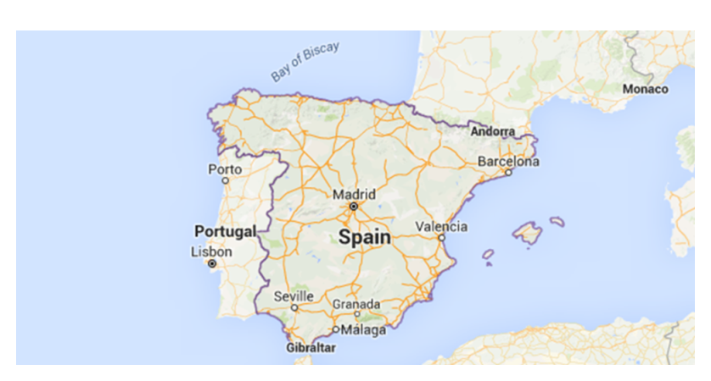
Subject | Spanish
Course | A-Level
Awarding Body | Edexcel/Pearson

Contents:
 |  | Page(s)
 | Course/specification overview | 3
 | Our Department Expectations | 4
 | Review/Revise | 5-6
 | Watch | 7
 | Listen To | 8
 | Read | 9
 | Research | 10-11
 | Complete | 12-24
 | Appendices/Resources | 25

Course/Specification Overview

Our vision is for all students to become ‘confident and enthusiastic communicators in a foreign language’. Our lessons are conducted in the target language and all our students end up speaking either Spanish fluently by the end of Year 13, even if they have not been used to speaking the language during lessons at GCSE.
The Modern Foreign Languages courses are designed for students interested in languages and communication who enjoy learning about other cultures and ways of life. An A level in languages challenges students to develop not only their ability to communicate effectively in the foreign language but also their ability to analyse information and apply knowledge.
A level - Paper 1 - Listening, reading and translation from Spanish to English
Paper 2 – Translation from English to Spanish, an essay on a piece of literature and an essay on a film
Paper 3 – Speaking - Discussion of a theme and a presentation and discussion on a topic of your choice

Units studied in Year 12:
- El cambio en la estructura familiar
- La vida laboral en España
- El impacto turístico en España
- La música española
- Los medios de comunicación
- Los festivales

Units studied in Year 13:
- La Guerra civil
- La dictadura
- La transición a la democracia
- La inmigración

La obra de teatro - Bodas de Sangre

La película – Volver (do not watch)

Our Department Expectations

As an A Level student of MFL, we expect you to have the following equipment:
- a plastic wallet with all the work from the Transition booklet in the first lesson of term
- a lever arch folder with dividers
- a bilingual dictionary
- lined paper & red/green/blue/black pens

A Level MFL students are expected to:
- attend all lessons punctually
- complete an hour a week of Independent study (directed work in addition to homework)
- take part in weekly speaking sessions in small groups with the foreign language assistants
- submit all homework on time and ask for support when needed
- communicate all absences as soon as possible to the teacher and catch up on missed work
- take an independent approach towards their learning and invest time in DIRT
- review and organise their class notes regularly, ensuring that they are filed carefully.

Studying a language is a marathon, not a sprint and will require resilience and good organisation. It is definitely a subject where the more you put in, the more you will get out!

Review/revise
- Grammar essentials
VERBS
- The present tense (regular verbs & the irregular verbs - hacer, ser, ir, ver, tener, estar
https://quizlet.com/gb/266367799/present-tense-verb-conjugation-flash-cards/
https://quizlet.com/gb/386154471/verbos-irregulares-en-el-presente-1-ir-ser-estar-flash-cards/
https://quizlet.com/gb/296068777/present-tense-verbs-flash-cards/
https://quizlet.com/284355713/hacer-flash-cards/
https://quizlet.com/gb/226121546/ser-tener-flash-cards/
https://quizlet.com/gb/504721149/ver-to-see-flash-cards/?new
https://quizlet.com/gb/386154471/verbos-irregulares-en-el-presente-1-ir-ser-estar-flash-cards/

- The preterite tense(regular verbs & the irregular verbs - hacer, ser, ir, ver, tener, estar
https://quizlet.com/gb/204286851/preterite-regular-ar-er-and-ir-verbs-flash-cards/
https://quizlet.com/gb/275780866/preterite-of-the-verb-ir-to-go-flash-cards/
https://quizlet.com/gb/289170750/preterite-tense-flash-cards/
https://quizlet.com/gb/232836031/preterite-tense-irregular-verbs-flash-cards/
https://quizlet.com/gb/504722253/preterite-ver-flash-cards/?new
https://quizlet.com/gb/504722591/preterite-estar-flash-cards/?new

- The imperfect tense
https://quizlet.com/gb/504722980/regular-imperfect-flash-cards/?new
https://quizlet.com/gb/504723517/ser-imperfect-flash-cards/?new
https://quizlet.com/gb/504724582/ver-imperfect-flash-cards/?new
https://quizlet.com/gb/504724880/ir-imperfect-flash-cards/?new

- The future tense
https://quizlet.com/gb/397415800/spanish-simple-future-tense-gcse-flash-cards/
https://quizlet.com/gb/504726499/future-tense-irregular-flash-cards/?new

- The conditional tense
https://quizlet.com/gb/504726914/conditional-tense-in-spanish-regulars-flash-cards/
https://quizlet.com/gb/504727210/irregular-conditional-flash-cards/?new
There are lots of activities to practise these in the ‘Complete’ section of this booklet.
Need to revise? Remember to use your exercise books with notes, along with your Knowledge Organiser booklet. Still need more notes or want online practice? How about trying the following?
- www.languagesonline.org.uk
- www.verbix.com
- https://www.conjuguemos.com/
- https://www.spanishdict.com/conjugation (scroll down to ‘conjugation drills’)

- Vocabulary essentials

- Opinions
https://quizlet.com/gb/338005009/general-vocabulary-opinions-1-spanish-aqa-flash-cards/
https://quizlet.com/gb/338005542/general-vocabulary-opinions-2-spanish-aqa-flash-cards/
https://quizlet.com/gb/338006381/general-vocabulary-opinions-3-spanish-aqa-flash-cards/
https://quizlet.com/gb/338007201/general-vocabulary-opinions-4-spanish-aqa-flash-cards/

- Important Adjectives
https://quizlet.com/gb/504729142/gcse-spanish-useful-adjectives-flash-cards/?new

- Quantifiers & Connectives
https://quizlet.com/gb/337997092/general-vocabulary-connectives-spanish-aqa-flash-cards/
https://quizlet.com/gb/504728396/spanish-quantifiers-flash-cards/?new

- Question words
https://quizlet.com/gb/337999992/general-vocabulary-asking-questions-spanish-aqa-flash-cards/

Make sure you copy down any you don’t know.
Also, we are going to start with the family topic so please revise and make sure you’re confident with the vocabulary. https://quizlet.com/gb/504716140/family-and-relationships-1-flash-cards/?new
These are some foundation topics or elements of vocabulary that you need to be confident with before starting the A Level course.
You will be tested on these in the first few lessons of Year 12.

Watch

The news. Click on https://www.rtve.es/noticias to watch the Spanish news.

Films
- Ocho Apellidos Vascos (Emilio Martínez-Lázaro, 2014)
- El Laberinto del Fauno (Guillermo del Toro, 2006)
- María, Llena Eres de Gracia (Joshua Marston, 2004)
- Abel (Diego Luna, 2010)
- Las 13 Rosas (Emilio Martínez-Lázaro, 2007)
- Las Lenguas de la mariposa (José Luis Cuerda, 2000)
- Diarios de motocicleta (Walter Salles, 2004)
You will also find Spanish films on Netflix and Amazon Prime

Documentaries
- BBC Mundo Historia https://youtube.com/playlist?list=PLLhUyPZ7578dr2pmCEH55ZQQ-XJWFHSDd&si=_Qvh8mBoRatnire9
- RTVE Noticias – documentales https://youtube.com/playlist?list=PLFLBjMW4wU7jWKp3V_k8pw8HH4d-AAy9M&si=EkzSbQu3k2y0xCOr
- DW Documental - Trailer | DW Documental
- Europe on the Edge – Katya Adler - Watch Europe on the Edge with Katya Adler on BBC Select

Listen To

Latin artists - choose a couple that you like and answer the questions. Do a gap fill of one putting the word you have extracted down the side and link the audio.
- Rosalía
- Willie Colon
- Romeo Santos
- Marc Anthony
- Carlos Santana
- J. Balvin
- Anuel AA
- Shakira
- Farruko
- Becky G
- Carlos Vives
- Daddy Yankee
- Enrique Iglesias
- Gente de Zona
- Juan Magán
- Juanes
- Luis Fonsi
- Maluma
- Maná
- Nicky Jam
- Sebastián Yatra
- Ricky Martin
- Bad Bunny
- Ozuna
- Pedro Capó
- La Oreja de Van Gogh

Questions
- ¿Quién canta?,
- ¿Cómo se llama la canción?
- ¿Por qué te gusta la canción?

Other
- https://lyricstraining.com
- Podcasts – Notes in Spanish.com and choose from beginners or intermediate level
- Spotify – Top 50 Charts in that country
- Audio books – Amazon (Harry Potter) https://stories.audible.com/start-listen
- Radio Garden app – listen to worldwide radio live
- News in Slow Spanish – app www.newsinslowspanish.com
- https://coffeebreaklanguages.com/coffeebreakspanish/
- https://www.rtve.es/radio/radio3/ - this is what young people in Spain listen to. It is like Radio one or Capital FM
- https://www.rtve.es/radio/radio5/ This is the current affairs radio station to listen to the news

Listen to this podcast and summarise it in English.
Notes in Spanish Intermediate 5 - La Familia • Notes in Spanish Intermediate
Read
Newspapers & magazines
Switch to Spanish browsers such as and http://es.yahoo.com/ as well as www.google.es . This way, you will read Spanish every time you log on and it will become part of your everyday activity.
Look at the www.bbc.com/mundo for BBC reporting in Spanish. Click on Videos for clips and reports in Spanish.
For Daily News:
- EL PAÍS: el periódico global
- Noticias - BBC News Mundo
- www.abc.es
- www.terra.es
- https://www.antena3.com/
- www.primerasnoticias.com/ A newspaper for young people
- Go to www.donbalon.com for football website and related articles.
- Go to www.hola.com for a Spanish celebrity gossip magazine (note that some content requires a subscription). This also has short clips in Spanish.

Spanish Novels
TOP TIP: Don’t look up every word you are not sure of when reading an article/ book
Yes… you read that right. When you are reading articles etc, try not to look up every word as it will take you forever. Skim and scan the text to get the gist. Remember to use the context or the article, cognates and common sense to figure out what the article is saying. Pick out a couple of words that you like the look of, that you feel may be real hurdles to getting the idea of the text, look them up carefully and add them to your vocab list. The aim at this stage is to get the gist of the article, not be able to translate it completely. Translation is a whole different ball game and you will learn it soon enough.
You will be surprised how much more enjoyable reading will be if you really pay attention to this tip.

Kindle
Download books to a Kindle. If you also download a Spanish/English dictionary, when you select a word you don’t understand, you will get an instant translation of the word. This will allow you to read more difficult text with greater ease. It will also help you to increase your vocabulary.

Novels set in Spain and written in English
- Mad Dogs and an English girl (a stranger in the Franco’s Spain) - Caroline Waterman
- A Load Of Bull (an Englishman’s adventures in Madrid) – Tim Parfitt
- Spanish Steps (travels with my donkey) - Tim Moore
- Winter in Madrid (set after the Civil War) – C.J. Sansom
- Sacred Sierra (a year on a Spanish mountain) - Jason Webster
- Andalus (the Moorish influence in Spain) - Jason Webster
- Blood Med (part of the series of detective novels set in Valencia) - Jason Webster

Research
If you are searching for information, try switching to the Spanish https://es.wikipedia.org/wiki/Wikipedia:Portada
Remember that anyone can write on Wikipedia so you must validate your research elsewhere and never quote from it! It is a good place to start though.

British Council support available from http://schoolsonline.britishcouncil.org/

- Some key dates – what happened in these years?
- 1492
- 1936
- 1939
- 1975
- 2004
- 2014

- Name a famous Hispanic person and write 5 interesting facts about him/her.

- Find one advertisement (image or film clip) for a product in Spain. ¿Cómo se llama el producto y por qué se debe comprarlo?

- Research about family life in a Spanish speaking country. Find an article, choose six key facts to write in English and prepare a short list of vocabulary.
You may use an article onhttp://www.languages.co.uk/ http://www.languagesresources.co.uk/index.html Log on to the website, select Spanish, then Personal Information, then Family. Scroll down to the bottom of the page and open up the file entitled ‘Comprehension on la familia’.
Also try this link: http://www.bbc.com/mundo/internacional
- Research a region of Spain and a country in Latin America and prepare a presentation to include the following:

- la capital
- la situación geográfica
- productos
- industrias
- clima
- cultura
Regions:
CCAA de España por población

- Andalucía
- Cataluña
- Comunidad de Madrid
- Comunidad Valenciana
- Galicia
- Castilla y León
- País Vasco
- Islas Canarias
- Castilla-La Mancha
- Región de Murcia
- Aragón
- Extremadura
- Principado de Asturias
- Islas Baleares
- Navarra
- Cantabria
- La Rioja

Ciudades autónomas
- Ceuta
- Melilla

Any interesting video that gives you a flavour of each region is here: https://www.youtube.com/watch?v=-KDwJK0pLNc&t=310s

Complete

PRESENT TENSE
To form the present tense, replace the infinitive ending with:
-ar verbs: o, as, a, amos, áis, an
-er verbs: o, es, e, emos, éis, en
-ir verbs: o, es, e, imos, ís, en
Tú is used for people you know and in the present tense the verb will always end in n-s.
Usted is the formal word for ‘you’ and the verb takes the same ending as él or ella, and therefore has no -s at the end.
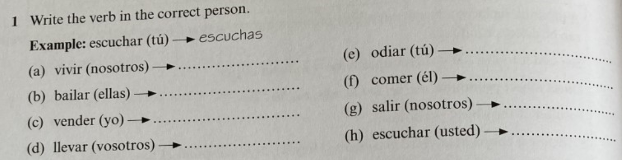
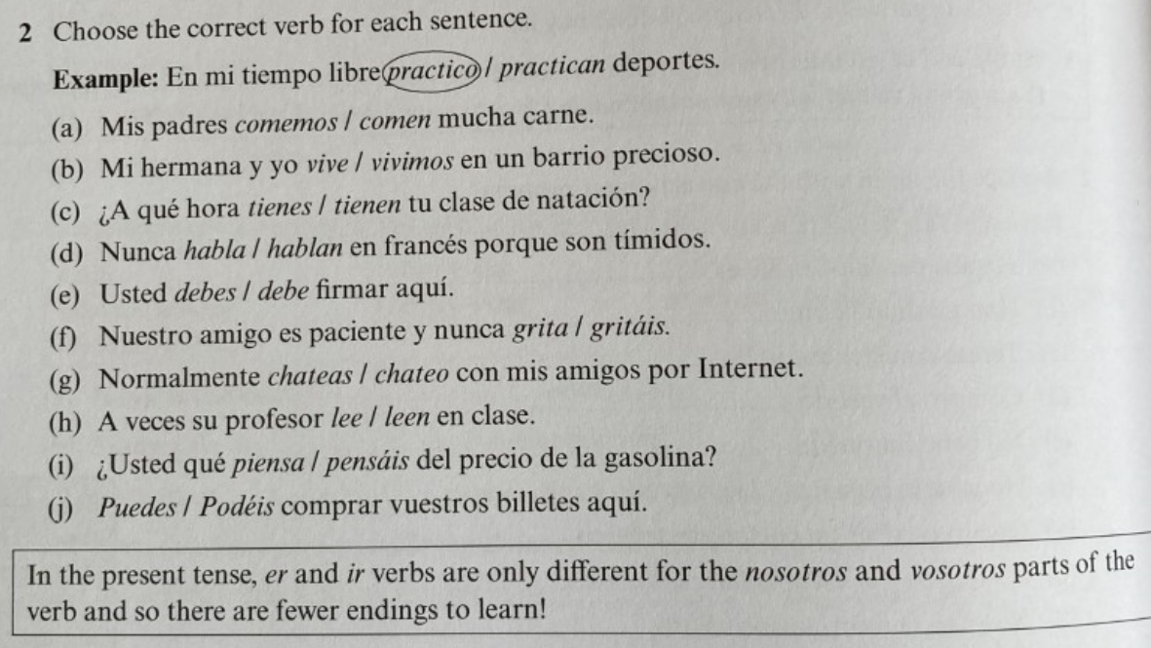

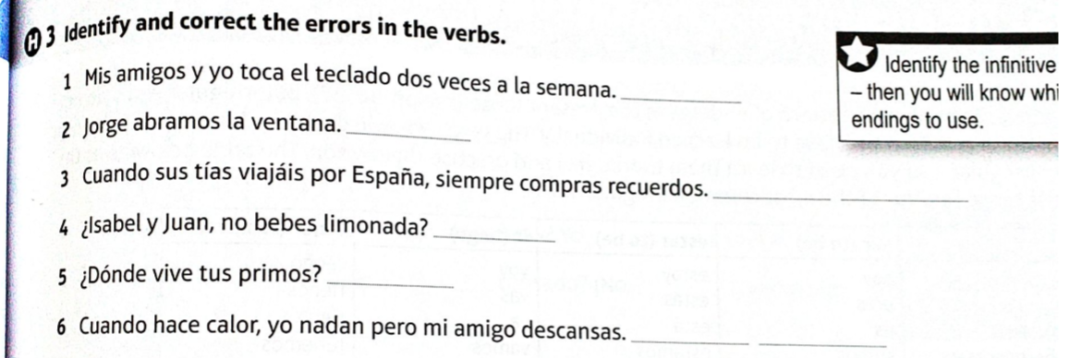

PRESENT TENSE – IRREGULAR VERBS
1.
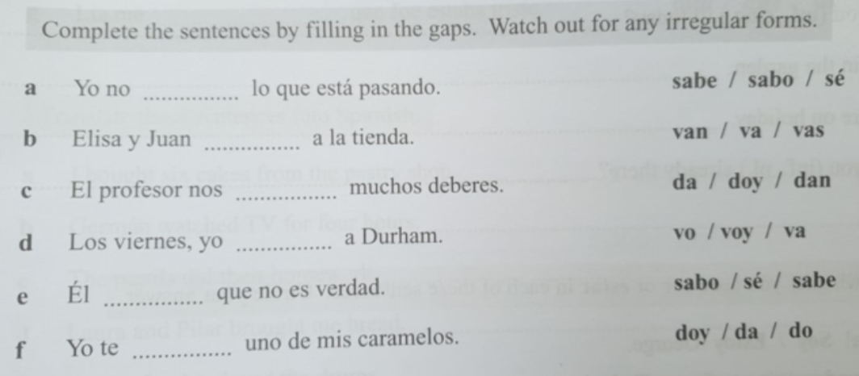

THE PRETERITE TENSE
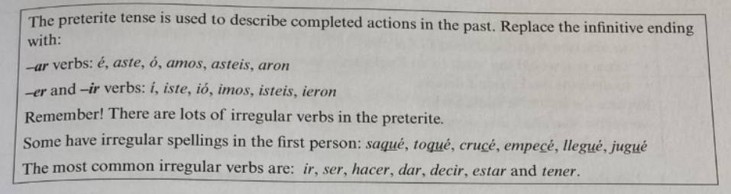
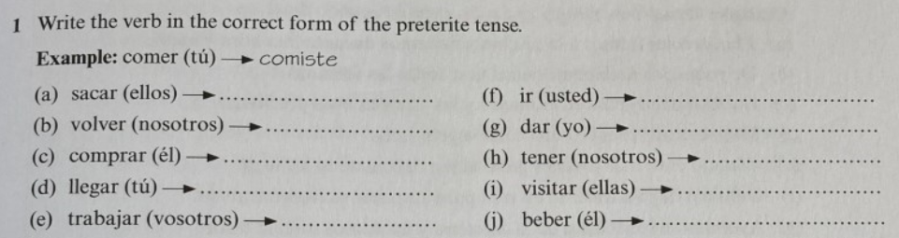
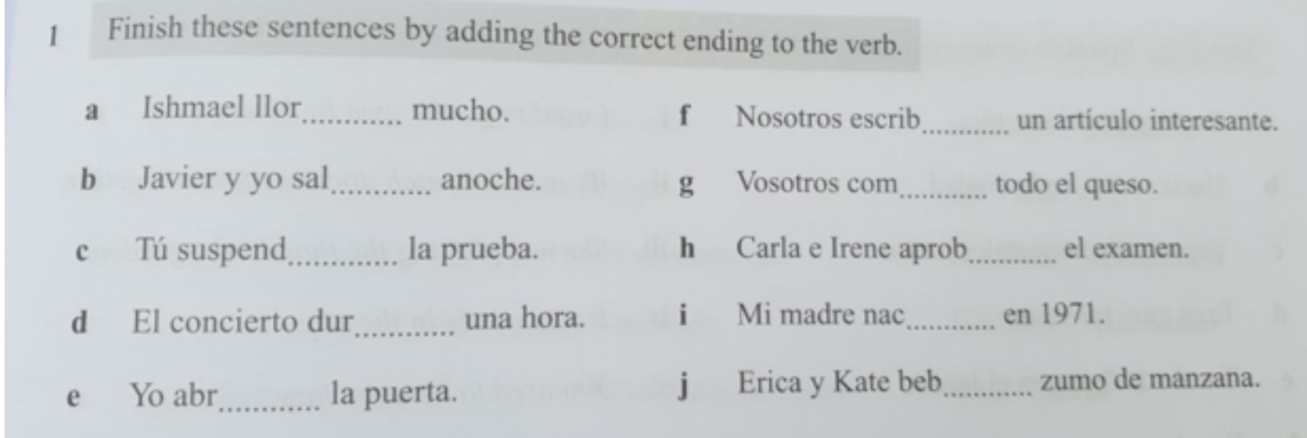
Here you will have to use the verb in the first half of the sentence to help you form the preterite in the second half of the sentence. You may have to use a dictionary to figure out the infinitive.
Ejemplo: Hoy como un bocadillo pero ayer comí un perrito caliente
1) Hoy me levanto a las siete pero ayer me ____________ a las seis
2) Hoy desayuno cereales pero ayer ________________ tostadas
3) Hoy me ducho con agua caliente pero ayer me _____________ con agua fría
4) Hoy me lavo los dientes despacio pero ayer me ______________ los dientes rápidamente
5) Hoy me visto en el dormitorio pero ayer me _____________ en el cuarto de baño
6) Hoy salgo de casa a las ocho pero ayer ______________ a las siete y media
7) Hoy cojo el autobús pero ayer ________________ el coche
8) Hoy trabajo en la primera planta pero ayer _______________ en la última planta
9) Hoy termino el trabajo a las cinco pero ayer _______________ a las seis
10) Hoy vuelvo a casa bastante temprano pero ayer ______________ muy tarde
11) Hoy ceno carne pero ayer _________________ pescado
12) Hoy bebo un vaso de leche pero ayer ______________ una Coca-Cola.
13) Hoy leo mi libro pero ayer ________________ una revista de deporte.
14) Hoy me acuesto a las diez pero ayer me ________________ a las doce.

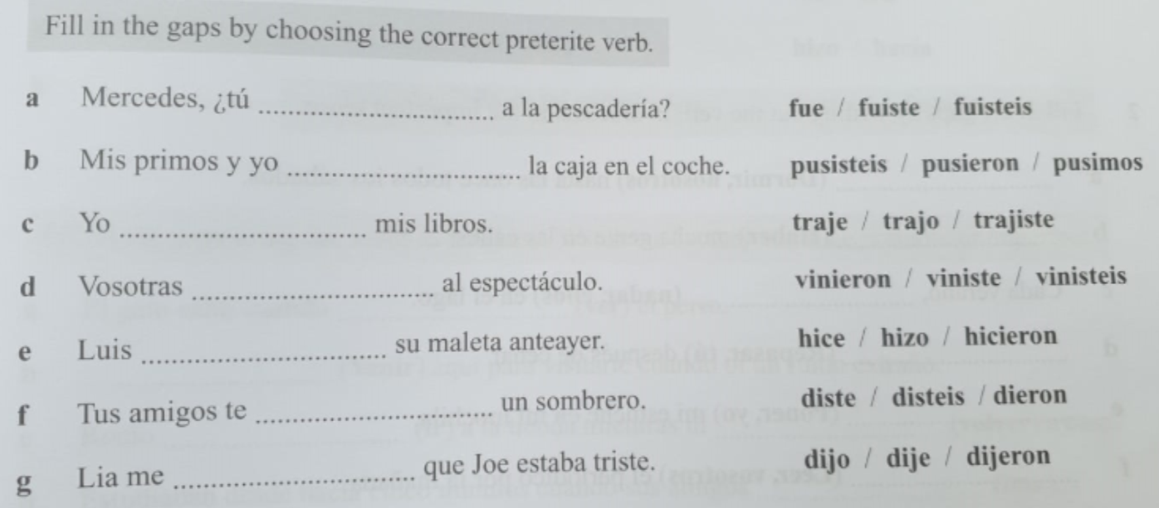

THE IMPERFECT TENSE

AR: aba, abas, aba, ábamos, abais, aban
ER and IR: ía, ías, ía, íamos, íais, ían
Ser = irregular: era, eras, era, éramos, erais, eran

- Yo ……………………………………….en Nueva York. (vivir)
- Jessica ……………………………………con su mamá. (hablar)
- ……………………………………..pescado cada semana. (comer)
- Los perros …………………………………….. en la calle. (jugar)
- …………………………………..la casa. (limpiar)
- Vosotros …………………………………….. español. (practicar)
- Ellos …………………………………….. toda la noche. (beber)
- (Tú) …………………………………….. (correr)
- Usted no …………………………………….. . (estudiar)
- (Nosostros) ……………………………………... (bailar)
- Ellas ……………………………………... (estudiar)
- (yo) ……………………………………..verduras diariamente. (comer)
- (ella) ……………………………………..esas cosas. (decir)
- Vosotros ……………………………………... (caminar)
- (yo) no …………………………………….. . (saber)
- (nosotros) …………………………………….. la ventana. (abrir)
- Ella me …………………………………….. (mirar)
- Ellos …………………………………….. tres bolsas. (traer)
- (Él) …………………………………….. a entender. (empezar)
- (Él) ……………………………………..muy alto. (ser)
- (Ellas) ……………………………………..a la playa cada día. (ir)
- (Ellos) no ……………………………………..de México. (ser)
- (vosotros) ……………………………………..películas todas las semanas. (ver)
- (nosotros) ……………………………………..al cine seguido. (ir)
- (tú) …………………………………….. a este bar. (ir)
- Cuando ……………………………………..estudiantes... (ser)
- (nosotros ) Nos ……………………………………..mucho. (ver)
- Mi hermano …………………………………….. gordo. (ser)
- La ……………………………………..todo el tiempo. (ver)
- (yo) Cuando ……………………………………..niño lloraba mucho. (ser)
- Cuando (tú) ……………………………………..a la tienda... (ir)
- Mis abuelos ……………………………………..franceses. (ser)
- ¿Adónde …………………………………….. ? (ir)
- (yo) Lo ……………………………………..mucho. (ver)
- (ustedes) La …………………………………….. por aquí. (ver)
- (vosotros) Cuando ……………………………………..adolescentes... (ser)
- Cuando tú ……………………………………..joven... (ser)
- (nosotros) …………………………………….. a ese restaurante. (ir)
- (nosotros) ……………………………………..los aviones. (ver)

FUTURE TENSE
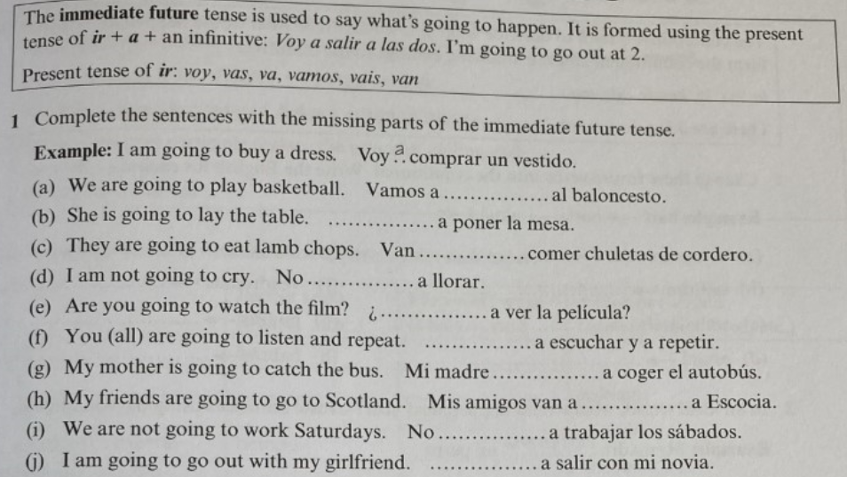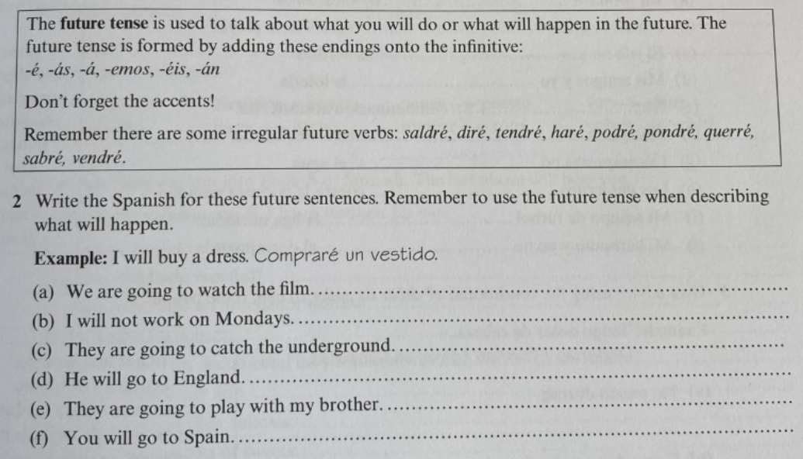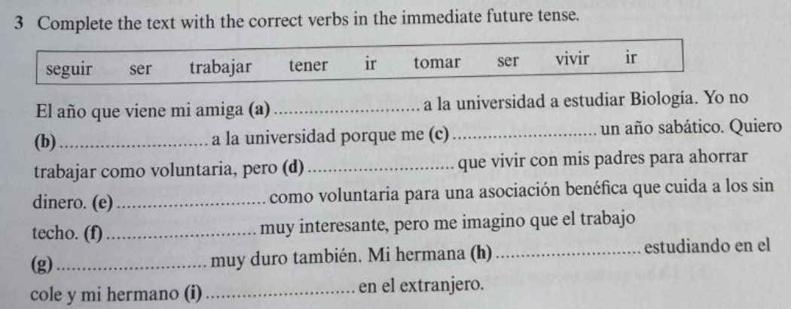

Prepare a presentation on your family.
Here is some additional vocabulary https://quizlet.com/gb/504717405/family-and-relationships-2-flash-cards/?new
Prepare a presentation on the Spanish region and the Latin American country
See research section.

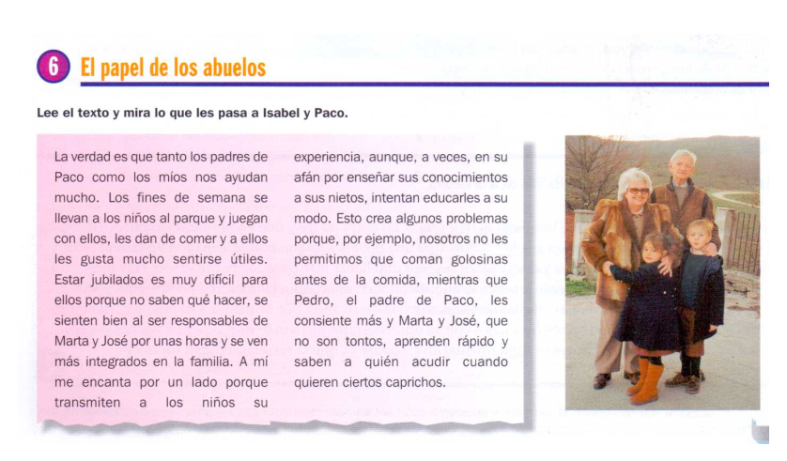
Complete the reading comprehension exercises.

Answer the questions in English.
- Whose parents (Paco’s or Isabel’s) are more helpful?
- How do the grandparents help at the weekends?
- Why is it hard for the grandparents to be retired?
- How does looking after Marta and José make the grandparents feel?
- Why does Isabel like them looking after the children?
- What problems does it cause?
- What do the children quickly learn?

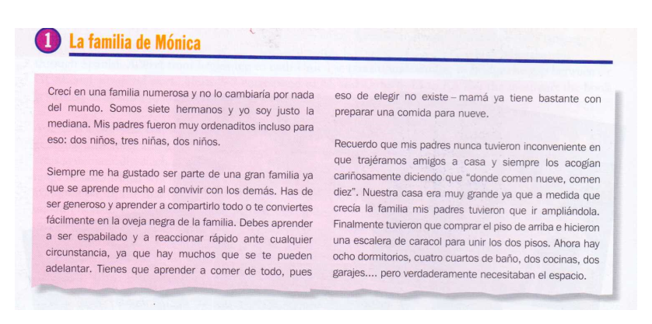

Contesta las preguntas
- ¿Cuántos hermanos tiene Mónica?
- ¿A Mónica, le gusta ser miembro de una gran familia?
- ¿Qué se aprende como miembro de una familia numerosa?
- ¿Es que se puede ser quisquilloso?
- ¿Cómo acogían sus padres a los amigos de Mónica y sus hermanos? ¿Por cuál razón?
- ¿Cómo era la casa de Mónica?
- ¿Qué hicieron los padres de Mónica cuando la casa llegó a ser demasiado pequeña?
- ¿Cómo es la casa ahora?

La familia española
Antes de leer el texto, señala si las siguientes afirmaciones son poco o muy frecuentes en España:
Creo que esta situación es … | Muy frecuente | Poco frecuente
Un chico de 26 años que vive con sus padres
Una mujer que trabaja fuera de casa
Una familia con cuatro hijos pequeños
Una persona divorciada
Un hombre que vive solo

Lee el siguiente texto con atención:

Así somos
En una familia española de finales del siglo XX, y también en las familias europeas, hay muy pocos niños. La tasa de natalidad de España es muy baja (1,2 hijos por mujer). Sin embargo, los hijos no se van de casa pronto. Su salida se retrasa cada vez más porque las viviendas son caras y el paro entre jóvenes es muy alto. Lo normal es que no formen una pareja estable hasta los 27 años.
En comparación con otras sociedades europeas, en las familias españolas hay pocos divorcios (0,5 por mil), quizá porque la ley de divorcio sólo tiene veinte años. No es muy alto tampoco el número de nacimientos fuera del matrimonio en España ni en otros países mediterráneos.
Algunos hombres y mujeres viven solos (3% y 6% respectivamente), pero normalmente las personas solteras conviven con sus padres. Todavía hay bastantes familias (un 9 por ciento) en las que conviven tres generaciones: padres, hijos y abuelos. Otro cambio importante es que actualmente casi el 50% de las mujeres españolas entre 15 y 64 años trabaja fuera de casa.
Seguro Contador, Informe sobre la familia española
- ¿Verdadero o falso?
- Los hijos en España se van de casa pronto
- Las familias tienden a tener pocos hijos
- España es el país de la Unión Europea con más divorcios
- Hay mucho trabajo para la gente joven
- La ley del divorcio española tiene veinte años.
- Hay muchas madres solteras en España

- Busca en el texto las palabras que signifiquen…
- Cantidad / porcentaje de niños y niñas que nacen
- Vivir con alguien
- Casas
- Una persona que no trabaja está en el …

- Haz una lista comparando las diferencias y las similitudes entre España e Inglaterra (siguiendo los puntos del texto proporcionado)

- Sudamérica: Perú
- Lee la carta de Roberto y completa su ficha personal.
  - Nombre ……………………………………………….
  - Edad ……………………………………………….
  - Nacionalidad ……………………………………………….
  - Familia ……………………………………………….
  - Aficiones ……………………………………………….
  - Profesión ……………………………………………….
  - Idiomas ……………………………………………….

- Describe a Roberto.
Éjemplo: Es un chico que vive en Pisco…
- Escribe una carta similar con información.


Hola, ¿qué tal? Me llamo Roberto y vivo en Pisco a unos 220km de Lima, la capital peruana. Tengo 17 años y estoy cursando el bachillerato al mismo tiempo que ayudando en el restaurante de mi abuelo que se llama la Charanga.
Nuestra familia vive aquí desde hace años, aunque somos de la sierra, y todos hablamos quechua, el idioma indígena, al igual que español. Tengo dos hermanos y tres hermanas y nos queremos mucho, aunque nos vemos todos los días.
Soy bastante alto de ojos negros y pelo liso. Me encantan la vida aquí en la costa porque siempre hay algo que hacer – hay muchas fiestas y las montañas están cerca. Me fascinan hacer senderismo en los Andes a salir a las islas de Ballestas en el velero con mi padre. Solemos pescar y a veces hago buceo. Nunca me aburro y pienso quedarme aquí siempre, aunque a muchos de mis amigos les aburre la rutina y quieren viajar a estudiar en el extranjero.

Reading poetry is relaxing, and it develops your understanding of grammar as well as increasing your vocabulary.
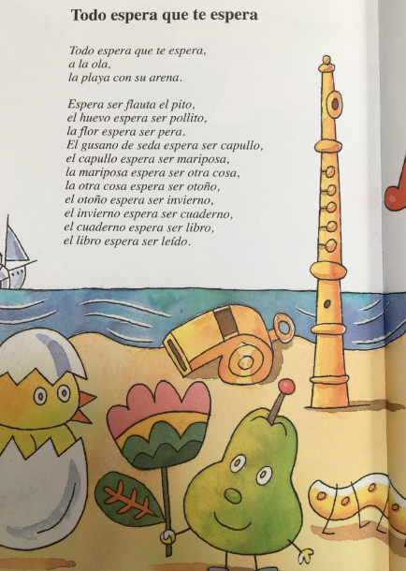
- Read the poem for gist
- Use www.wordreference.com to look up new words. Remember to write them down. Make a quizlet or similar to help you to learn them.
- Can you write your own version?
- If you like drawing, can you illustrate it?
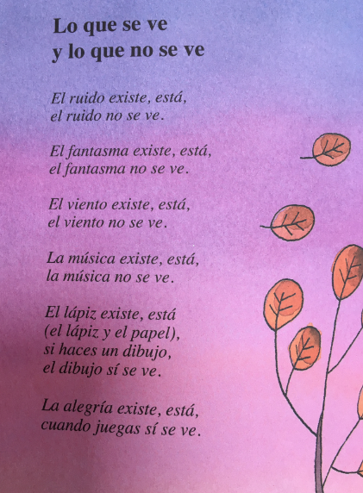
- Read the poem out loud.
- Work out what it means
- Can you make up two more verses?

TASKS | COMPLETED?
Grammar:
- Present
- Preterite
- Imperfect
- Future
- Conditional
Notes made / grammar activities completed
Vocabulary:
- Foundation Transition Vocab
- GCSE Family vocabulary reviewed
- New vocabulary learned
Watch:
- Write about what film/series you watched in Spanish
- Write five facts from a documentary you have watched.
Listen:
- 2 Summaries completed in English of…. (news story/podcast)

Read:
- Summarise 2 articles from BBC Mundo in English and annotate with vocabulary.
- Summarise 1 article from Hola in English and annotate with vocabulary.

- Reading comprehensions
Research:
- Prepare a presentation on your family to show off your GCSE and new vocabulary
- Prepare a presentation on the area of Spain/South American country you have researched
Other:
- Poetry: read and adapt your own, and illustrate your own version if you like

Appendices/Resources

Online dictionaries
- https://www.spanishdict.com
- www.wordreference.com
- www.leo.org

Apps
- Quizlet
- DuoLingo
- Vocab Express
- Spotify
- Radio Garden
- SpanishDict
- RNE Audio

