
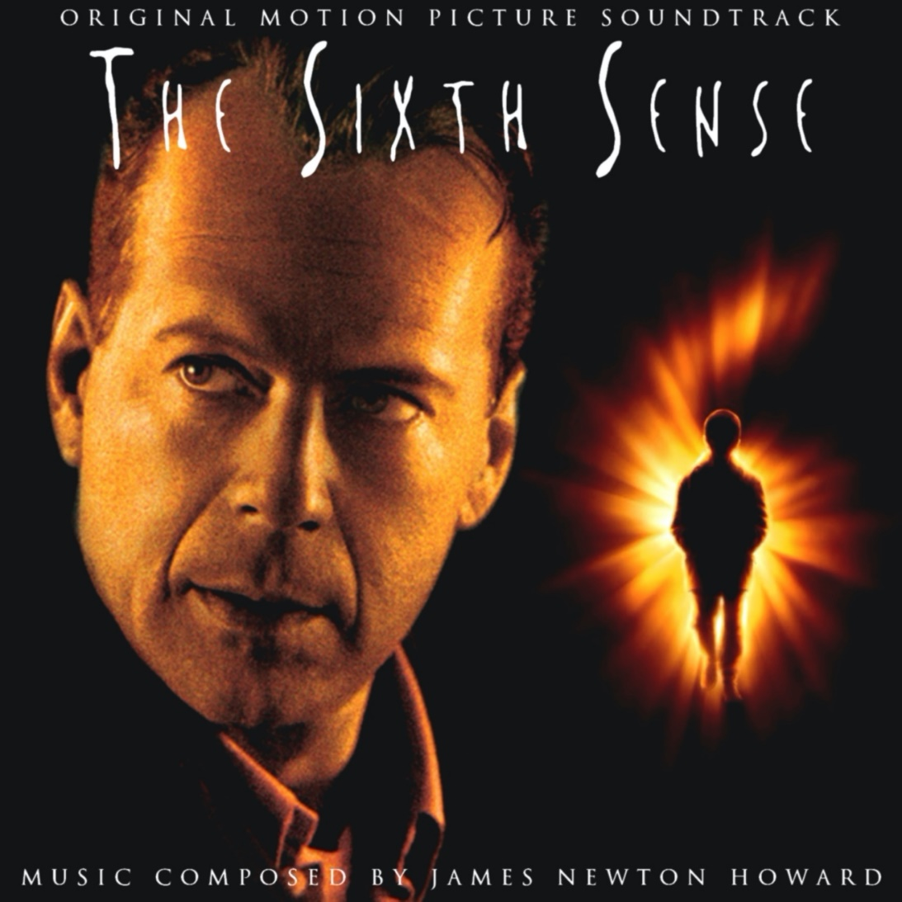
Year 11 > 12 Bridging Work
Summer Term 2026

Subject | Digital Media
Course | Cambridge Technicals Level 3
Awarding Body | OCR

Contents:
 |  | Page(s)
 | Course/specification overview | 3
 | Our department expectations | 4-5
 | Watch and Listen to | 5
 | Read and Research | 5
 | Complete | 6-11
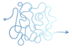 | Appendices/resources | 12-25

Course/specification overview

Each year you will need to complete 2 Coursework units and 1 exam unit – you will need to pass both exam units to get a grade
Year 12:
Unit 1 – Exam 90 GLH– Media Products & Audiences
Unit 21 – Coursework 30 GLH – Plan and deliver a pitch for a media product
Unit 3 – Coursework 60 GLH - Create a media product

Year 13:
Unit 2 – Exam 90 GLH – Pre-Production and planning
Unit 20 - Coursework 60 GLH – Advertising Media
Unit 23 – Coursework 30 GLH - Create a personal media profile

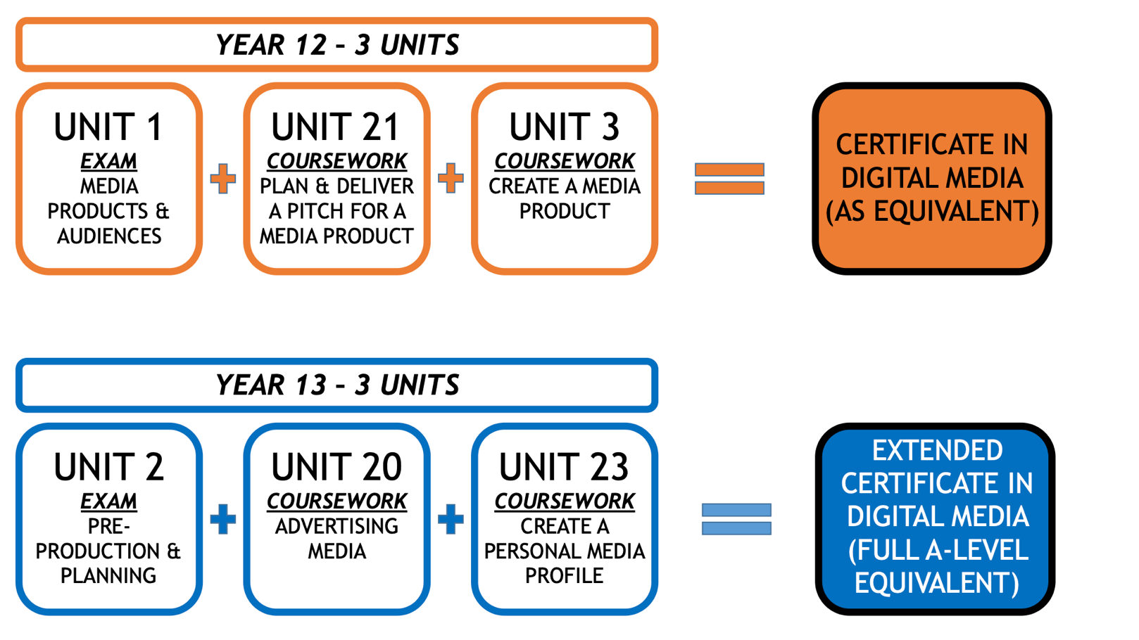

Our department expectations

Welcome to the Digital Media-Level 3 Cambridge Technicals course at Hayes School.
This is an exciting course, which will develop your technical skills and broaden your
knowledge and understanding of the Media. At this level, we expect students to be disciplined and self-motivated. Under normal circumstances the Media Department is able to provide you with essential equipment: DSLR cameras, tripods, microphones, green screens, lighting equipment and editing software (which includes iMovie, Adobe Photoshop, Adobe InDesign, Adobe After Effects and Adobe Premiere Pro).

Part of the role of a dedicated media student, is to adapt to any given situation. Therefore, we hope that you will be both creative and resourceful, when it comes to using equipment. Please visit websites that demonstrate how to get the best out of your mobile phones, try out free editing software eg GIMP and see which one best work for you. Over the coming months, spend as much time as you can reading articles on: Media Pre-Production, Production and Post-Production (Adverts – TV and Posters, Horror Films, Magazines, Radio and Websites), Lighting, Set Design, Cinematography and Cameras, Film Directing, Script Writing, Storyboarding, Graphic Design, Acting, Advertising, Colouring and Editing.
Our Vision within the Media Arts department is to help our students to become active and critical audiences of the mass media. We want students to take responsibility for their Media consumption habits and help them to understand the effects of their choices. We also see the creative potential of the media and want to encourage Media Arts students to become active producers of Media texts. We do not subscribe to the narrow view that the Media is a dangerous thing.
For students that do opt to study Media Arts subjects at Hayes there are a range of potential pathways that one could follow. Anyone that completes an A-level or Cambridge Technical Level 3 qualification in Media or Film will have the opportunity to study further at university.
There is a wide range of Media-based courses at universities across the country – ranging from more academic courses looking at Media Theory and the potential effects of the mass media on society; to more production-based courses where students will develop creative skills to a professional standard. From studying a broad subject such as Media Studies pupils could then narrow down their focus at University and concentrate their study on one discipline for example Digital Media, Film Studies, TV Production, Screenwriting, etc. Alternatively, if University isn’t for you then studying Media Arts courses will provide a good grounding for going on in to work within the Creative Industries. In particular, the Applied Media qualification will give students the necessary skills for working as part of a Media Agency where research, pre-production, production, and post-production skills will be needed.
Ultimately, we also hope that having studied Media Arts at Hayes you will develop a passion for creating your own Media products and that this is something you will continue to pursue after you complete your studies.
Hayes School 6th Form takes students from a wide range of schools, who have studied a variety of GCSE syllabuses. We want to ensure that everybody is equally able to access the content of this OCR Level 3 Cambridge Technical course and so the following tasks give you a chance to ensure you are fully prepared.
Watch & Listen

You will need access to horror films in order to prepare for UNIT 21.
We do have some horror films on DVD in school for loan, but they can all be access through Streaming services and other formats.
Do contact me if you are unable to access the film you want on JXM@hayes.bromley.sch.uk
You will also find many online clips analysing most sub-genres of horror films

Research & Read

There are many online sources to help you investigate your chosen horror films.

Some key websites are as follows, but there are many more.
As with all online research, you need to check how reliable the source is. Information from academic sites will be the most trustworthy.

Imdb.com

  - The main source of information on basic details about any film

Rottentomatoes.com
  - The best place to find reviews. Ones with a red tomato are positive reviews and ones with a green tomato splat are negative

Englishmedia.co.uk
  - The Media Magazine is directly aimed at Sixth Form students studying Film and Media courses. We have a subscription and you can read the latest issues or search specific topics and films
  - Login: MADatHayes
  - PW: Haftas

Complete
The theme of ‘Horror’ will play a big part in the coursework for year 12. Get a head start and complete the below – you can actually use it as part of your coursework!
The horror genre breaks down into 6 main categories, which we call sub-genres. These are:
• Slasher
• Paranormal
• Zombie
• Vampire
• Gorno
• Psychological
To help you produce this report we have broken down the project into the following tasks
:
Task 1: Find a film for TWO of the 6 sub-genres of horror. You MUST choose PARANORMAL HORROR and then choose another of your choice. Include a poster for each – tell us who directed it and if it had a famous star in it. (A4 side for each sub-genre)
Task 2: Briefly, explain the story for each film in no more than 10 bullet points
Task 3: Explain why each film fits into that sub-genre and not one of the others
Task 4: Write a short review explaining which your favourite is and why, and which is your least favourite.
Extension:
Can you research and apply a media theory to back up and support your arguments.
To help you research for this project and give you wider information about our courses we have our Media Arts Guide, accessible through our website.
https://www.hayes.bromley.sch.uk/home/curriculum/media-arts/
Your Bridging Unit Report is normally due to be submitted by the end of your first month in the Sixth Form – end of September. However, with no exams to worry about, you might well be able to complete this task during this term.
Please note, however, that the Bridging Unit is not only a way for you to start thinking about Digital Media as a subject but is also a way to show your Sixth Form teachers that you understand the work demands of Camtech and A Level subjects and are on the right courses. Therefore, it is very important that you complete this task to the best of your ability and meet any deadlines set.

I have attached below a range of resources, on both terminology used in Digital Media (Sound, Cinematography, Editing and Mise en Scene) and analytical vocabulary, to help you with your Bridging Unit tasks. I have also included the brief, for the start of the course in September. You may like to read through the brief, in order that you can research and prepare for the course. Please feel free to email me if you have any questions.
Good luck to you.
Kind regards
Mr Moreton

This is the brief for Unit 21, which would normally be handed out at the start of September - Plan & Deliver a Pitch for a Media Product.

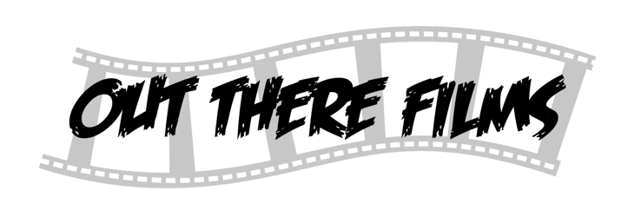

Dear Account Manager
We at Out There Films are looking for a dynamic team to come up with a range of ideas for a new British Paranormal Horror film, one of which will need to be developed into a pitch and presentation, including a range of planning documents.
We have a proud history of creating innovative and engaging British films aimed largely at a youth market of 16-25 year olds.
About the Product
We are a completely independent British film production company. We produce low budget but exciting horror films and are looking at the sub-genre of Paranormal. This sub-genre focuses on supernatural elements such as ghosts, evil spirits and demons. Our films typically give opportunities to exciting new talent rather than well-known existing ‘stars’.
Proposal & Pitch Portfolio
We are looking for the following materials to be produced to complete your proposal and pitch portfolio:
- A profile of your Target Audience (Young People is a big group! We want to know the specifics)
- An understanding of the codes & conventions of the subgenre of paranormal.
- Evidence of research into existing paranormal horror films.
- A report into the Production, Distribution & Exhibition of the proposed idea.
- A formal pitch of your proposed idea, which will be supported by promotional materials.
- Focus group feedback regarding your idea.

We have a limited budget so we can only consider the most creative and inventive ideas. We need to receive the above by 9th February 2027.
Yours Sincerely
Mr Polter Geist
Chief producer
Out There Films
P.Geist

Appendices/resources
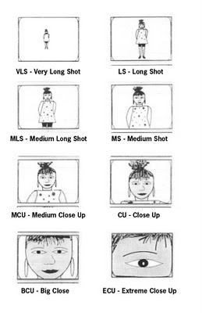
CAMERA TERMINOLOGY

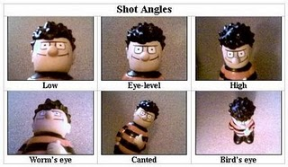

Aerial shot (or crane): a view from directly overhead to afford a clear view – sometimes used to emphasize the spectacle. A crane shot is usually necessary to achieve this (sometimes called a bird’s eye shot) http://www.youtube.com/user/FilmSchoolOnline#p/u/9/8tZiFwSmhBI
Canted Angle – A shot which is tilted to one side. This is often used to create a feeling of disorientation.
Close up (and variations): close ups, including extreme, big and medium close ups, are used to draw the viewer closer and to involve them in what is happening; they also used to observe reactions and emotions, such is happiness, elation or tension. These shot often used to privilege the protagonist over other characters and position the audience with him or her
Crab Shot: a type of shot which involves the camera being placed in a confined space. e.g. A shot taken from inside a cupboard is the subject opens the cupboard door.
Crane Shot (or Aerial): a type of shot in which a camera is positioned on a specially designed crane, which can be raised and lowered and will. A crane shot is a high-angle shot but the versatility of the equipment allows a director to start a shot from a high-angle and then swoop down toward the subject at ground level. http://www.youtube.com/user/FilmSchoolOnline#p/u/9/8tZiFwSmhBI
Deep Focus: a camera technique that allows objects both near and far from the camera to be in focus at the same time.

Establishing shot: the shot (usually wide or long), often used at the start of a programme or film, a new section of a programme or at the start of a new scene to establish the relationship between the set/location and the characters and to show the whole view
Hand-Held shot: A shot filmed with the camera, not on a tripod but instead held by the cameraman, often whilst walking. This makes the shots seem quite shaky. This can make the audience feel the scene is more realistic, or can make us feel like we are part of the action
Head-On Shot: for a type of shot in which the action comes directly toward the camera. Head-On shots are often used in war or action movies to enhance the sense of involvement and excitement of the audience, for example, charging cavalry may be directed at the camera.
High angle: to provide a view from above the subject(s), often making the subject look vulnerable, isolated or powerless. This is sometimes combined with a crane shot into a closer shot of the subject(s).
Long Shot: a distance shot where the camera is a long way from the subjects being filmed. A long shot can be effective as an establishing shot that sets the scene for the action and roles in the viewer.
Loose Frame – Describes a shot where there is a lot of room around an object or person. Usually used to show them as being alone or isolated or unimportant.
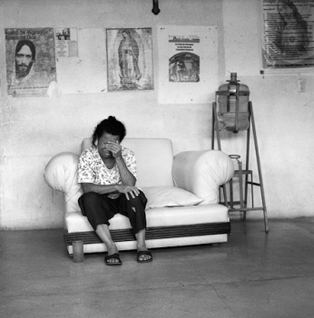

Low-Angle Shot: a shot where the camera approaches a subject from below eye level. A Low-Angle shot can emphasize the size of the object being filmed and add to a point of view perspective. It can make the character shown seem big and powerful and it can make us or the character we are seeing through, seem small and weak.
Master Shot: a camera shot used at the beginning of a sequence to establish the component elements and relationships in such a way as to allow the audience to make sense of the action follows.
Pan: camera action involving gently moving the camera 180°across the subject matter in a horizontal plane
Point-of-View Shot (POV or Subjective Filming): a camera shot taken from the position of the subjects, used to enhance a sense of realism and audience involvement in the action.
Pull Focus – Describes a shot where one thing was on focus, and then the lens is changed so that something else stops being blurry and becomes in focus. Often used to show how something has become more important.
Rule Of Thirds – Describes a technique used to make a shot look interesting. Rather than placing a person or object in the middle of the frame, they are placed at the sides, or where the lines cross on this imaginary grid.

Shallow Focus – Describes a shot where an object near the front is in focus, and everything else behind is out of focus (blurry). Often used to make one thing seem more important.

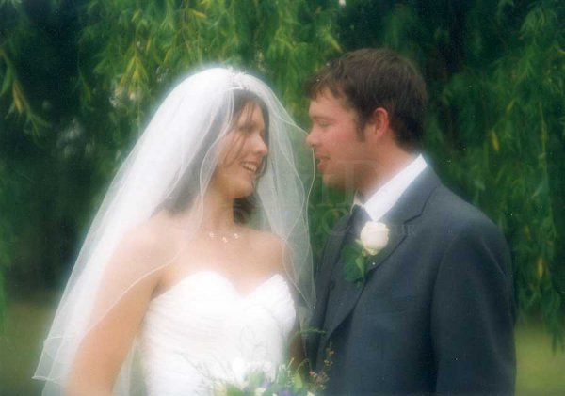
Soft focus: in images, the use of a special lens or filter to create a hazy light around the subject. Soft focus shots are associated with the romantic or sentimental treatment of subject matter.

Tight Frame: Describes a shot that is composed with the person or object given very little space around them. Often used to make them seem important, or trapped.
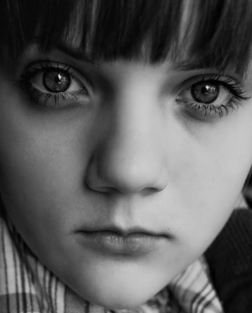

Subjective Filming (or POV): a type of shot in which the camera is positioned as if looking at the world through the character’s eyes.
Tilt: a camera movement that involves moving the camera vertically up and down from a fixed position.
Tracking Shot: a camera shot in which the camera moves along rails to follow the subject. When the rails are replaced by a moving platform on wheels, the shot is called a dolly shot. As you wont know how this shot was filmed you can call it either a Tracking OR a Dolly shot.
Whip Pan: a very fast pan between two or more characters all points of interest. He gives the impression camera has been ‘surprised’ by activity and is used in the place of a more conventional cu or shot/reverse shot.
Wide shot: this can be used as an establishing shot of a set or location or to show a large crowd of people. They can also emphasize the isolation of a single figure.
Zoom/Reverse Zoom: the adjustment of the camera lens to allow the operator progressively to move in close off or to pull away from the subject.
180 degree Rule – Where, during a scene featuring two people or more, we can imaging an imaginary line joining those two people together. Adhering to the 180 degree rule would mean you would always ensure your camera was on one side of that line and the camera would never be crossed to the other side. Sticking to the 180 degree rule allows the viewer to feel comfortable, helps us understand the positioning of the characters and makes it feel like real life. ihttp://www.youtube.com/user/Sarahmediafilm#p/c/6A39684E8F4376B7/0/HdyyuqmCW14
Breaking the 180 degree rule (Crossing the Line) – Where, during a conversation or a scene between two people, the camera does NOT stick to one side of the line (see above) and crosses over at some point. This disorientates the viewer as we are unable to work out the position of the characters within the room. It makes the scene seem odd or strange and may reflect the feeling of the characters. ihttp://www.youtube.com/user/Sarahmediafilm#p/c/6A39684E8F4376B7/0/HdyyuqmCW14
To see video examples of various shot types:
http://www.youtube.com/watch?v=fe2PqbUk0bU&feature=related

EDITING TERMINOLOGY
Action match: A shot that cuts to another continuing a piece of action or movement between the shots. Allows audience to see a smooth action despite a cut in the shot. For example we might see someone shoot a gun, and the editor would perform an action match so we then see the bullet hit someone else and they fit together seamlessly so we see both people’s perspectives. http://www.youtube.com/user/Sarahmediafilm#p/c/9A8A1640CC2BB752/1/laUPi7MPOSQ
http://www.youtube.com/watch?v=ONMSe_zhq70
Continuity Editing: an editing style that aims to present the text in a chronological manner to emphasize the real-time movement of the narrative and to create a sense of realism for the viewer by giving the impression of continuous filming. Continuity editing creates a narrative that approximates to the real experience of moving through time, even though screen time usually covers a much longer period. Audiences feel comfortable with a linear progression that reflects their everyday experience. http://www.youtube.com/watch?v=qoaw7iTPlZc
Cross cutting (also known as Parallel editing): Where an editor cuts between two separate scenes happening in two separate locations at the same time. This serves to illustrate a contrast or a link between them. For example, cross cutting between adults having a quiet drink in a pub, and a wild teenage party will contrast the two age groups. Another example is in the Godfather where the editor cut back and forth between the christening of a child in a catholic church, and the violent killing of several men. The cross cutting in this sequence emphasises the violence as we see it juxtaposed against childlike innocence and religion. http://www.youtube.com/user/FilmSchoolOnline#p/u/13/A7SLL9esQOA
Cut: The move from one shot to another can tell us lots of things. For example, it can draw our attention to things. If a woman is daydreaming at her desk and the editor cuts to a scene of a man, we can assume that she may be dreaming about him.
Cutaway: a brief shot that is not totally necessary but is cut into a scene showing a related action, object or person, not necessarily part of the main scene, before cutting back to the original shot. For example, a couple may be having an argument which is the main scene but the editor may choose to include a cutaway shot of their child’s crying before cutting back to the couple arguing. This emphasises the child’s emotions and helps the audience to understand that we are to disapprove of these people’s argument. http://www.youtube.com/watch?v=ONMSe_zhq70
Dissolve: Dissolve is when the first shot is on screen and the 2nd shot starts appearing on top of it more and more until all you can see is the 2nd shot. Often used to link two scenes or two people together. Sometimes used to show time moving on etc.. http://www.youtube.com/watch?v=qoaw7iTPlZc
Ellipsis: the removal or shortening of elements of a narrative to speed up the action. For example an editor might use ellipsis in a sequence about a young man taking a drink by cutting straight to him as an old man, drunk and alone. The editor has missed out the story in the middle to speed up the action and show us how quick this man’s life has passed.
Eyeline Match: a type of editing that maintains the eyeline or level when cutting from a character to what’s the character sees. The effect of the edit is to create a sense that what the camera sees is what the character sees. It puts us in the position of the characters and helps us feel empathy for them. http://www.youtube.com/watch?v=qoaw7iTPlZc
Fade: a type of moving image editing where the image gradually fades and disappears, leaving a white or black screen. A fade to black often suggests that time has passed, or a situation has ended. A fade to white often suggests a dream sequence.
Graphic match: A cut from one shot to another that look visually the same (possibly linked by a similar shape, a similar colour etc. They are there to show us a clear link between two scenes. Often this is making a comment on the issue. For example, a young girl playing with a red doll then is cut together using a graphic match with a woman holding a baby dressed in red. This might suggest that the young girl has grown up into the woman. Or it might emphasise the gender stereotype of women looking after babies. http://www.youtube.com/watch?v=qtbOmpTnyOc

Jump Cuts: a cut that moves to a very similar part of the same scene but missing a piece of action out (eg a character is on one side of the room, and then is on the other and we don’t see him walking). They are often used to disorientate the viewer or show how disorientated a character is. For example, if a party of young people was being shown and included lots of jump cuts, it would represent the young people as disorientated, implying they were drunk and wild. http://www.youtube.com/watch?v=ONMSe_zhq70
Linear Narrative: a sequential narrative with a beginning, a middle and an end-in that order. Linear narratives provide a straightforward, sequential representation of events leading to a single resolution. As such, easily accessible to audiences and are the dominant form in mainstream media representations.
Long take: each time a shot is recorded it is called a take. A long take is one that is allowed to remain on screen for a long duration before it is cut. Long takes are often used to slow the pace of the scene down, making it calmer and more peaceful http://www.youtube.com/user/Sarahmediafilm#p/c/AACD3B2246DAEFF3
Montage: a montage is a series of shots edited together to show time passing and something happening in that time. Famous examples are in Rocky where we see a montage of shots of Rocky training and getting better and better before his fight. http://www.youtube.com/watch?v=DP3MFBzMH2o http://www.youtube.com/watch?v=CQvNu8LoTo0
Parallel Action (Cross-cutting) the narrative technique of showing two or more scenes happening at the same time by cutting between them. http://www.youtube.com/watch?v=zn05SNN9p3g
http://www.youtube.com/user/FilmSchoolOnline#p/u/13/A7SLL9esQOA

Short take: a short take is one that is allowed to remain on screen for a short time before the editor cuts to something else. Short takes are often used to speed the pace of the action up, making it more dramatic and exciting. http://www.youtube.com/user/Sarahmediafilm#p/c/AACD3B2246DAEFF3
Shot / Reverse Shot: cutting between two people having a conversation (rather than including them both in one static mid shot) can help to contrast them and make them seem different. It highlights their differences and also allows us to see the reactions of characters.
Slow motion: used in the editing process to slow down the action for emotional or comic effect.
Split Screen: an editing technique which involves the cinema screen being split into two or more parts to allow the showing of events that are taking place at the same time.
Superimpose: the appearance of writing/symbols or images on top of an image so that both are visible at once, increasing the amount of information the viewer has in one shot.
Visual effects: depends on what it is. Often it depends on what the character’s reactions to these special effects are. For example, a man who has no reaction to a massive fiery explosion will seem brave and masculine. Graphics on screen (eg numbers and facts as seen in CSI, may represent someone as intelligent or competent in their work. Showing someone in colour when the rest of the image is in black and white emphasises them and draws the audience’s attention to them as important.
Wipe: a moving image editing technique that involves one image wiping another off the screen. This suggests that whatever scene / character pushes the other one off the screen, is more important or powerful. Wipes can go left or right, up or down and even be in shapes like stars! http://www.youtube.com/watch?v=VnixMJvOtpI
SOUND TERMINOLOGY
Ambient sound: The sounds of the location eg water noises near a river, cows mooing in a farm etc. They tell us what kind of place we are in and if we see how characters react to these sounds it tells us a lot. Noisy cars, horns, people, traffic represent a region as being busy and urban and not very homely.
Asynchronous sound: Asynchronous sound is where the sound is either out of sync with the visuals or is unrelated to the visuals. Sound that is just out of sync would make the viewer feel disorientated and would make the characters and scene seem strange. Sound that is unrelated to the visuals may be there for emphasising something. For example, in the Godfather film, we see a man murdering people in cold blood, but hear the sounds of a priest christening a baby. This contrast emphasises the loss of innocent life. http://www.youtube.com/watch?v=bC1-6nDGRfc&feature=related
Contrapuntal sound: sound or music that seems strange in comparison to the scene we are seeing. For example, in the film the Shining, during beautiful scenes of winding roads and countryside on a sunny day, we hear quite scary ominous music. http://www.youtube.com/watch?v=rQNqFfXSt38&feature=related
Dialogue: the words the characters say. What do the characters actually say? Do they reveal their beliefs, or their attitudes? How do they say it? If someone’s voice sounds nervous and wobbly it tells us a lot about their character. If they speak softly it implies they are weak or emotional. If they have a deep booming voice it makes them seem more masculine. Don’t forget accents as they tell us where someone is from and emphasise their differences from others.

Direct address (also known as breaking the 4th wall): where the character talks to the audience directly. Don’t confuse this with a point of view shot. It is very unusual and breaks the reality for the audience, but also helps us to see that character as an equal, a friend, as someone to sympathise with. Often seen in shows like Scrubs and Malcolm in the Middle.

Diegetic Sound: sound that you could hear if YOU were one of the characters inside the scene. This include words the characters say, background noises like traffic and crowd noise and even music IF it is heard by the characters eg at a club, on a television etc Diegetic sound can set the mood of the piece, influence a character’s behaviour or emotions, and help the viewer to see a scene as realistic etc
Non Diegetic Sound: Other sound that the characters in the scene could not hear . For example, a musical soundtrack, a voice over etc. Non diegetic music sets the scene and time period as well as atmosphere. A voice over allows the audience to hear someone’s thoughts and empathise with them.
Pitch: Low pitch described a sound that is deep and low (eg Thunder) and high pitch describes a sound that is higher and lighter (eg a phone ringing)
Rhythm: Describes the beat of the music, whether it is fast or slow. Sound or music with a fast rhythm is often used to increase a sense of urgency or threat. Sound or music with a slow rhythm is often used to depict calmness and peace. Sound or music with an irregular rhythm is used to confuse the audience and make them feel uncomfortable.
Voice over: the use of a voice, over images, perhaps as an introduction, a linking narrative device for or to comment on action. It allows the audience to see inside the head of a character, helping us to empathise with them.
Sound bridge: a portion of sound that covers a cut, normally to link two scenes together. For example if you were to see a woman talking about how much she missed her boyfriend, and her voice continued as a sound bridge on top of the shot of him, even if just for a few seconds, it emphasises that he is the man she is talking about. Sound bridges are often used to try and mask cuts from the audience, making it seem more realistic. http://www.youtube.com/watch?v=oIkpD2Nr5yI&playnext=1&list=PL011F31D3E38DBB59
Sound motif: hard to spot in a short clip. But this is a sound which normally represents a certain character. For example the Da DA of the shark in the film jaws. We associate that music with them.
Sound Effects: a sound accompanying an action, sometimes musical. For example in the film Psycho, short sharp violin noises accompany each stab of the knife during the famous shower scene. This emphasises the violence of each stabbing motion and makes it more dramatic.
Soundtrack: music from a soundtrack (all the sounds) or score (just the music) emphasises the themes and emotions of a scene or character. Think about the beat and instruments used. For example a high energy dance track with loud crashing tones will emphasise someone’s youth.. a girly soft piano music might help us to see a woman as stereotypically delicate and feminine.
Synchronous sound: synchronous sound is sound that is in sync with the visuals and was filmed at the same time.
MISE-EN-SCENE TERMINOLOGY
Lighting (general): can be used to highlight important characters
High Key Lighting: a bright and well lit scene with very few shadows. Often used to make a location or character seem friendly, happy, safe. http://www.youtube.com/watch?v=sUvkWkxFb2M
Low key Lighting: a dimly lit scene with lots of shadows. Often used to make a location or character seem shady, untrustworthy, dangerous, unsafe. http://www.youtube.com/watch?v=91gU93J2Q8k&feature=relmfu
Chiaroscuro Lighting: a scene lit with extreme lighting, lots of shadows, some very bright parts. See the effects of low key lighting. Also used to make a location or character seem very dramatic and unusual. http://www.youtube.com/watch?v=9SlH_uvPuRw
Body Shape and Language: the way a character’s body looks and the way they hold their body eg confident, slumping down, cowering from someone etc It tells us what type of person they are and how they feel about others.
Facial Features and Expression: the way a character’s face looks and shows emotion. For example a shocked expression, sadness, a look of love. You can also comment on the way they look such as a interesting features such as bad teeth, small, squinty eyes etc It tells us what type of person they are and how they feel about others.
Props: items a character possesses or picks up eg a gun or a bunch of flowers etc.. They can tell us lots about what type of person someone is
Costumes: clothes a character is wearing. You could comment on the style, shape, choice of item, colour, etc. They can tell us lots about a character, what type of person they are, how they are feeling etc. For example, a floaty dress might represent someone as being traditionally girly. A policeman’s uniform might represent someone as having authority and power. Baggy, shapeless clothes might suggest someone is shy, where as tight clothing might suggest they are confident and flirtatious.
Hair & Make Up: the appearance of the hair of a character and the cosmetics a character might be wearing such as lipstick, a skin head etc. They tell us things about the character. For example, a woman wearing very little make up might be seen as being very naive and innocent.
Voice / Tone: the way a character speaks tells us a lot. Someone who stutters might be nervous. Someone who shouts may be angry and powerful.
Colour: colours in a scene often represent things. Red can represent anger, passion, danger, love. Blue can seem calm and peaceful, sometimes sad. You must pick the most appropriate meaning for the scene.
Location: a place where the scene is set. A location can tell us lots about the people in it. For example a dirty, bloodstained basement could signify that a character was a villain or up to no good. A messy bedroom might signify that the character who owned it was disorganised. Don’t forget to look out for how a character reacts to their location as well (eg if they are comfortable there or not)
Breaking the Fourth Wall (Direct Address): describes a time where a character may look directly at the camera and speak to the audience. This is highly unusual but can be seen regularly in shows like Malcolm InThe Middle. This is designed to emphasise that character as the most important, as powerful, and as someone we should be siding with as it helps us feel like we are “one of them” and as though we are one of their friends.
GENERAL TERMINOLOGY
Agenda: a plan or belief system within a group, normally hidden from others. For example there is a belief that the BNP have a racist agenda.
Antagonist: the leading villain in the show (or the one the protagonist has to go up against)
Archetype: an easily recognised type of character that can be found in many stories. For example, the hero, the princess, the damsel in distress, the loyal friend, the villain, the temptress.
Binary Opposites: two contrasting characters or scenes that are seen in one show, that are clearly meant to be total opposites. For example there may be a sweet innocent girl who is scared and weak, paired against an evil powerful man. They would be binary opposite characters. Binary opposites could be concepts such as good/evil, light/dark, male/female, old/young
Connotation: hidden Meaning. For example, “the connotation of the main female
Conventional: something that is seen to be “normal”. So a conventional female character would be quite weak, girly, and may be a mother or a housewife.
Dominant Ideology: a set of beliefs that are widely accepted as being the most normal, or the most accurate. For example, the dominant ideology of men is that they are strong, brave and work to provide money for their families.
Homophobia: actions, behaviours, feelings or words which seem to discriminate against people because of their sexuality. This is normally because the person who is being homophobic believes there is a difference between sexualities and thinks that one sexuality is better than the other.
Juxtaposed: two different things placed next to each other to create meaning. For example a shot of a baby may be juxtaposed with a shot of a funeral to emphasise the circle of life.
Male Gaze: a theory by a lady called Laura Mulvey which suggests that all media products encourage the characters and audience to “leer” at and “look” at women. For example, “the camera angle looking down Sarah’s cleavage encourages the audience to take a ‘male gaze’ over the female character”
Media Language: simply means the combination of technical elements such as camera shots, camera movement, editing, sound and mise-en-scene.
Patriarchy: a type of society where men are dominant over women. Many feminists believe that we live in a patriarchal society where women are forced to be weaker and subservient.
Positioning: how the audience are encouraged to interpret a particular situation. For example, “the audience are positioned to sympathise with the female character.”
Protagonist: The leading character in the show
Realist / Realism: a style of tv show / film which attempts to be as “realistic” as possible. For example, “Shameless is considered a realist programme.” Being a “realist” programme doesn’t necessarily mean the show IS realistic or accurate.
Racism: actions, behaviour, feelings or words which seem to discriminate against people because of their skin colour. This is normally because the person who is racist believes that there is a difference between people who have different skin colours and they believe one skin colour to be better than another.
Sexism: actions, behaviours, feelings or words which seem to discriminate against people because of their gender. This is normally because the person who is being sexist believes there is a difference between the two genders and that one gender is better than the other.
Stereotype: an overly exaggerated representation of a type of person that is normally negative. For example a teenage stereotype would be a hoodie wearing, knife carrying, criminal.
Unconventional: something which is seen to not be “normal.” For example am unconventional female character might be powerful, the boss of a company, and very dominant over other characters.
Versimilitude: a feeling of reality / real life created by particular elements. For example, “The series Outnumbered creates a feeling of verisimilitude for the audience by using a real house, every day storylines that would affect an average family, and improvised dialogue.”
Xenophobia: -actions, behaviours, feelings or words which seem to discriminate against people because of their country of origin. This is normally because the person who is being xenophobic believes there is a difference between the countries and that one country is better than the other
Analytical vocabulary This shot/scene/example (etc.)...

ANALYTICAL WORD | MEANING
... establishes... | sets up, creates
... signifies... | Shows / acts as a sign for (e.g. red signifies danger)
... denotes... | provides a straightforward reading
... connotes... | Suggests or offers a cultural or interpreted meaning
... suggests... | provides a possible interpretation
... implies... | suggests
... illustrates... | provides a clear example of
... foreshadows... | hints at what is to come
...contrasts with... | offers a very different image / interpretation to (another example)
... is juxtaposed with... | creates opposite feelings/readings (compared with another e.g.
...demonstrates... | Is an example
...identifies... | Pinpoints, makes clear

Audience Readings This shot/scene/example (etc.)...

PHRASE | HOW TO CONTINUE THE PHRASE
... allows/invites the viewer to... | ... deduce / infer / understand / realise
...creates and expection that | ... X or Y will happen
... heightens the sensation of... | ... fear / dread / excitement / passion etc.
... invites the audience to... | ... sympathise / empathise / identify with (a character)

ESSAY WRITING
If you struggle remembering what technical elements you should mention, try and remember these to give you some hints:
CAMERA – CAMS | SOUND - DVDN | EDITING - PECT | MISE-EN-SCENE - PLACES
Compositions  Angles  Movement  Shots | Dialogue  Voice  Diegetic  Non-Diegetic | Pace  Effects  Cutting  Transitions | Props  Lighting  Appearance  Costume  Expression  Setting
If you are worried about how to structure your answer, just make sure that with every point you make you include the following information
TERMINOLOGY | MEANING FOR THE CHARACTER | MEANING FOR THE SOCIAL GROUP
Use a key piece of terminology to describe a technical element | Explain what the meaning of this aspect is and what it suggests about the character it relates to | Explain what wider significance this has in relation to representing the social group in question eg gender / class etc
  In ‘Monarch of the Glen’, the low angle medium close-up on Paul, from Amy’s height...
  ... signifies Paul’s dominance from Amy’s perspective.
  It reminds the audience that adults use their physical presence to dominate younger people – seen from Amy’s perspective this could be read as unfair
  In ‘Primeval’, the last shot of the tiger sequence is on Cutter, rather than Abby, the shooter.
  This establishes the male rather than the female point of view, de-spite the girl’s heroism...
  ... representing an old-fashioned masculine dominance of the narrative.
  In ‘The Silence’, diegetic sound is sometimes subjective, from Amelia’s point of view. Walking happily through the park the audience hears only things she touches: leaves, the wall and so on.
  This sympathetically illustrates how Amelia compensates for her deafness by making more use of other senses that hearing audi-ences may take for granted.
  This invites the audience to appreciate that a deaf person’s experience is different, rather than worse, than their own.
  In ‘Feather Boy’, both the children and the elderly residents exhibit negative body language, backing away from each other on first meeting.
  This suggests that both groups are unfamiliar and fearful of each other, because of their different ages.
  It represents the idea that in modern Britain, the young and old no longer spend time together and have grown far apart.

