

Year 11 > 12 Bridging Work
Summer Term 2026
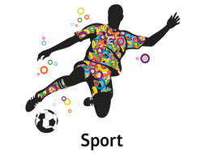
Subject | Sport
Course | Cambridge Technical
Awarding Body | OCR

Contents:
 |  | Page(s)
 | Course/specification overview | 3-4
 | Our department expectations | 5-6
 | Review/revise | 7-8
 | Watch | 9-10
 | Listen to | 11
 | Read | 12
 | Research | 13
 | Complete | 14-16
 | Appendices/resources | 17

Course/specification overview
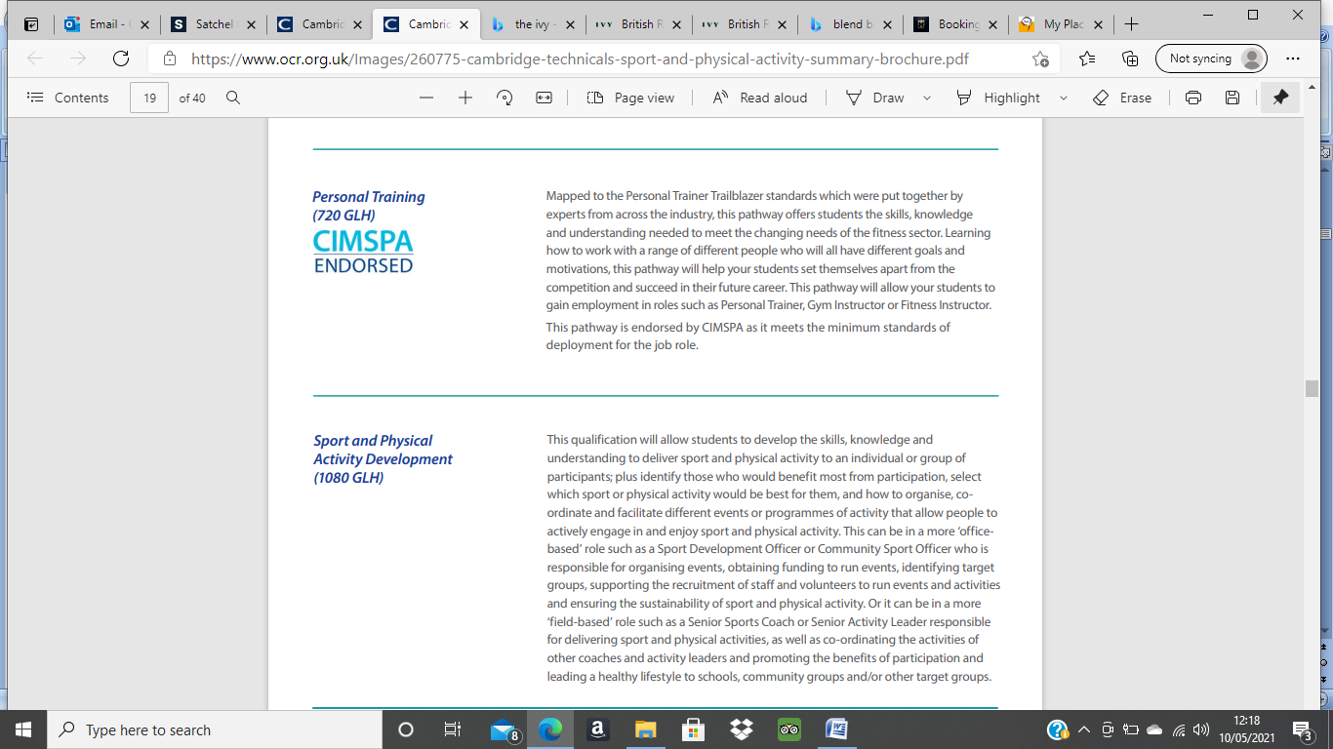

All students will start out taking the double award after which there is an option to study the triple award. This would involve you studying an extra 5 units over the course of the 2 years. Studying these extra units will involve a lot of independent work and study with teacher guidance.
Mandatory Units:
Double | Triple (red units plus the following)
Body systems | Performance analysis
Sports coaching and leadership | Organisation of sports events
Sport organisation | Nutrition and diet for sport
Working safely in sport | Working in active leisure facilities
Group exercise to music | Sport injury and rehabilitation
Improving fitness for sport | Practical skills in sport
Physical activity for specific groups | The business of sport
Health and fitness testing

Looking at the information above from OCR you can see the mandatory units that you will study. Some of the units are internally assessed (written assignments) and some are external (examined). Some of the examined units such as Body Systems and Sports coaching and leadership are worth more credits as the other units (these are the examined ones). You can also see the extra units you will study if you chose the triple award.

DISTINCTION
MERIT
PASS

As you can see your work will be marked against a pass, merit and distinction criteria. This will be for every assignment as well as your examination grades. You will be given an assignment brief at the start of each assignment where the P,M and D criteria will be shared. If you want to achieve a distinction you will need to brush up on some higher order thinking skills such Analysis, Evaluation, Predicting, Comparing and Contrasting. You final result will be 2 grades if you are doing the double award (eg DD) and 3 grades if you are studying the triple award (eg DDD). You can also achieve a Distinction* if you consistently achieve Distinctions in assignments.

Our department expectations

You will have 20 periods of Cam Tech per fortnight, there is an expectation that:
- Your attendance is a minimum of 97%
- All work produced in the first submission is to the best of your ability
- You meet assignment deadlines which are clearly marked on assignment briefs
- You respond to teacher feedback after first submissions.
- Participate in extra-curricular sport and have a commitment to an active healthy lifestyle
- Take responsibility for your own learning
- Be independent learners!

Below are examples of the different ways that you will be assessed.

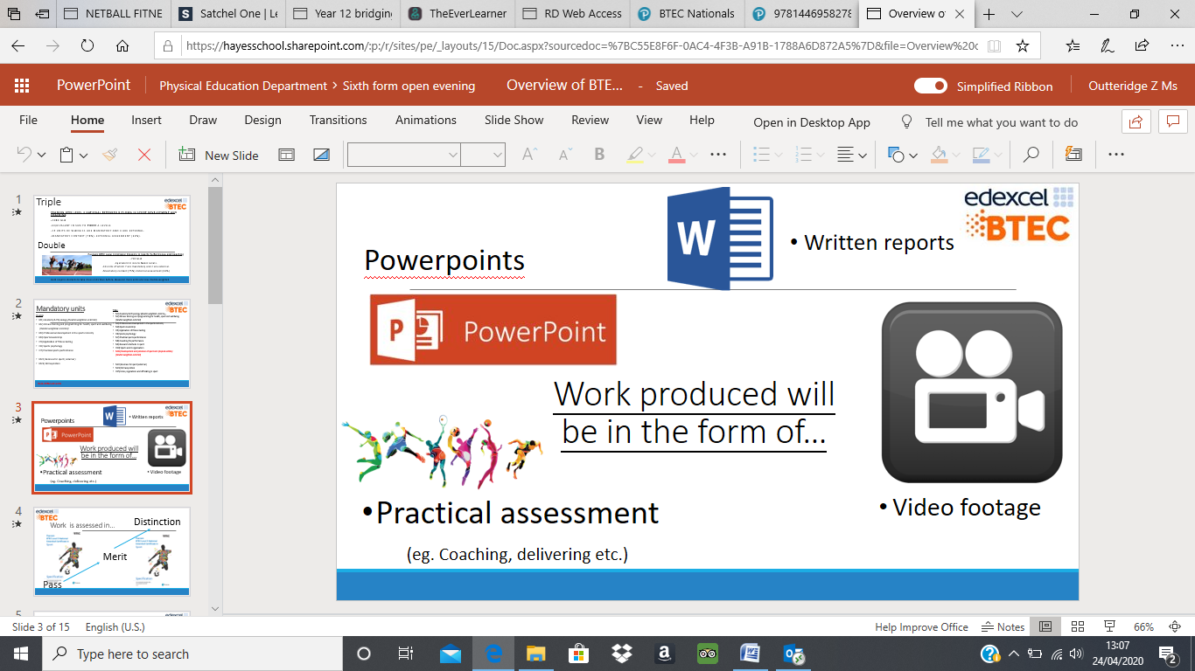

Below are the expectations we have of you when you hand in work.
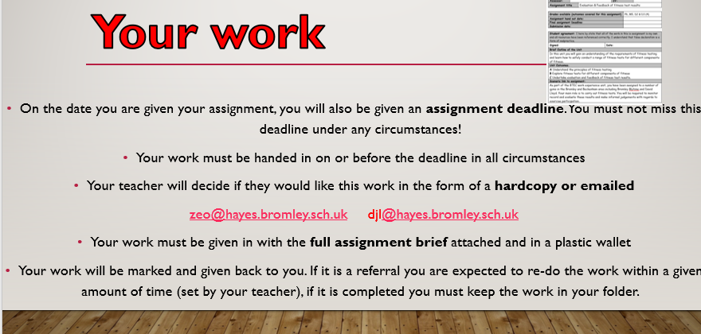

Cam Tech sport involves a lot of research through independent learning. Your ability to research, synthesize information and use a multiple of sources to contribute towards your assignments. Below are a list of Do’s and Don’ts that Miss Outteridge, the Head of Cam Tech, has set out.
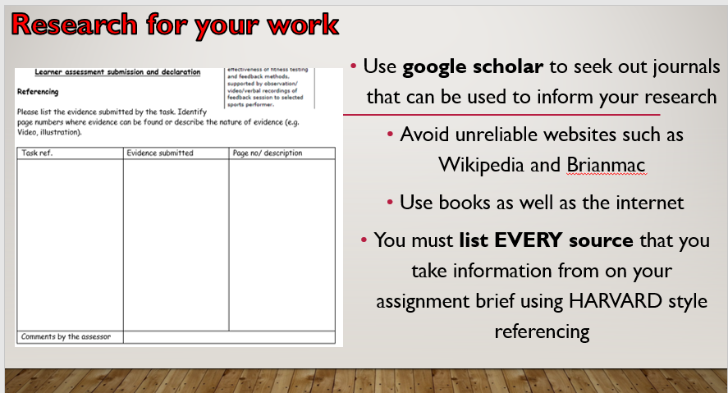

Review/revise
Much of the work that you do at GCSE will be applicable to your study in Cam Tech. It would be a good idea to review your learning for the following topics before you undertake the Cam Tech course of study
- Fitness Testing
- Principles of fitness testing
- Components of fitness
- Fitness tests
Top End sports gives a great recap of fitness tests including protocols and sports specific tests.
https://www.topendsports.com/testing/tests.htm

- Body Systems
- The effects of exercise on the skeletal system
- Structure and function of skeleton
- Types of bones
- Joints
- Types of movement
- The effects of exercise on the muscular system
- Types of muscle contraction
- Muscle fibres
- The effects of exercise on the respiratory system
- Structure and function of the respiratory system
- Gaseous exchange and tidal volume
- The effects of exercise on the cardiovascular system
- The structure of the cardiovascular system
- The heart, blood vessels, composition of blood
- Function of the cardiovascular system
- The effects of exercise on energy systems
- ATP-PC system and Lactate system
BBC Bitesize gives you a great overview of the topics above. These are especially important as they are the ones that you will be externally assessed in for your written exam.
https://www.bbc.co.uk/bitesize/topics/zxq7j6f

- Professional development in the sports industry
- Sports provision
- Socio economic barriers
- Careers in the sports industry
- Working safely in sport

Sports industry biz is a great way of keeping up to date with the latest developments in the sporting world, especially looking at the industry of sport and the potential impact that the coronavirus is having on sport
https://www.sportindustry.biz/

- Sport and society
- Effects of exercising to music
- Methods of improving fitness
- Barriers to participation
TandF online provide a monthly coverage of different issues surrounding sport and society. Have a look at the different volumes which relate to the topics above.
List of issues Sport in Society (tandfonline.com)

Watch

Unit 1: Body systems
https://www.youtube.com/watch?v=S-TE_3iYBCk&list=PLcdQDUUQX_4vcifsRu-iOyqZsxtlOsWxy

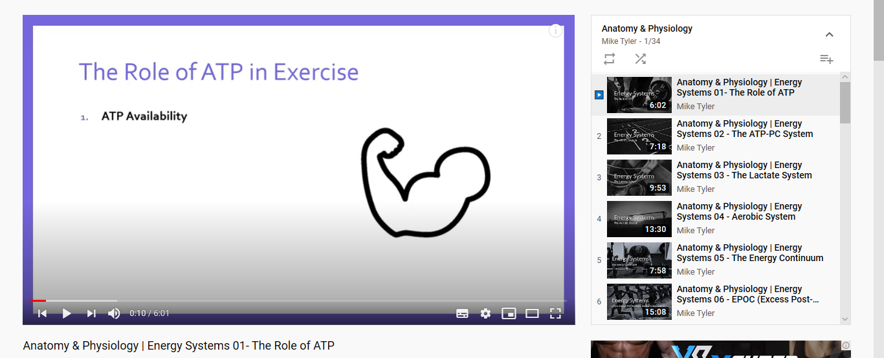

There are 34 videos to watch!
TED Talks

Watch this TED talk with Martin Hagger who is a Professor of Psychology at Curtin University.
Martin will provide an overview of the kinds of techniques that elite athletes use to prepare psychologically for their sport, give details of the scientific research into these techniques and how they work, and how the techniques might be used by competitive athletes and coaches to maximise performance.
https://www.youtube.com/watch?v=yG7v4y_xwzQ

Watch this TED talk in which Valorie Kondos Field, long-time coach of the UCLA women's gymnastics team, shares the secret to her success. Hint: it has nothing to do with "winning."
Why Winning doesn’t always equal success
https://www.youtube.com/watch?v=JJyeKiT8g4g

Watch this TED talk in which Diana Nyad tells her inspirational story.
In the pitch-black night, stung by jellyfish, choking on salt water, singing to herself, hallucinating ... Diana Nyad just kept on swimming. And that's how she finally achieved her lifetime goal as an athlete: an extreme 100-mile swim from Cuba to Florida -- at age 64. Hear her story.

Watch this TED talk in which David Epstein discusses the role of technology in sport and how the sporting body type and shape has evolved.
When you look at sporting achievements over the last decades, it seems like humans have gotten faster, better and stronger in nearly every way. Many factors are at play in shattering athletic records, and the development of our natural talents is just one of them.
https://www.youtube.com/watch?v=8COaMKbNrX0

Television
Gamechangers (Netflix) – A really interesting film which looks at uncovering the truth about meat, protein and strength, showcasing elite athletes and cutting edge science.
Icarus. 2017- A film around doping within sport and current issues surrounding the use of drugs within sport.
Stop at Nothing 2014 – Filmmaker Alex Holmes creates an explosive portrait of disgraced cyclist Lance Armstrong.
Live Sporting Events- This will support how you show your understanding by using current examples from sport.

Listen to
Listen to this examiner who explains the process of studying CamTech Sport...
www.youtube.com/watch?v=Q9yT3WHTNHs
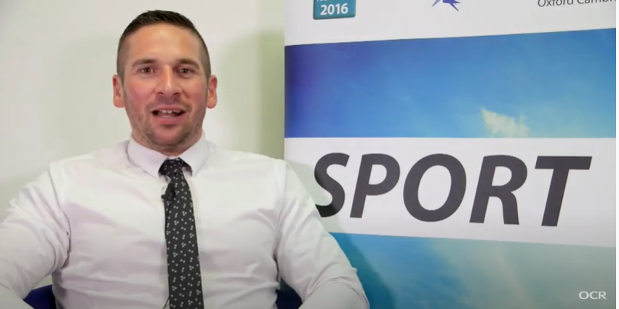


Listen to this radio programme from the BBC World Service. Sports Hour is a lively Saturday morning sports show with reports, debate and humour. There are over 280 shows available covering all world sport.
BBC World Service: Sports hour

Listen to this radio programme.
This is a daily podcast bringing you the latest from the Premier League, EFL, European football and more.
BBC Radio 5 live
Talksport radio
Listen to this podcast with ex professional footballer Peter Crouch which documents his experiences as a professional footballer

The Peter Crouch Podcast

Listen to this podcastfrom the British Journal of Sports Medicine. It covers all sorts of aspects of Sports Medicine, from the science behind running shoes to the power of sleep.
BJSM Podcast

Read

Body systems:
Bartlett R (2014) Introduction to Sport Biomechanics
Marieb E (2015) Human Anatomy and Physiology
Palastanga (2012) Anatomy and Human Movement; Structure and function

Improving fitness for sport:
Bean A (2013) The complete guide to Sports Nutrition
Bean A (2015) Which Sports Supplements really work
Brooks D (2004) The complete book of Personal Training
Coulson M (2013) Complete guide to personal Training
Delavier F (2013) Strength Training Anatomy

The business of sport:
Hong C, Harisson D (2011) Tools for Continuing Professional Development
MastersJ (2011) Working in Sport, 3rd edition
Wells et al (2010) A career in Sports: Advice from Sports Business Leaders

Sports coaching and leadership:
Martin B Cashel et al (20060 Outdoor leadership, theory and practices)
Prentice E etal (2012) Sports Leadership:Winning with your mind
Roe K (2014) Leadership: Practice and Perspectives

Health and fitness testing:
Archer D and Coulson M (2015) Practical Fitness testing. Analysis in exercise and sport.
Morrow etal (2010) Measurement and Evaluation in Human Performance

Research

Body systems:
www.humankinetics.com Educational resources for all areas of sport
www.sportsci.org Research into sport and anatomy
www.topendsports.com Information of many aspects of anatomy and physiology

Improving fitness for sport:
www.eis2win.co.uk Information on nutritional principles
www.uksca.org.uk UK strength and conditioning association.
Tips on how to become a S&C coach
www.bases.org.uk British association of sports and exercise sciences
www.nhs.uk/livewell Tips for leading a healthy lifestyle

The business of sport:
www.careers-in-sport.co.uk Careers in Sport – information about career options in the sports industry
www.nationalcareerservice.direct.gov.ukut Information about different careers
www.uksport.gov.uk/jobs-in-sport - Information about sports related jobs in the UK.

Health and fitness testing:
www.brianmac.co.uk – A wide variety of information related to fitness and training
www.pponline.co.uk – Peak Performance: free advisory newsletter that discusses strength and fitness
www.topendsports.com – A range of fitness tests and normative data.

Complete
Create 4 PowerPoint presentations with a slide of knowledge for each bullet point. You will need to use the research that you have compiled from the tasks above.
Fitness Testing
- Principles of fitness testing
- Components of fitness
- Fitness tests

Body systems
- The effects of exercise on the skeletal system
- Structure and function of skeleton
- Types of bones
- Joints
- Types of movement
- The effects of exercise on the muscular system
- Types of muscle contraction
- Muscle fibres
- The effects of exercise on the respiratory system
- Structure and function of the respiratory system
- Gaseous exchange and tidal volume
- The effects of exercise on the cardiovascular system
- The structure of the cardiovascular system
- The heart, blood vessels, composition of blood
- Function of the cardiovascular system
- The effects of exercise on energy systems
- ATP-PC system and Lactate system

The business of sport
- Sports provision
- Socio economic barriers
- Careers in the sports industry

Coaching and leadership
- Coaching styles
- Leadership styles
- Personality
- Working safely in sport
- Motivational factors

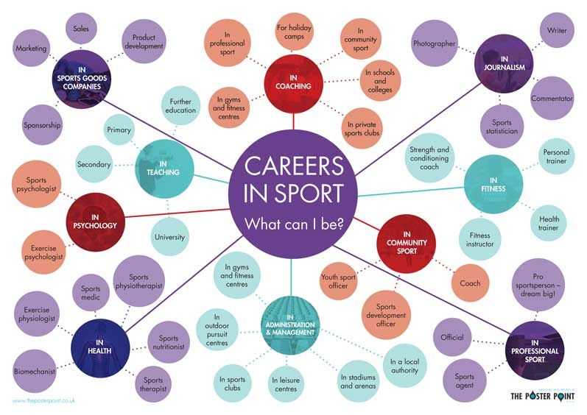
Career opportunities – Have a look through some of these articles and prospectuses to see where a career in sport could take you.

Information and research on sports related careers
https://www.bachelorsportal.com/articles/606/bachelors-degrees-in-sports-and-related-careers-are-a-slam-dunk-for-future-professionals.html
Example of Sports Science degrees at Leeds University
https://www.youtube.com/watch?v=aaP1PF5Btq8
What is Sports Management? –
https://www.youtube.com/watch?v=of-poWTX5NQ
Working alongside the Manchester city Physiotherapist
https://www.youtube.com/watch?v=Zu1EKF_dNVk
A day in the life of a Sports Psychologist
https://www.youtube.com/watch?v=C1K1ySWCS6s

Meet the strength and conditioning coach for Harlequins –
https://www.youtube.com/watch?v=VXv3UAfZ4m4
Sports Nutritionist and Personal Trainer
https://www.youtube.com/watch?v=kO6Y9ZXpsGY
Sports Coaching and Physical Education
https://www.youtube.com/watch?v=v5fdXdgC6tY
BSC Sports Therapy at the University of East London
https://www.youtube.com/watch?v=bRY9nhPWfU8

Appendices/resources

