A Level
Sociology PLC

Please complete this PLC. It audits your learning and covers - albeit briefly - key areas of the specification. It is RAGed (red, amber, green) so that you can identify your strengths and weaknesses or gaps in your knowledge. However, it is important that you continue to revise all areas right up until the actual exam in Year 13.
Unit 1: Introduction to sociology
Unit 1
Brief content
Completed
handbook?
Read
notes?
R
A
G
Brief
comments
What is sociology?
Outline of the course,
meaning of sociology, key
issues etc.
Social norms
Explanation of social norms,
values, rules and status as well
as social identity etc.
Socialisation
Explanation of socialisation,
including primary and
secondary.
Functionalism
Durkheim, organic analogy,
Talcott Parsons, social control,
consensus.
Marxism
Karl Marx, infrastructure,
superstructure, class conflict,
exploitation, false
consciousness.
Feminism
Liberal feminism, Marxist
feminism, radical feminism,
black feminism.
Social action
theory/interactionist
theory
Max Weber, Verstehen,
meanings, micro theory,
labelling.
New right
Charles Murray, underclass,
individualism, neo-liberalism.
Postmodernism
Pre-modernity, modernity,
postmodernity,
fragmentation, identity,
hybridity.
Social perspectives
review
Micro, macro, structural,
social action, conflict,
consensus.
Unit 2: Research methods (paper 1)
Unit 1
3)
Paper 1 &
(
Research Methods
Completed
handbook?
Read
notes?
R
A
G
F Brief
comments
Varieties of data
Primary vs. secondary,
quantitative vs. qualitative, types
of research methods.
Positivism vs.
Interpretivist
Positivism as science,
quantitative data,
generalisations, trends, macro,
interpretivist, meaning,
insightful, understanding.
PERVERT
Practicality, evidence, reliability,
validity, ethics, representation,
theory.
Sampling
Quota, strata, random,
snowballing, cluster, systematic,
opportunity etc.
Surveys
Types of surveys, strengths and
weaknesses, examples.
Questionnaires
Types of questionnaires,
strengths and weaknesses,
examples.
Structured
interviews
Strengths and weaknesses,
theoretical issues, examples.
Unstructured
interviews
Strengths and weaknesses,
theoretical issues, examples.
Observations
Covert and overt, strengths and
weaknesses, theoretical issues,
examples, Hawthorn effect.
Participant
observations
Covert and overt, strengths and
weaknesses, theoretical issues,
examples, Hawthorn effect.
Experiments
Strengths and weaknesses,
theoretical issues, examples.
Longitudinal
research
Types, design, strengths and
weaknesses, theoretical issues,
examples.
Triangulation
Formulation, parts of
triangulation, reasons for
triangulation.
Official statistics
Where to find them, strengths
and weaknesses, theoretical
issues, examples.
Surveys and
education
Famous examples from
educational research, strengths
and weakness.
Interviews and
education
Famous examples from
educational research, strengths
and weakness.
Experiments and
education
Famous examples from
educational research, strengths
and weakness.
Observations and
education
Famous examples from
educational research, strengths
and weakness.
Official statistics
Key uses in educational research,
strengths and weakness.
Unit 3: Education (paper 1)
Unit 3 (paper
1)
Brief content
Completed
handbook?
Read
notes?
R
A
G
Brief
comments
Functionalist
perspectives
Durkheim’s (values, skills,
mini-society), Parsons
meritocracy, bridge, ascribed
(
status), Davis and Moore
).
allocation/filter
(
Marxist
perspectives
Althusser and the ISA, Bowls and
Ginitis (correspondence theory,
hidden curriculum, myth of
meritocracy), Willis – Learning to
Labour.

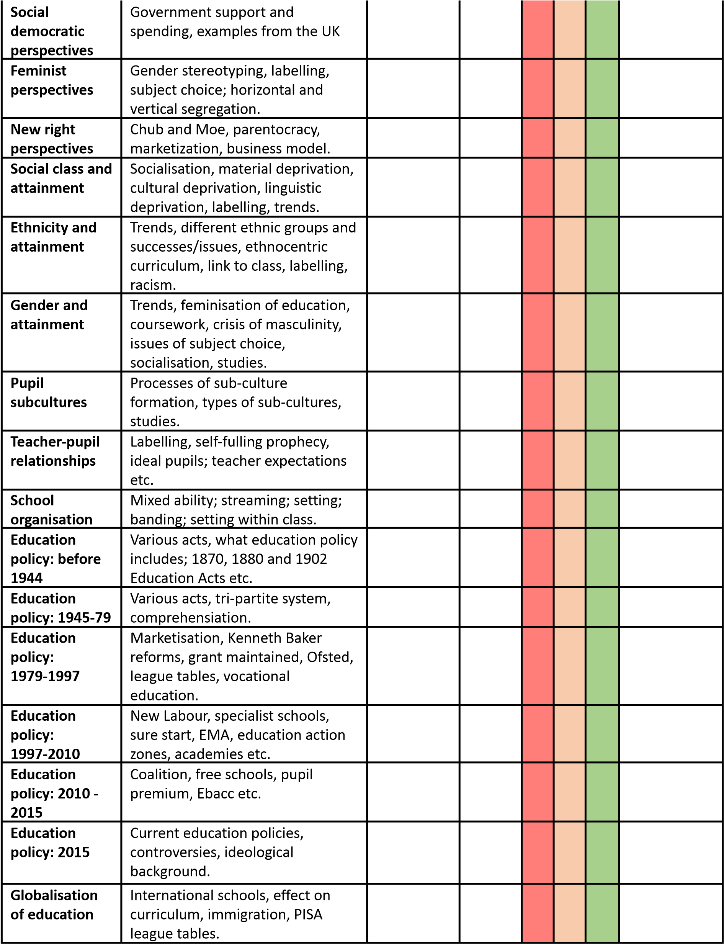

Unit 4: Family and Households (paper 2)
Unit 4
(
paper
2)
Brief content
Completed
handbook?
Read
notes?
R
A
G
Brief
comments
The family and
social
structure
Family types and definitions;
functionalist, Marxist, Feminist,
New Right and postmodern
perspectives on the family; the
family and social change; changing
family structures; social policy and
the family; modernity and
postmodernity.
Family
diversity
The growth of family diversity;
single/lone parenthood; ethnicity
and family diversity; diversity and
the decline of traditional
conventional families.
Relationships
Changing patterns of marriage and
cohabitation; divorce and family
breakdown; the changing life
course; personal life and the family
and life expectancy.
Gender, power
and the family
Conjugal roles, housework and
childcare; conjugal roles, power
and emotion work; domestic
violence and abuse.
Childhood
The social construction of
childhood; changing childhood;
contemporary perspectives on
childhood.
Demographic
changes and
the family
Demography and the birth rate;
the death rate and life expectancy;
migration; globalisation; the aging
population.

